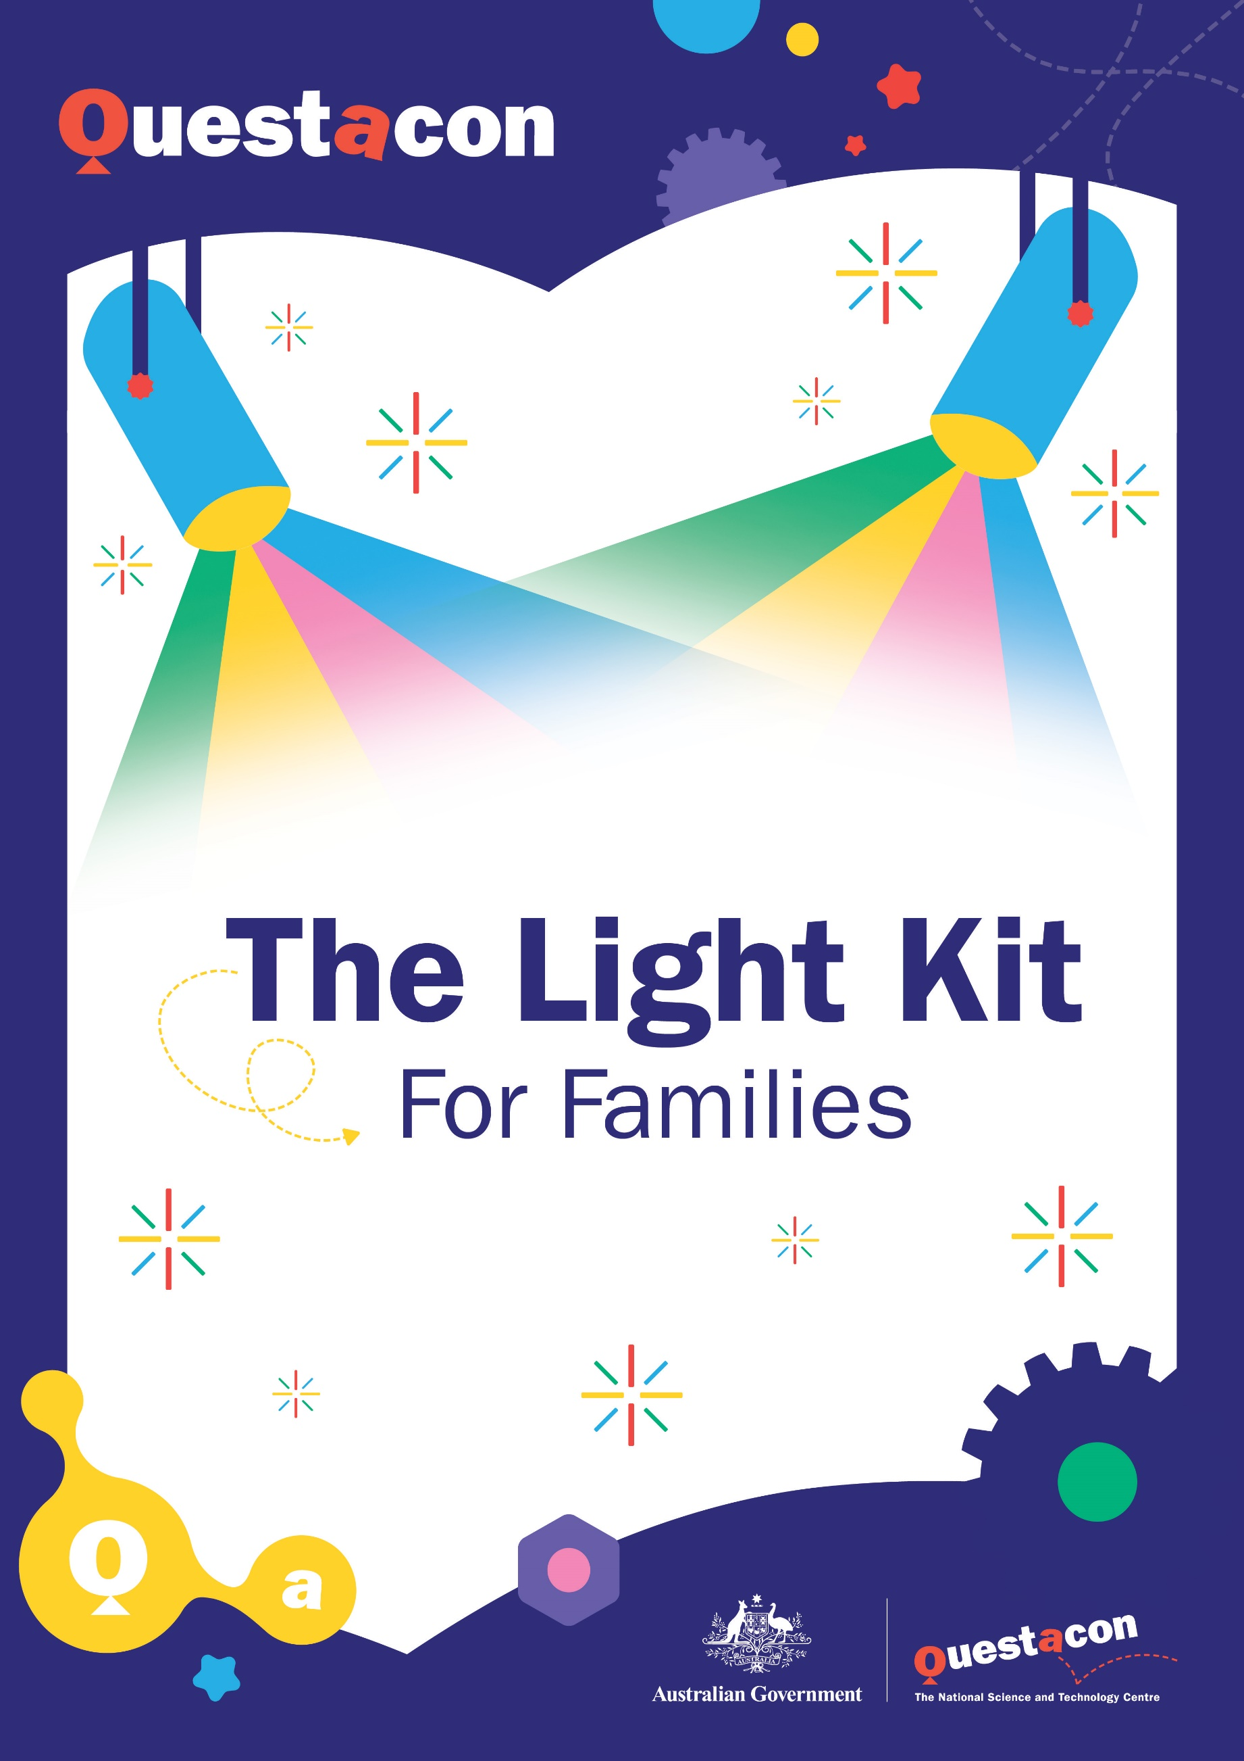

Exploring Light: tips for guardians

**The activities in this kit explore light and light refraction.**

Light refraction involves the **bending** of light as it moves through a different object, which can result in **magnification or distortion.** We can **block or filter** light, and **split** light, creating rainbows.

When doing the activities in this kit, we encourage you and your family to move slowly and take the time to explore using Questacon's **Question, Guess, Test and Observe** method.

Any experiment can be performed with this, first by asking a **question**, having a **guess** (hypothesising) about what might happen, **testing** it out, and finally, making **observations** about what happened.

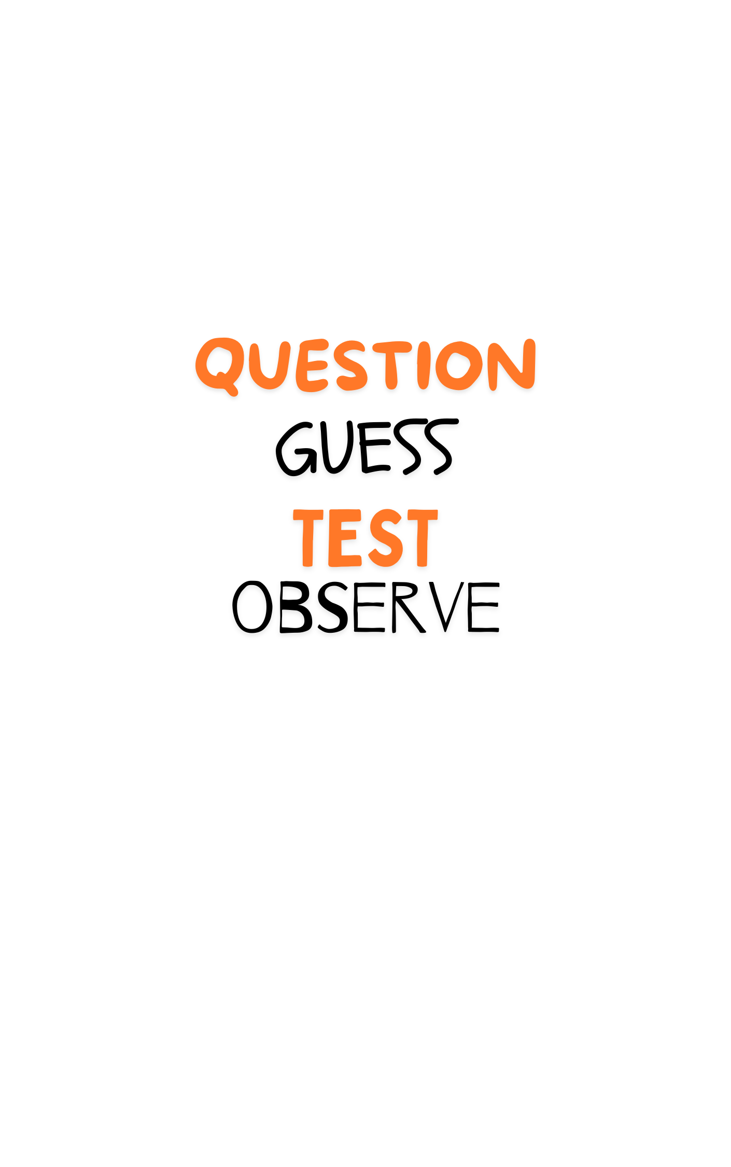We encourage you to change these activities to suit your needs, available equipment, and interests. Feel free to explore further and encourage your family to try new things, especially when it comes to combining elements from different activities!  Everyone sees light differently so use this as an opportunity to talk about what you each see and why that could be different for other people.

A note on safety: This kit contains small parts and is not suitable for children under the age of 5. These activities involve looking at lights. Choose your lights with care; long exposure to overly bright lights can cause damage. Do not stare at the sun.

What’s in the box?

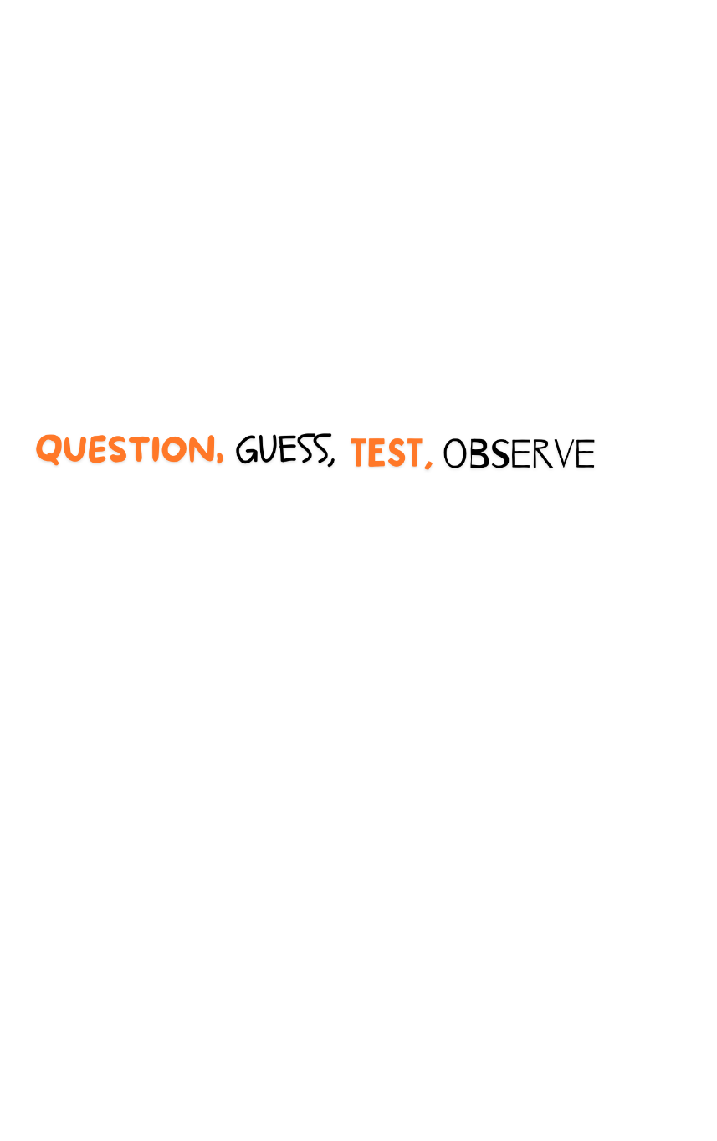This kit contains the materials and instructions for 5 experiments.

But with a bit of imagination, and the method, the possibilities are endless.

**The Experiments**

**Wobbly Lens**

Observe how water can

bend images.

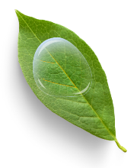

**Splitting and Blocking Light**

Observe the splitting of the colour spectrum, and where different light colours appear on that spectrum.

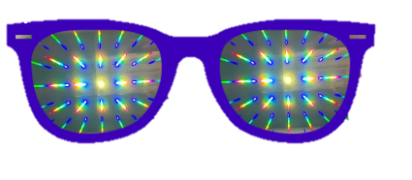

**DIY Kaleidoscope**

Observe the beautiful

patterns of mirroring.

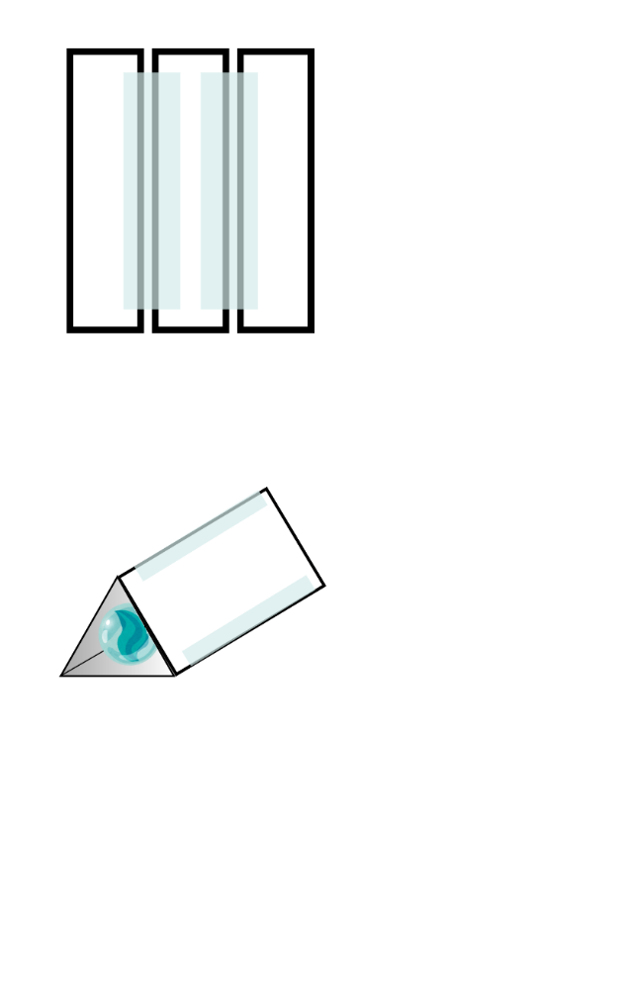

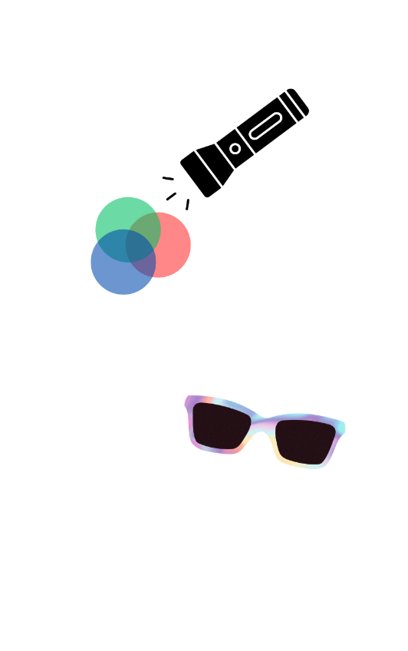

**Polarisation**

Observe how polarising

filters affect light.

**Colour Filters**

Observe how different

coloured filters affect light

and how combining filters

can create new colours.

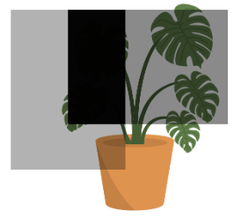

**This Kit Contains:**

· 4 pairs of diffraction glasses

· 6 colour filters: 2 x red, 2 x blue and 2 x green

· polarizing filter x 2 (grey)

· mirrors x 9

· marble x 3

· sandwich bags

**You will need:**

* 3 x torches or phone lights
* paper
* coloured pencils, markers, or crayons
* tape

Designing an Experiment

If you are looking to extend your family’s scientific skill set, try designing an experiment!

You can use the template provided or try making your own.

There are a few important things you need to know when designing your experiment and an order in which to do things, we will go over those now!

1. **Question**

All experiments start with a question that the scientist (YOU!) want to know the answer to. Think *how, what*, and *why*?

After you have a question sometimes you will want to do some research to see what other people have discovered about the topic.

1. **Hypothesis**

A hypothesis is your educated guess for the answer to your question.

You can include an explanation here. Why do you think this will be the answer?

1. **Variables**

When doing experiments there are some things we want to change and some things we want to stay the same, these are called variables.

**We only want to change one thing at a time, so we know which variable is affecting the dependent variable.**

* + **Dependent Variable**

Is the thing you are measuring or observing.

* + **Independent Variable**

Is the thing you change to see how it affects the dependent variable.

* + **Controlled variables (controls)**

These are things that you keep the same to ensure the experiment is focused on the variable that you’ve changed.

1. **Method**

This is your set of instructions, a bit like a recipe in a cookbook.

Your method tells people what you are going to do and when. It should be written in a way that you could give the instructions to a friend, and they could follow it and get the exact same result as you, without your help!

* + Sometimes it can be helpful to add drawings of what you are going to do.
  + Trials
    - When we do a scientific experiment we need to test things more than once to make sure we always get the same result. You can specify how many times you want to do the test.

1. **Results**

What did you observe? You can write, draw, or create a graph or table to record your data and observations. It’s ok if your results aren’t what you expected! Just write down what happened.

1. **Conclusion**

Does your result match your hypothesis? If yes, you **accept** your hypothesis. If not, you **reject** your hypothesis.

Rejecting your hypothesis isn’t a problem, it just means you get to start again! Make a new hypothesis, change your independent variables and controls, write a new method, and see if you get a new result!

1. **Question:**

When we finish our experiment, we may get an answer to our question, but we might also now have more questions! Are there any new questions that your experiment has prompted you to ask?

Experimental Design

An example!

**Question:**

How can I stop apple slices turning brown?

**Hypothesis:** I think lemon juice will stop apples turning brown because we put it in fruit salad and the fruit salad doesn’t go brown.

**Variables:**

* **Independent:**

Lemon Juice vs no lemon juice

* **Dependent:**

How brown the apple becomes.

* **Controls:**

Use wedges from the same apple.

Leave apples in the same place and for the same time.

**Method:**

1. Cut two wedges of the same size from an apple and place in two clean bowls.

2. Squeeze 10ml lemon juice onto one apple wedge.

3. Leave the apples for one hour.

4. Look at both apples and compare their colour.

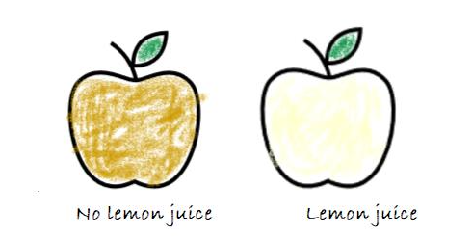

**Question:** Now I wonder if temperature also impacts the apple wedges changing colour?

**Conclusion:**

I confirmed my hypothesis that lemon juice helps apples to not turn brown.

**Results:**

The apple that had no lemon juice turned quite brown, while the apple with the lemon juice on it only turned a little brown.

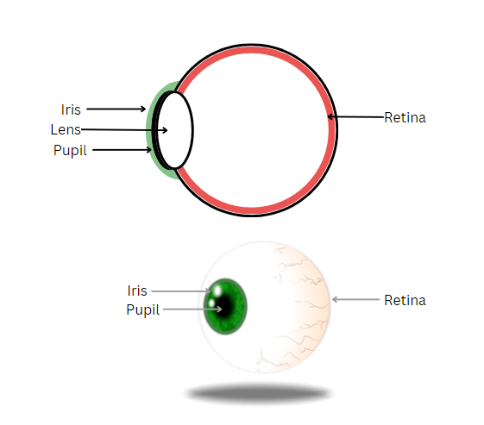The biology of colour

Your retina, which covers the back of the eye, contains light receptors called rods and cones.

Rods help with night vision and let you see in shades of grey while cones are responsible for your colour vision.

There are three types of cone cells which each identify different light wavelengths (colours)

* one type is the most sensitive to long wavelengths (red)
* one to medium wavelengths (green)
* and one to short wavelengths (blue)

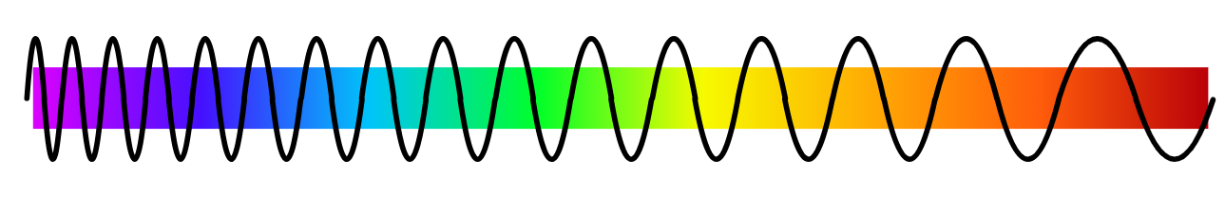

When we look at an object, light enters our eyes and stimulates the cone cells. Our brain then interprets the signals from the cone cells so that we can see the colour of the object. For example, when the red and blue cones are activated, we will see the colour purple.

If your eye can identify all 3 colours you have full colour vision, which has the scientific name **Trichromacy,** and can see nearly 1 million different colours.

Some people have **Anomalous Trichromacy** which means one of their cones doesn’t identify one or more wavelengths. You might know this as **colour blindness** or **colour vision deficiency**. Not everyone with Anomalous Trichromacy has the same loss of colour. Anomalous trichromatic vision can range from almost full colour perception to an almost total absence of a colour.

There are three types of Anomalous Trichromacy

* **protanomaly**, which is a reduced sensitivity to red light
* **deuteranomaly** which is a reduced sensitivity to green light (the most common form of colour blindness)
* **tritanomaly** which is a reduced sensitivity to blue light (extremely rare).

If you look at the pictures below you can see what a person with each type of colour blindness might see.

The Wobbly Lens, Kaleidoscope and Polarising experiments in this kit can be completed no matter your colour vision. The Colour Filter and Diffraction experiments will be different for every person. While you use this kit, take the opportunity to talk to your friends and family about what colours they see!

Colour Vision in animals:

Many animals also use rods and cones to perceive colour. Dogs only have two types of cones and therefore only see combinations of yellow and blue. They have far more rods than humans, however, which allows them to see very well in the dark.

Wobbly Lens

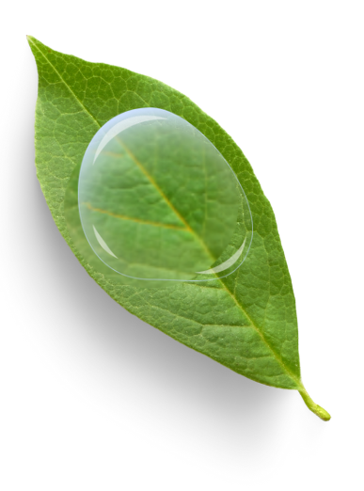 **Aim:** Observe how water can bend images.

**You will need:**

* Sandwich bag
* Water
* Paper
* Crayons, pencils, or markers

**Set-up:**

Working over a sink, fill the resealable bag half up with water, and then carefully remove the air and seal up the bag so there are no air bubbles. Dry the outside of the bag. Write a message or draw a picture on your paper.

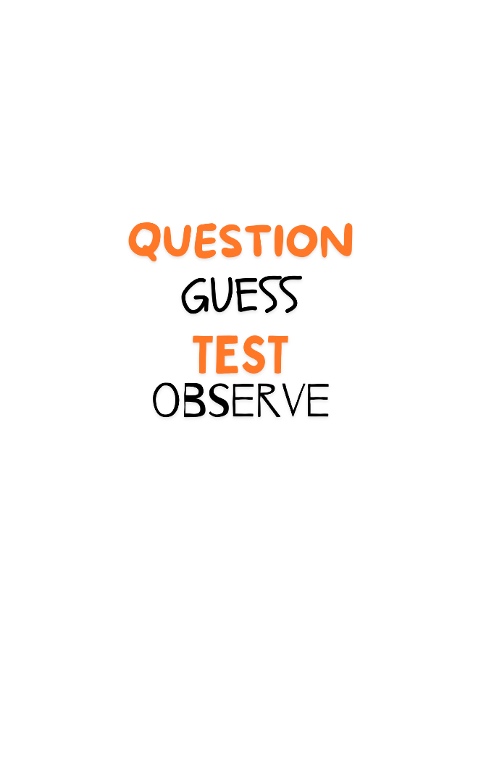

**Example**

* What happens to the picture or message when you look through the bag of water?

What other questions could you ask?

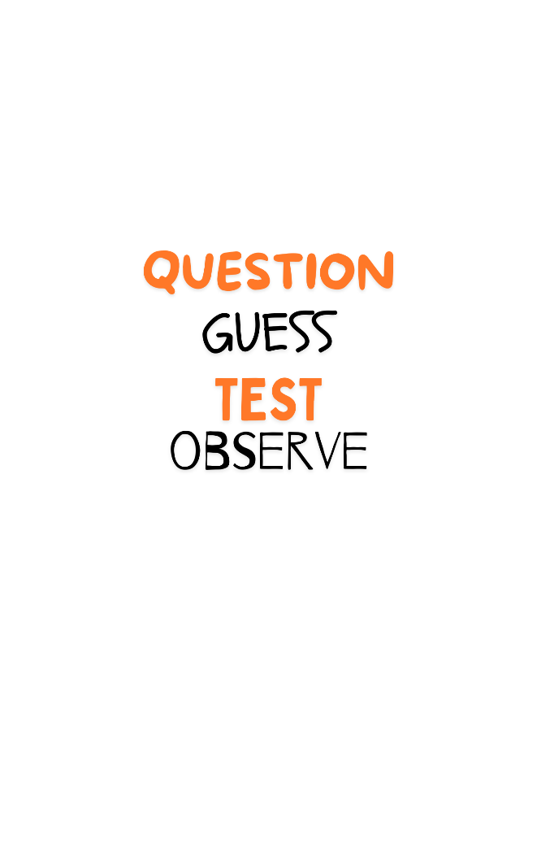

**Now make your**

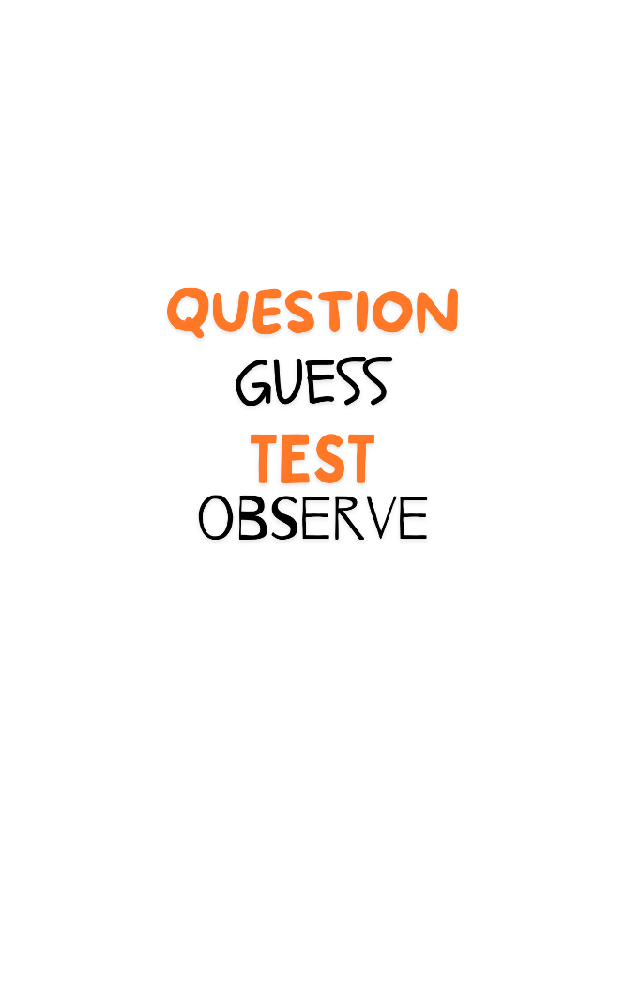

**Time to**

Hold the water-filled bag over the writing/pictures and look through the water. Experiment with looking through the bag while gently squishing the bag, holding it at different heights and angles.

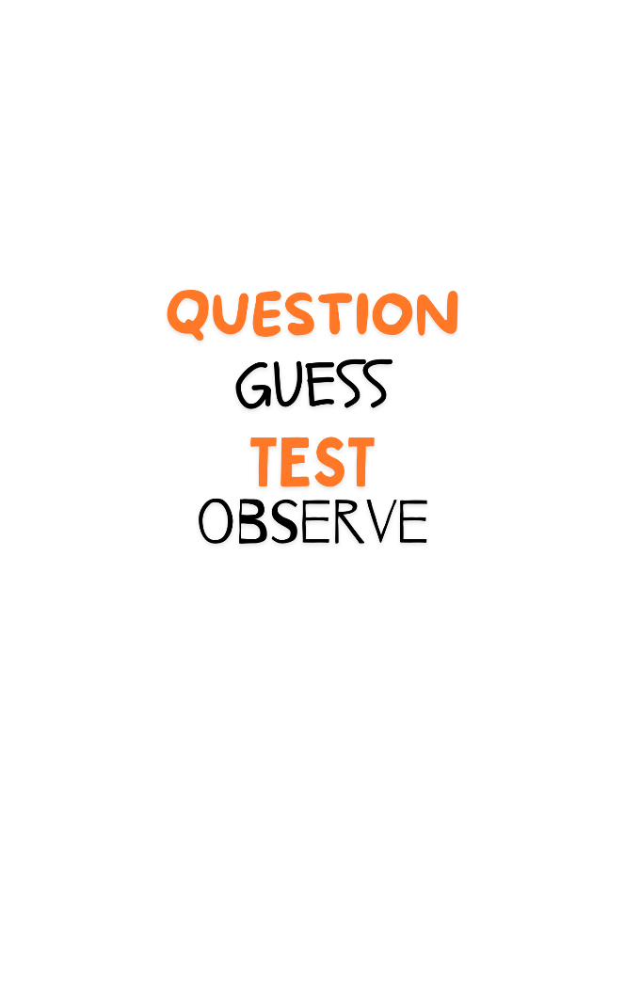

**What did you ?**

**The Science**

When light bends, it changes how things look. A magnifying glass works because it bends, or refracts, light through a curved piece of glass. This makes things look larger than they really are. In this experiment, the water is bending the light, so it acts as a magnifier.

**Extend:**

What other questions could you ask now that you have done the first experiment?

Some we thought of include:

* Can you make the words or pictures bigger AND smaller?
* What happens if you move the bag closer or further from the picture?
* What happens if you change the shape of the bag?

What other materials could you try with this experiment?

* What if the bag had no water in it?
* What other tools magnify objects? Is there anything in this kit?
* Use a magnifying glass, binoculars, or a telescope to look at things far away. How do they look when magnified? What if you turn the magnifying glass, binoculars, or a telescope around and look?

**Real World Applications:**

We use lenses to bend light every day! You can see them most commonly in glasses but lots of other things use lenses too. Cameras, binoculars, telescopes, and projectors all use lenses to change how we see things.

The word lens comes from the Latin word for lentil because the first lenses looked a bit like lentils in shape!

Colour Filters

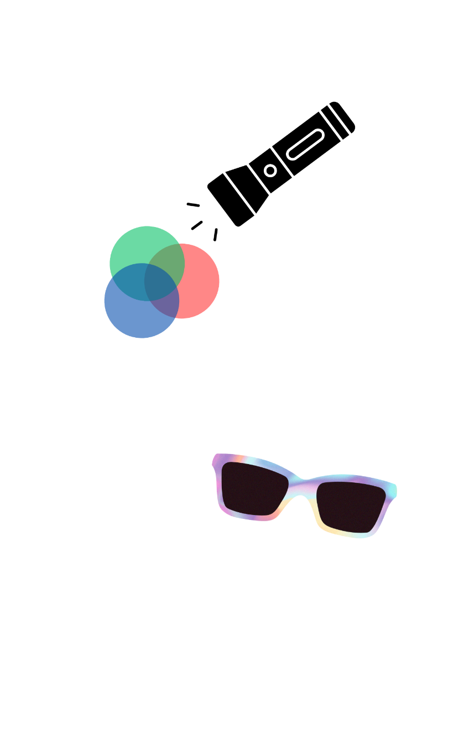**Aim:** Observe how different coloured filters affect light and how combining filters can create new colours.

**You will need:**

* colour filters: red, blue and green
* 3 x light source (torch or phone torch)
* white paper
* tape
* pencil/small toys
* a dark room



**Example**

* Is white light made up from different colours?

What other questions could you ask?



**Now make your**



**Time to**

This experiment is best done in a dark space.

1. Shine a light in the wall – what colour is the light?
2. Place a thin object vertically (up and down) in between the light and the wall (we stuck a pencil into a piece of cardboard to make it stand up). What colour is the shadow?
3. Tape one colour filter onto each light source/torch and shine at the same place on a white wall or white paper. What colour is the light where it meets on the wall?
4. Place the same object as before in the same place between the light sources and the wall. What happens to the object’s shadow?
5. Place a larger object in front of the lights. What changes?
6. Try switching off one of the lights, now what colours can you see?
7. Experiment with the location of different filters and different objects to see what affect it has on the shadows and colours.

**What did you ?**

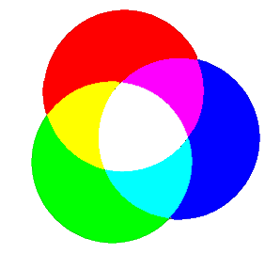**The Science:**   
Simple:

The Primary colours of light are **Red**, **Blue,** and **Green**. When we shine these 3 colours at the same place, we see white light. By blocking different combinations of light, like you did with your objects) you can make shadows of 7 different colours, blue, red, green, black, cyan, magenta, and yellow.

When you block two lights, you see a shadow of the third colour—for example, block the green and blue lights and you get a red shadow.

If you block only one of the lights, you get a shadow colour that is a mixture of the other two – for example, block the blue light and the green and red mix to create yellow.

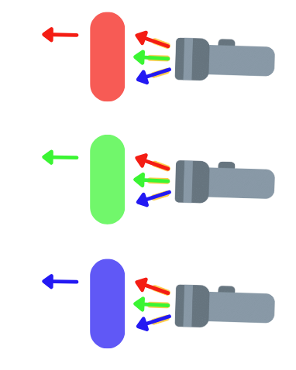

Detailed:

The visible light spectrum (the light the human eye can see – for more read **‘*Biology of colour’ above)*** covers a range of wavelengths, which we see as different colours. Low-energy light appears red, while high-energy light appears violet.

Each colour filter will absorb all the colours from a light source except for its own. The filter allows that colour to pass through and this is why you perceive the light as that colour when it comes out the other side.

The colour of an object is not a part of the object. In fact, the colour we see depends on the light that is shining on the object, and the light that is reflected off the object. For example, a granny smith apple isn’t green; when we see the apple under sunlight (light that contains all colours), the green light (or wavelength we see as green) is reflected, while all other colours are absorbed. Because green light is reflected, that is the colour we see. An object that reflects all colours looks white, while an object that absorbs all colours looks black.

This only works because sunlight contains all colours. If you shine a light that only has one colour on an object and that object absorbs that colour, the object will look black. For example, if we shone a red light onto the green apple, all the red light would be absorbed by the skin of the apple and no light would be reflected, making the apple appear black. **You can test this yourself!** This is why shining different-coloured lights on coloured objects makes them change colour.

**Extend:**

* Put a small hole in a piece of paper and hold in front of the coloured lights. Try moving it different distances from the lights. Try differently shaped holes.
* What combinations make what colours?
* Can you make an object appear black? How?
* Does the distance of the colour filter from the torch impact the strength of the colour?

**Activity**

Check out artworks by Carnovsky (<https://www.carnovsky.com/RGB_BLACK_wallpapers.htm>)

Look at the artworks through your colour filters. What do you see?

Can you use your pens, markers, and crayons to draw disappearing pictures or write hidden messages?

Splitting and Blocking Light

**Aim:** Observe the splitting of the colour spectrum, and where different light colours appear on that spectrum.

**You will need:**

* Diffraction glasses
* Colour filters
* A light source (torch, phone torch)



**Example**

* What are the different colours of light?

What other questions could you ask?



**Now make your**



**Time to**

* Put on the diffraction glasses and observe your surroundings. Look towards a light source – such as a phone torch. **Do not look directly at the sun**. What do you observe?
* While wearing the diffraction glasses look through a colour filter. What changes?



**What did you ?**

**The Science:**

Diffraction glasses

To understand diffraction glasses, we first need to understand diffraction. Diffraction happens when light bends as it passes through a hole or around an edge. Try squinting your eyes and looking at a light. You should see lots of long lines coming off the light. If you tilt your head the lines will move. This is the diffraction (bending) of the light against your eyelashes.

Your diffraction glasses use holographic lenses with lots of tiny lines in them. These lines are like your eyelashes except there are thousands. When you look around, light hits the holographic lens and diffracts into the different parts of the colour spectrum.

Colour Spectrums

Light behaves like a wave. If the wave is going up and down quickly, it has a high frequency. If the wave is moving up and down slowly it has a low frequency. Humans can see light that moves within a certain range, knowns as the visible spectrum, but once it moves faster or slower it becomes invisible to us. When visible light is separated out into its component colours it appears as a rainbow. The order of colours (from higher to lower energy) is violet, indigo, blue, green, yellow, orange and red.

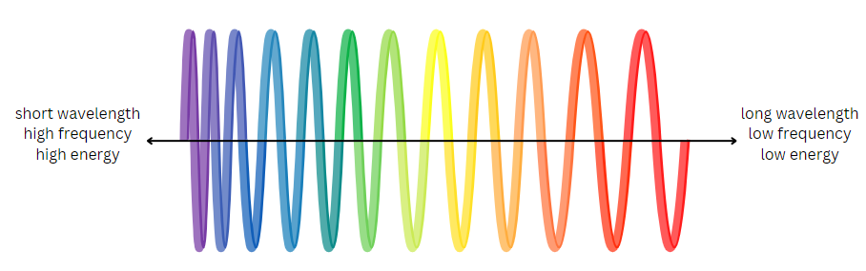

**Red** travels the furthest of any visible light colour because it has the longest wavelength. It is better able to penetrate objects and is scattered the least by air molecules. **Violet,** being at the other end of the spectrum, is the opposite. You should be able to see this when you look at a light through your diffraction glasses. The violet colour will be closest to the light source while the red is furthest away.

**Extend:**

* Which part of the spectrum is brightest?
* Looking around, what colours occur most often?

**Research**

* What animals can see colours humans can’t?
* What technologies use other types of light?

DIY Kaleidoscope

**Aim:** Observe and understand reflection.

**You will need:**

* Mirrors (these have a film over them that will need to be pulled off)
* marble,
* sticky tape,
* polarised glasses.



**Example**

* What happens when mirrors face each other?

What other questions could you ask?



**Now make your**

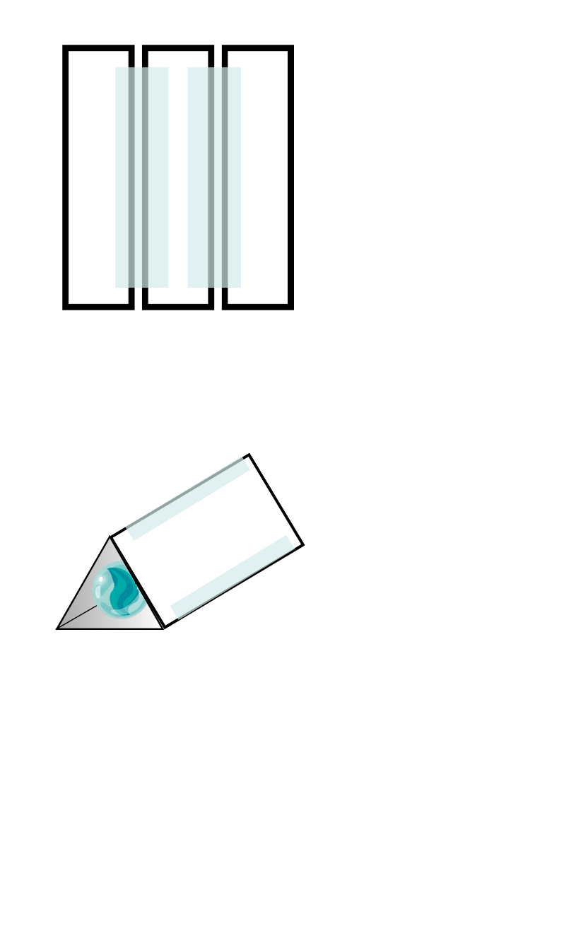

**Time to**

1. Place the 3 mirrors face down so that the longer sides are next to each other, with a small gap between them.
2. Tape the outer mirrors to the mirror in the middle.
3. Lift the mirrors and arrange them into a triangular prism, so that the reflective surfaces are on the inside.
4. Tape the last mirror in place.
5. 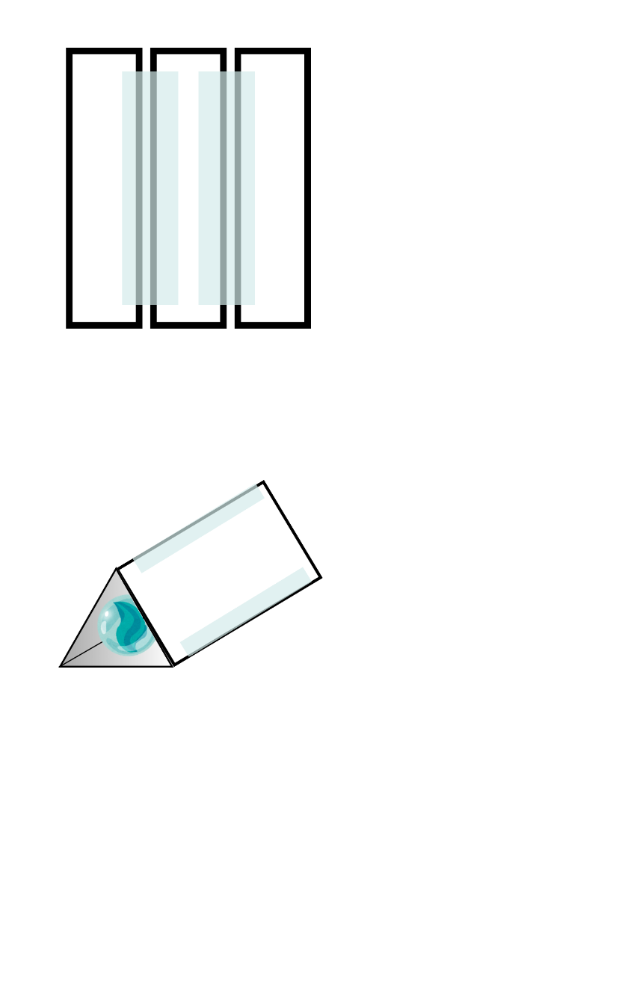Tape the marble over one end.
6. Look through the kaleidoscope in a well-lit area and try moving or turning it while you look through.



**What did you ?**

**The Science:**

Light bounces off the mirror, also known as reflecting. The image that is reflected depends on the angle of the mirror and the angle that you view it. For example, you can create an infinite tunnel of reflecting mirror images, if you place two mirrors opposite each other.

When we arrange three mirrors in an equilateral triangle, they are angled at 60 degrees from each other. This arrangement of mirrors allows us to create a striking symmetrical multiplication of patterns. This happens because each of the 3 mirrors reflects an image onto the other two, over and over, and over again.

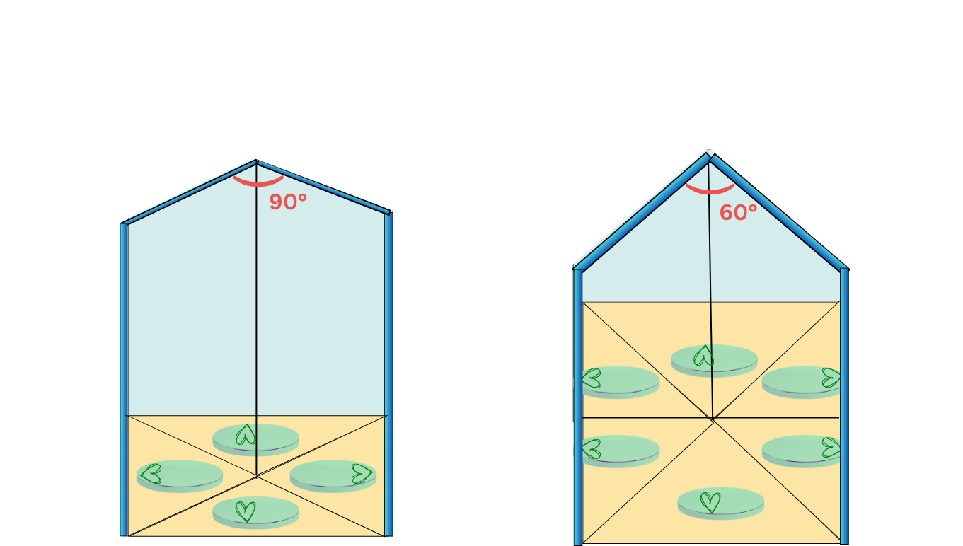

**Extend:**

* What happens if you add more mirrors or change the mirror angles?
* How does the spherical marble bend light compared to the flat mirrors?
* Fill your sandwich bag with glitter, beads or another small colourful item and tape it in the place of the marble. Does this change the effect of the kaleidoscope? How?

Polarisation—tricks with light

**Aim:** Observe how polarising filters affect light

**You will need:**

* 2 x polarising filter
* (optional) electronic screens (TV, phone, monitors, laptop etc.)



**Example**

* What do polarizing filters do?

 What other questions could you ask?



**Now make your**



**Time to**

1. Take the 2 polarizing filters and look through them one-by-one
2. Overlap two polarising filters and look through them.
3. Slowly rotate one of the layered polarising filters, 90 degrees and back. What happens?
4. Look at different electronic screens through a polarising filter. Try and slowly rotate the polarising filter, or change the viewing angle, while looking at the electronic screens through the polarising filter. Does anything change?

**Extension**

1. Cut a small piece(about 2cm) off the end of one of your pieces of film.
2. Align 2 polarising filters so that they block all the light, and add a third polarising filter at a tilted, roughly 45 degree angle in between the two. What happens? Does the location or angle of the 3rd filter change what you can see?



**What did you ?**



**The Science:**

Simple: A filter is something you use to only let part of something pass through. For example, a water filter catches little bits of dirt, and only lets clean water through. A polarising filter is a filter for light, meaning it only lets part of the light hitting it pass through.

Detailed: We cannot see this with our eyes, but light is a wave that travels from its source (e.g. the sun or a lightbulb) to your eyes. Light waves vibrate as they travel, like waves in the ocean. Unlike ocean waves though, light waves can vibrate up and down, left and right, or any other direction.

Many light sources produce non-polarised light, like the sun. This means that the light beam contains light waves that vibrate in different directions. Other light sources produce polarised light, like some TVs and monitors. This means that the light beam contains light waves that all vibrate in the same direction.

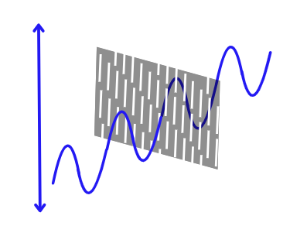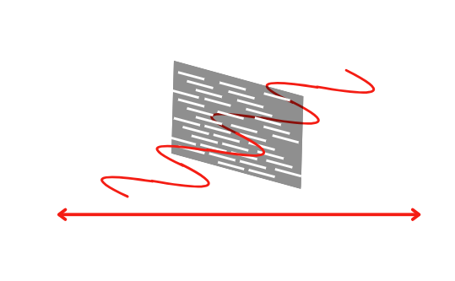

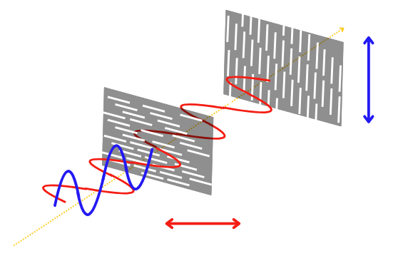A polarising filter is made up of material that has a ‘preferred’ direction of vibration. Polarising filters let light waves with the ‘preferred’ direction of vibration pass through in their full intensity, and completely blocks light waves that vibrate perpendicularly (or at a right angle) to the ‘preferred’ direction. This is why when you overlay two polarising filters perpendicular to each other, they block all the light.

For light sources that produce polarised light, like some TVs and monitors, because all its light vibrates in the same direction, polarising filters can block all of it at the right angle.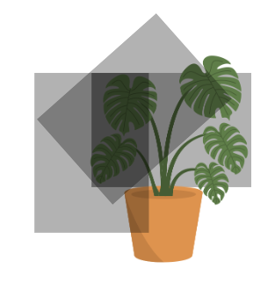

**The 3rd filter…**

Why does adding a third polarising filter between two polarising filters allow light to pass through? This is a question that puzzled physicists at the start of the 20th century.

We know that polarising filters will allow a light wave that vibrates in the ‘preferred’ direction to pass and block a light wave that vibrates perpendicularly to the ‘preferred’ direction. For a light wave that vibrates in any other direction, polarising filters do something more particular. The polarising filter weakens the light wave and changes it to be aligned with the ‘preferred’ direction. The 3rd polarising filter, at a tilted angle, changes the vibration of the light wave to a direction that can now partially pass through the second polarising filter.

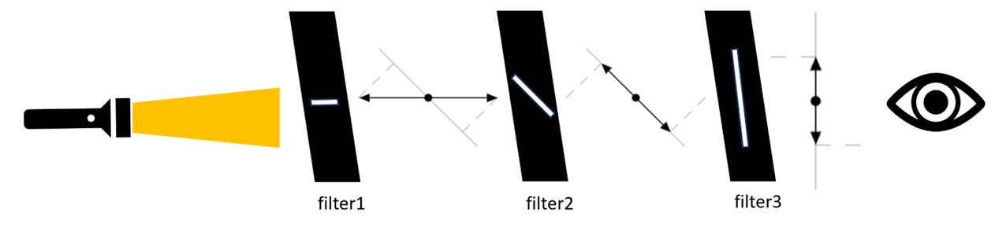

**Extend:**

* Some sunglasses use polarisation to reduce glare. If you have a pair of polarised sunglasses at home, you can try overlaying a polarising filter on them. What do you observe? Can you think of a test you can use to tell polarised and non-polarised sunglasses apart in the shops?

Real world application: Polarisation and Material Stress

Looking at plastics through polarising filters allows us to see a property of plastic called stress. Stress describes how much force is acting on a particular area of the plastic. Places that have lots of coloured bands closer together show areas of higher stress, meaning there are more forces acting on that area. Parts of the plastic with fewer colours have lower stress.

**Aim:** Observe polarised light as it goes through plastic

**You will need:**

* 2 x polarising filters
* clear plastics, e.g., drink bottles, cracker packaging, plastic forks, plastic cups, plastic rulers, etc
* (optional) electronic screens (TV, phone, monitors, laptop etc.)



**Example**

* What plastic materials show the most stress?

 What other questions could you ask?



**Now make your**



**Time to**

1. Check if your tv or computer is polarised by holding one filter in front and rotating. If the screen goes black, then it is polarised. If you don’t have access to a polarised screen, you will need someone to hold one of your polarising filters behind the objects you are looking at.
2. Place a plastic item in front of the screen or film.
3. Hold another polarising filter in front of the plastic and look through it.
4. Slowly rotate the polarising filter at the front, 90 degrees and back. Does what you see change?
5. Try this out with different types soft and hard plastics.



**What did you ?**

**The Science:**

Plastics may develop areas of stress as they are made into products that you can use. To make plastic materials, the plastic is first melted so it becomes soft and easy to shape. The melted plastic is then squeezed out or moulded into different shapes, and then cooled until it hardens. The process of shaping and cooling the plastic can create areas of stress on the plastic, which we can see using the polarising filters! In industry, polarising filters are used to perform stress tests on transparent plastics to see where the plastics are weakest and most likely to break.

**Everyday uses for polarised light**

Through these experiments, you might have already noticed some everyday uses for polarised light – for example, polarised sunglasses can reduce glare by only letting in light going in one direction and blocking everything else. This makes them really good for looking at reflective surfaces, like water. But did you know that 3D movies also use polarised light?

3D movies trick your brain into seeing depth by showing a slightly different 2D image to each eye. You might notice that if you take off your special glasses at a 3D movie, things look a little bit blurry, or like two images are on top of each other. That’s because 3D movies are actually two movies being shown at the same time, one on top of each other.

This is where polarised light comes in. Each film is projected through a polarising filter that polarises the light from the projector in opposite directions. The lenses of the special glasses you wear when you see a 3D movie are also polarised in opposite directions. This means each of your eyes will only see one movie, and the lens will block out the other movie that is polarised in the other direction. Because each eye is seeing a slightly different movie, your brain combines the two movies together, making things look like they’re popping out of the screen!

The end… for now

While you have now worked your way through all the experiments we planned for you, there is so much more for you to explore!

Just remember to...

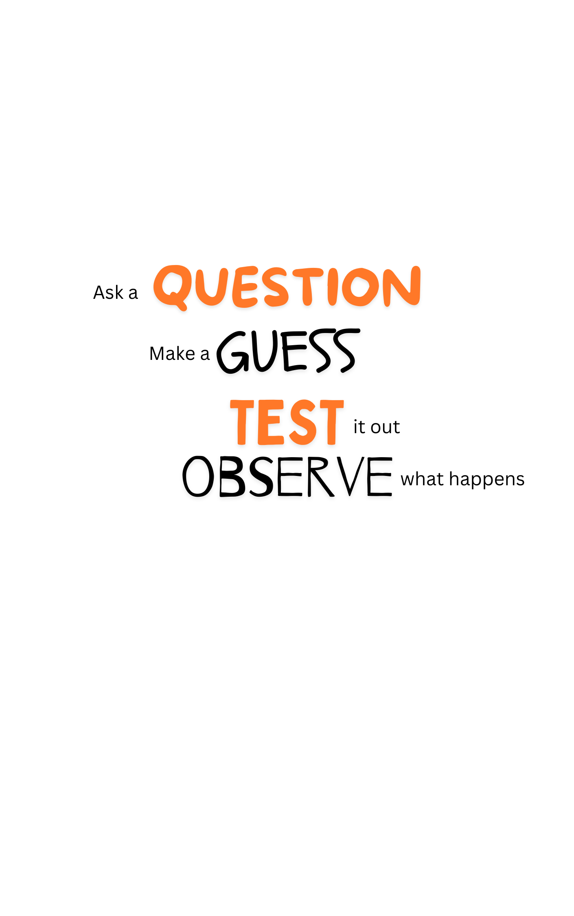

For more fun Questacon activities visit

https://www.questacon.edu.au/learn-and-play/activities

Experimental Design

**Question:**

**Hypothesis:**

**Method:**

**Variables:**

* **Independent:**
* **Dependent:**
* **Controls:**

**Results:**

**Next question:**

**Conclusion:**