

Questacon Annual Review 2019


Table of Contents
Questacon Overview 3
Minister’s Introduction 5
Chairman’s Message 6
Director’s Update 8
Key Statistics for 2019 10
Questacon Advisory Council 10
Powered by Partnerships 17
National Programs 25
Teacher Support Activities 35
Questacon’s Centre Activities 43
International Engagement 52
Digital Engagement 59
Inspiring Australia 61
Indigenous Engagement 65
Key Events 2019 68
Questacon People 76
Questacon Partners and Supporters 85

Questacon Overview
Questacon – The National Science and Technology Centre is an asset of the Australian Government, helping to build a foundation of science engagement across the Australian community. Operating as a specialist division of the Department of Industry, Science, Energy and Resources, Questacon’s vision is for a better future for all Australians through engagement with science, technology and innovation. As Australia’s economy continually transforms and evolves over the coming generations, we work with partners and supporters to deliver inspirational learning experiences to young Australians, their teachers, families and communities, from our Centres in Canberra, across Australia and internationally.
Through our Statement of Authority, we are empowered by the Australian Government to engage, connect and inspire all Australians in science, technology, engineering and maths (STEM) through a journey of lifelong learning. Our aim is to inspire, spark curiosity, delight and wonder, to equip tomorrow’s leaders with the enterprise skills necessary to navigate and flourish in the future world.
Our main Centre located in the heart of the nation’s capital, houses more than 200 hands-on exhibits, engaging over half a million visitors each year. The Centre also hosts our changing exhibitions, including our most recently installed Born or Built? Our Robotic Future exhibition. The Excited Particles team continues to inspire our visitors through interactive science shows and demonstrations, including a range of special events for our youngest visitors including Little Explorer’s Day and Science Time.
We design, develop and build exhibits at our second facility in Canberra, The Ian Potter Foundation Technology Learning Centre, working with a range of valued knowledge partners across Australia and internationally. The Ian Potter Foundation Technology Learning Centre is also the base for Questacon’s national programs. These travelling programs work in partnership with local institutions, teachers, researchers and businesses to transform the inspiration from our touring program into an enduring legacy lasting well beyond our visit.
Questacon is responsible for providing national leadership and coordination for the Inspiring Australia Network. Working in collaboration with Australian state and territory governments, host organisations in each jurisdiction, and multiple divisions across the Department of Industry, Science, Energy and Resources, this national network ensures the outstanding work of passionate individuals and organisations across Australia connects to a broader STEM ecosystem, while remaining relevant to local community’s needs.
As an influential voice in the global science centre community, Questacon is a vehicle for delivering activities to support the Australian Government’s science agenda, as well as contributing to international science centre capacity building, and promoting awareness of the United Nations’ Sustainable Development Goals.
Questacon’s work is supported by partners who share our vision of investing in Australia’s young people. Our partners see the value of long-term and sustained investment in the future, with partnerships typically spanning multiple years through a variety of activities and programs, locally and nationally.
Our most significant asset is our passionate and professional staff and volunteers, and we are exceptionally proud of our achievements, partners and supporters.
We look forward to the years ahead as we continue to chase our dream of a better future for all Australians through engagement with science, technology and innovation.
Visit us at www.questacon.edu.au
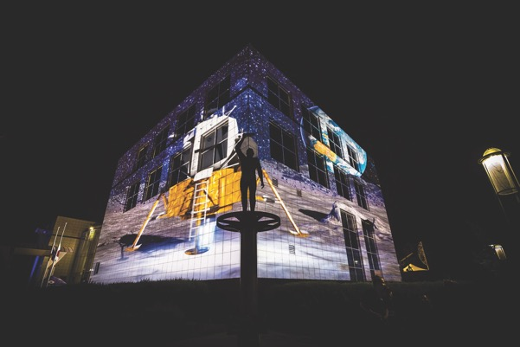

Minister’s Introduction
Science, technology, engineering and maths (STEM) are integral to our everyday lives. These skills make it possible to drive across town, to use your own solar cell generated power, to cook a meal or stream a movie, and to stay in touch with friends or family across the country or around the world. Beyond the everyday, these skills and knowledge improve and save lives through medical and technological advances.
STEM makes a significant contribution to our economy, and is key to our future as a prosperous nation. Many jobs in the years ahead will require these skills, which is why it is so important to encourage an interest in STEM subjects from an early age, and to enable those who influence our young people to inspire and support this interest.
This is something Questacon has been doing brilliantly for more than three decades. Whenever I visit, I see this first hand. Both adults and students are entranced by the unique blend of interactive exhibits, energetic presentations and the many and varied opportunities to explore and learn.
My own childhood interest in how things worked led to me becoming an engineer. However, I was one of only two girls in my mechanical engineering class. While things are improving, gender equity in STEM remains a priority. The Women in STEM Decadal Plan, which I was pleased to launch in April this year, will direct our focus and energy to this critical task in an unprecedented unified way.
Questacon has an important role to play in achieving this shift. Through its exhibitions, outreach, national networks and flagship activities, Questacon creates opportunities for all young (and not so young) people, right around the country. It sparks their curiosity to question the world around us, their courage to think big, and their ability to turn bright ideas into reality.
This is the kind of ambitious thinking that took us to the Moon 50 years ago, something I was pleased to help celebrate at Questacon’s Apollo 11 50th anniversary exhibition in July. This major milestone is a tangible reminder of what is possible through science and technology. We can only imagine what the young minds inspired by this exhibition might be capable of in another 50 years.
Almost undoubtedly, it will include some form of artificial intelligence – a topic Questacon will increasingly explore through exhibitions such as Born or Built?, which examines the blurring line between humans and technology, and the questions the choices that will shape our future.
And the whole nation was invited to celebrate the science and technology of today and the future, as thousands of community and school events were held around the country for National Science Week. I was thrilled to kick off the festival with a lesson on black holes, just one of many diverse activities that attract a wide audience from children to adults, and science amateurs to professionals.
Questacon has delivered another 12 months of exemplary science engagement that excites and motivates us all. I look forward to seeing what is in store for the year ahead.
The Hon Karen Andrews MP
Minister for Industry, Science and Technology
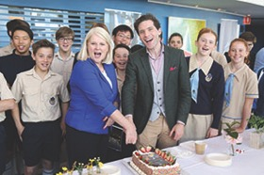

Chairman’s Message
As a member of the Questacon Advisory Council, over the past 15 years I have seen Questacon grow in reach and influence, establishing a truly national presence.
The vision and leadership of Professor Graham Durant, Dr Bobby Cerini and Ms Kate Driver coupled with the culture and passion of ‘team Questacon’ has made a tangible contribution to science communication in Australia. Questacon creates those ‘Eureka Moments’ that ignite the ever-important spark of curiosity.
I am pleased to say this evolution is continuing, with plans to enable even more people to enjoy a Questacon experience in their own communities. This includes expanding the Shell Questacon Science Circus and rolling out the Engineering is Elementary program nationally, after its successful pilot last year. Also, a Questacon/Australian Space Agency partnership will develop a Space Discovery Centre in Adelaide and national program of space awareness and educational activities.
As Questacon’s national presence has expanded, its programs and experiences now increasingly operate alongside other initiatives and locally-led community activity to stimulate interest and participation in STEM. This represents growing awareness of the need for STEM-skilled workers to support our economic prosperity into the future.
There is also growing visibility of Questacon’s role in supporting national policy goals in diverse areas such as economic growth, regional capacity building, Indigenous participation and representation, public engagement with research and innovation, and science diplomacy through sector leadership and international engagement. Government has recognised the importance of Questacon’s work nationally, and it continues to grow as a national collaborative leader.
In 2019, Questacon and INPEX entered into a four-year partnership to engage young Australians in a conversation about energy, its use, and the role it will play into the future. Through this partnership, Questacon and INPEX aim to raise awareness of energy related topics and increase energy literacy within Australian and Japanese communities. This partnership will enable delivery of Energy Shows, Young Persons’ Energy Dialogue, Teacher Workshops and a Science Circus Tour to Japan. In addition to these activities, Questacon and INPEX will champion the United Nations’ Sustainable Development Goal, SDG 7 – ensuring access to affordable, reliable, sustainable and modern energy for all - to highlight the sustainable development challenges faced by the global community as we progress towards the year 2030.
I am also pleased to report Shell has committed to continue its investment in the Shell Questacon Science Circus for 2020. This investment marks a 34-year milestone for this successful partnership that sees industry and government working together to benefit local communities across Australia and internationally.
Through another partnership, the Australian Science Teachers Association (ASTA), the Commonwealth Scientific and Industrial Research Organisation (CSIRO) and Questacon will continue to deliver the STEM X Academy program, thanks to a donation from the Q Australia Foundation. The program makes a genuine impact on teachers and I thank the Q Australia Foundation for its generosity.
It is a privilege to contribute to Questacon’s important work, along with my fellow Council members and Questacon’s dedicated staff, at this pivotal time when harnessing the nation’s STEM talents is so important.
I would like to sincerely thank outgoing Council members, Professor Ian Young AO, Professor Karin Barovich, and the Hon Dr Annabelle Bennet AO SC for their support and invaluable advice and service to Council.
In 2019 we also warmly welcome new Council members, Ms Lily Serna,Dr Ken Dutton-Regester and Professor Alan Duffy.
Leon Kempler AM
Chairman, Questacon Advisory Council
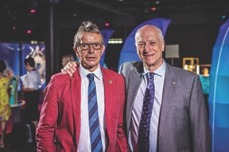

Director’s Update
I remember that 2020 was a year that was frequently looked upon as the future. For me as a child 2020 was the far-distant future. Well here we are in 2020 reflecting upon a very busy and productive year at Questacon during 2019 and the possible futures of the young students who visit Questacon daily. What an exciting time to be alive on planet Earth and what a time of discovery and disruption.
Our young Mini-Q visitors will be growing up throughout the 21st century. What will their future be like I wonder? It is indeed a time of challenge and opportunity for us all. We see our task as creating excitement, motivation and a positive outlook for the future as we help young Australians develop the knowledge and skills to make their hopes and dreams a reality.
As Director, I am fortunate to work with such a passionate and hard-working team. It is indeed a pleasure and a privilege to work in an organisation characterised by such a diverse range of staff of amazing ability and enthusiasm.
There are many highlights of 2019 but winning an Inclusion Award is one that makes me particularly proud of the Questacon workforce.
Questacon is well-supported by an amazing Advisory Council, a new Q Australia Foundation and our colleagues in the Department of Industry, Science, Energy and Resources. Questacon’s work is powered by enabling partnerships that allow us to extend our geographical and social reach across Australia.
We seek to create inspirational learning experiences for visitors of all ages at the Centre and in as many locations as we can visit in any one year. We work support a better future for Australians through engagement with science, technology and innovation. In 2019 more than half a million visitors attended Questacon facilities in Canberra, with three-quarters coming from interstate. We reached another 54 000 people in regional locations through our outreach activities and travelling exhibitions. More than 20 per cent of the population were aware of National Science Week, with 1.5 million people participating. Sixteen young Australian scientists trained through the Shell Questacon Science Circus, building skills and capability in our national cohort of science communicators.
Seven state and territory based Inspiring Australia Managers connected communities, researchers and organisations across all jurisdictions, including linking to more than 50 STEM hubs in regional Australia to engage their communities. We also reached into classrooms across the nation, with 640 teachers participating in Questacon’s teacher professional development sessions. Online, our website attracted 2.1 million visitors and we have more than 200 000 social media followers.
The start of a new year is a time to look back with pride and look forward with anticipation. In 2019 we celebrated the 50th anniversary of the first lunar landing. In 2020 we wil l be acknowledging the 50th anniversary of the first Earth Day with its focus on environmental sustainability. We will be developing space-themed exhibits in partnership with the Australian Space Agency and anticipating missions to further explore Mars.
We will continue to work with our partners to build our national presence and international outlook, to deliver inspirational learning experiences across Australia and globally with our partners within the global science centre community.
In 2020 we will continue to promote awareness of the United Nations Sustainable Development Goals and work towards a highly sustainable operation across all of our work.
Professor Graham Durant AM
Director, Questacon
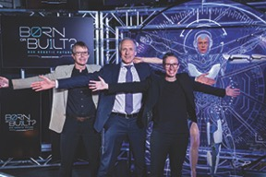

Key Statistics for 2019

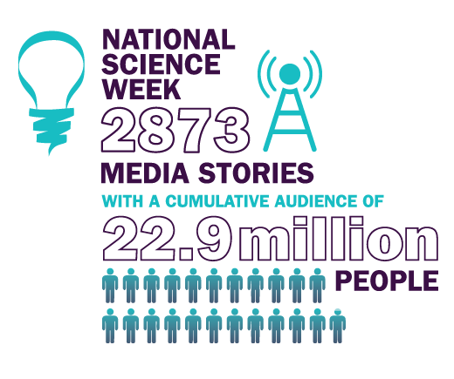
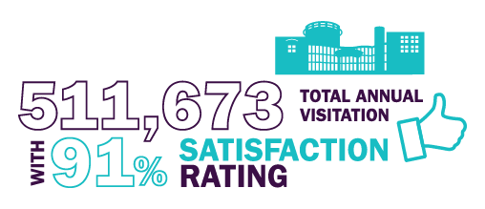
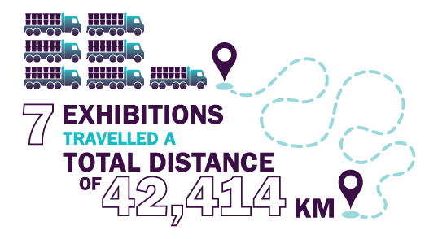
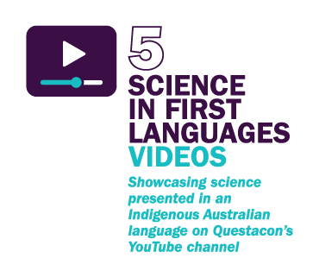
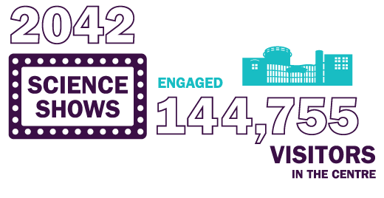

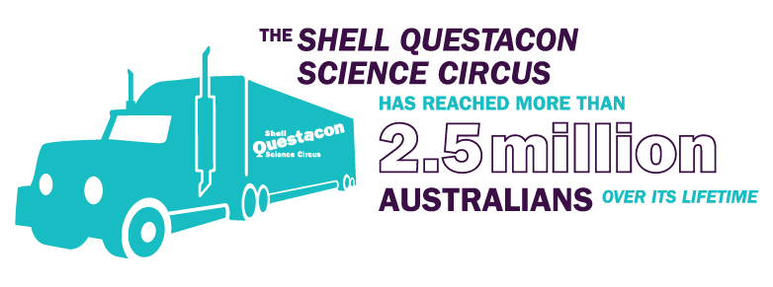
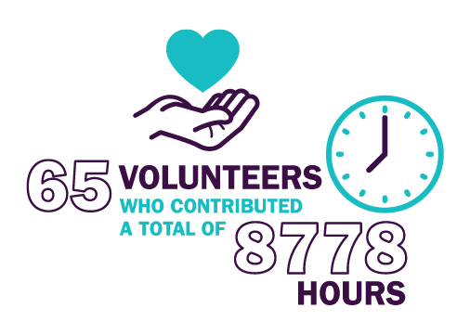
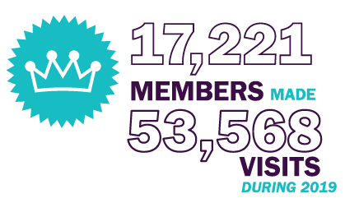

Questacon Advisory Council
Questacon is supported by an Advisory Council appointed by the Prime Minister and the Minister. The role of the Advisory Council is to advocate for and advise Questacon. Membership is drawn from eminent scientists, academics, business leaders and philanthropists who all share a passion for Questacon’s vision and mission.
The Advisory Council farewelled the Hon Dr Annabelle Bennett AO SC, Professor Ian Young AO and Professor Karin Barovich, as their appointments came to an end in 2019. This year, new members, Professor Elanor Huntington, Ms Jamila Gordon, Ms Lily Serna, Professor Alan Duffy, and Dr Ken Dutton-Regester were welcomed as they were formally appointed to the Advisory Council.
At the invitation of the Chair and throughout 2019, Dr Sarah Pearson, Chief Innovation Officer at the Department of Foreign Affairs and Trade, Ms Margaret Leggett, Branch Manager at the Department of Education and Training, Dr Cathy Foley, Chief Scientist at CSIRO, and Ms Michele Graham, General Manager at the Department of Industry, Innovation and Science, attended a range of Advisory Council meetings and also continued to act as advisors to the Council.
Advisory Council members work together to serve as a source of independent advice to the Director and Executive of Questacon, to raise the profile and build the brand of Questacon, and engage with stakeholders and advocate for the work of Questacon.
Throughout the year, Advisory Council members attended key events including the launch of Questacon’s Born or Built? Our Robotic Future exhibition, and the stakeholder networking launch for Questacon’s new partnership with INPEX.
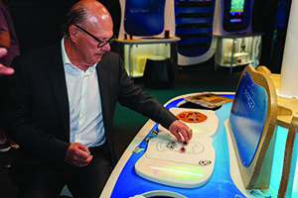
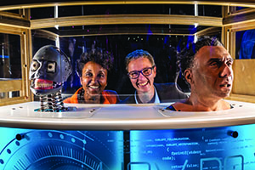
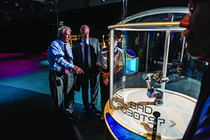
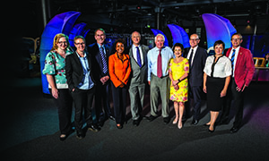

The Advisory Council 2020

Mr Leon Kempler AM: Chairman
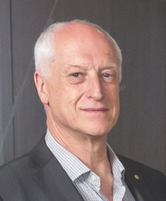
Mr Kempler holds a number of Chair positions including Chair of Questacon Advisory Council. He is also the national Chairman of the Australia-Israel Chamber of Commerce and, in June 2019, was announced as President of the Museums Board of Victoria. Mr Kempler’s experience as Chair of the Questacon Advisory Council and philanthropic institutions brings strategic leadership to guide the Council’s independent advice for the Minister, Questacon and the Department of Industry, Science, Energy and Research.
Mr Kempler has received a Medal of the Order of Australia for his tireless efforts and contribution for furthering Australia-Israel bi-lateral trade and relations, and was appointed a Member of the Order of Australia for his significant service to the community through contributions to national cultural institutions, charitable, education and children’s medical foundations.

Mr Eddie Kutner: Deputy Chair
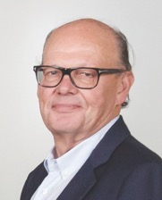
Mr Kutner is the Deputy-Chair of the Questacon Advisory Council. He is a Fellow of the Institute of Chartered Accountants, with 30 years’ experience in property investment and finance. After a successful career as a chartered accountant, Mr Kutner moved into property development, becoming a founding Director of Central Equity, Chairman of the Audit Committee and Executive Chairman of the Central Equity Group. He is also the Founder and Chair of Wonderment Walk Victoria Limited, a not-for-profit established for the purpose of promoting art, science and knowledge.
In addition, Mr Kutner is Chair of the Q Australia Foundation, which was established through his support and investment in 2017. Its remit is to enhance education and engagement with science and technology in Australia. In February 2019, Parliament granted the Foundation full deductible gift recipient (DGR) status, enabling it to provide philanthropic support for the development and growth of Questacon’s work.

Dr Gregory Clark AC: Visiting Fellow, Australian National University
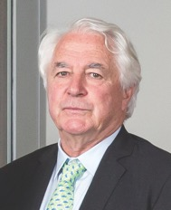
Dr Clark is a world-renowned scientist, technologist and businessman. He is the Chairman of KaComm Communications and a Visiting Fellow at The Australian National University, the American Physical Society, and the Australian Academy of Science, Engineering and Technology. Dr Clark’s experience in the space science industry, with particularly strong links to the public and private space industry in the United States, as well as his connections to science and technology partner organisations across Australia, are particularly valuable in the context of Questacon’s focus on space.
Dr Clark spent 15 years with IBM’s Research Division in New York and was also Director of Strategy (Telecommunications) at IBM Headquarters. He is a former President of News Technology Group, member of the News Corporation Executive Committee and former Chairman of GlobalStar and SatMex. Dr Clark was instrumental in optimising satellite design for the commercial delivery of digital content such as pay TV. In addition, Dr Clark served 10 years as a Director of the ANZ Banking Group and is currently a Director of NextDC, the largest Australian data centre company. He was awarded the Centenary Medal by the Australian Government and the Einstein Medal by the Israeli Government, and also the Pawsey Medal by the Australian Academy of Science, Engineering and Technology.

Ms Lily Serna: Australian mathematician and SBS television presenter

Ms Serna is a data analyst at the enterprise software company, Atlassian, specialising in building mathematical and statistical models. A mathematician with a passion for education, particularly in STEM advocacy, Ms Serna is best known for her professional media host work on SBS’s Letters and Numbers and as the co-host of SBS’s Destination Flavour.
Ms Serna was a member of the Board of the Australian Mathematical Sciences Institute for four years and in 2012 was appointed Numeracy Ambassador for National Literacy and Numeracy Week. Ms Serna graduated with first-class honours Bachelor of Mathematics and Finance and a Bachelor of International Studies at the University of Technology, Sydney.

Ms Jamila Gordon: CEO and Founder, Lumachain

Ms Gordon is CEO and Founder of Lumachain, a technology platform that disrupts traditional enterprise supply chains, globally. Ms Gordon is one of Australia’s most respected digital and technology leaders. She was selected by Microsoft to be its global Awardee in the 2018 International Women Entrepreneurship Challenge (IWEC).
Ms Gordon was the Group Chief Information Officer of Qantas Airways and Leighton Holdings/CIMIC. Prior to this she was a global executive with IBM based in Europe, leading some of IBM’s largest transformational ‘mega-deals’ with Solectron Manufacturing, AXA Insurance and ABN AMRO Bank. The SBS interviewed Ms Gordon as part of a series celebrating people from disadvantaged/refugee backgrounds who have made a significant contribution to Australia’s technology and business landscape for the network’s 2018 Australia Day celebrations.

Dr Ken Dutton-Regester: Researcher, QIMR Berghofer Medical Research Institute
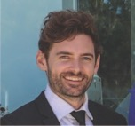
Dr Dutton-Regester is a Research Officer at the QIMR Berghofer Medical Research Institute, investigating melanoma gene dependencies that will kill melanoma cells when turned off, to determine their suitability as novel drug targets. Dr Dutton-Regester previously worked at the Dana Farber Cancer Institute and Broad Institute of Harvard MIT to undertake his National Health and Medical Research Council CJ Martin Overseas Early Career Fellowship.
Dr Dutton-Regester is the Founder and Creative Director of Excite Science Communications, which is dedicated to pushing the boundaries of science communication by exploring innovative learning approaches to excite the next generation of future scientists and communities through the benefits of medical research.

Professor Alan Duffy: Astronomer, Research Fellow and Professor, Centre for Astrophysics and Supercomputing, Swinburne University of Technology

Professor Duffy is a Research Fellow and Professor at the Centre for Astrophysics and Computing, Swinburne University of Technology and Lead Scientist at The Royal Institution of Australia, home of Australia’s Science Channel.
Professor Duffy has worked on the world’s largest astronomical facility, the Square Kilometre Array, and participated in two Australian Research Council Centres of Excellence. Professor Duffy graduated with a PhD from the Jodrell Bank Centre for Astrophysics, University of Manchester and conducted postgraduate work at the Sterrewacht, Leiden Observatory in The Netherlands.

Professor Elanor Huntington: Dean of Engineering and Computer Science, Australian National University
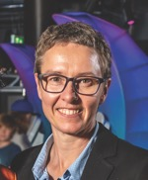
Professor Huntington is the first female Dean of Engineering and Computer Science at The Australian National University and one of the few in the world. She is a strong public advocate for engineering in the community and for attracting more young women to take up careers that draw on STEM skills.
Professor Huntington was previously the Head of the School of Engineering and Information Technology with the University of New South Wales Canberra at the Australian Defence Force Academy, and is also a program manager in the Australian Research Council (ARC) Centre of Excellence for Quantum Computation and Communication Technology.

Powered by Partnerships

Principal Partner
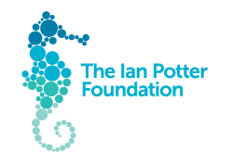
The Ian Potter Foundation has been a Principal Partner of Questacon since 2014, enabling the delivery of a flagship offering, the Questacon Smart Skills Initiative. This suite of programs allows Questacon to inspire and empower young people across Australia by engaging them with technology, innovation, design and entrepreneurial learning experiences.
The Questacon Smart Skills Initiative engages teachers and young people in innovation, technology, engineering and design thinking through exciting challenges, projects and workshops. Programs include Questacon Maker Project workshops and holiday workshops for students, the intensive three or five-day Questacon Invention Convention, delivered in Canberra and regionally, Questacon Smart Skills touring workshops for students and teachers, and the online Enterprising Australians.
Since the start of the Smart Skills Initiative in 2015, Questacon has delivered inspirational workshops to more than 71 574 people across Australia, thanks to the $7.8 million grant from The Ian Potter Foundation. Questacon’s second facility, The Ian Potter Foundation Technology Learning Centre, was named in recognition of this generous grant and is the hub for Questacon’s education and learning activities, along with exhibition development and production.
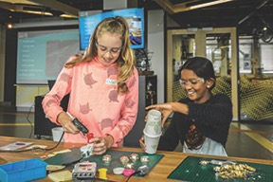

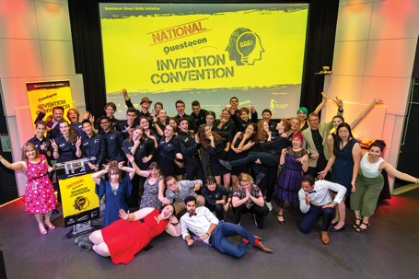

Principal Partner

Shell is Questacon’s longest-standing corporate partner, having worked with us for 34 years to deliver the Shell Questacon Science Circus across regional and remote Australia. This program is one of the world’s longest running science education and learning programs, engaging and inspiring young people and their communities in STEM through science shows and workshops.
This partnership, along with the support from The Australian National University, has allowed the Shell Questacon Science Circus to reach more than 2.5 million Australians, visiting more than 600 towns and 110 remote Indigenous communities over its lifetime. The program is run by students enrolled in the Master of Science Communication Outreach at The Australian National University. To date, more than 450 students have completed this program, which provides students with the opportunity to gain valuable practical skills in science communication while completing regular coursework.
At Shell’s invitation, the Shell Questacon Science Circus attended the Resources Technology Showcase in Perth in November 2019. As part of this event, a public showcase was attended by school groups and the general public. Presenters from the Shell Questacon Science Circus delivered science shows and an activity focusing on engineering and innovation.
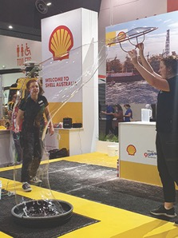

Principal Partner

In 2019, The Australian Defence Force and Questacon entered into a new partnership to deliver a professional learning program for primary school teachers, Engineering is Elementary. This innovative program was developed by the Museum of Science, Boston, to equip teachers with tools and skills to enable the delivery of fun and engaging STEM content in the classroom.
Australia’s future as a knowledge economy depends on emerging generations being engaged with foundation skills in STEM. By creating awareness of the application of STEM to real world problems, Engineering is Elementary aims to inspire students to consider future careers in STEM fields.
With the support of The Australian Defence Force as Principal Partner, Questacon will deliver Engineering is Elementary workshops to 1000 primary school teachers in up to 500 schools across Australia over three years from 2019 to 2022. Teachers will be provided with high quality and accessible teaching resources and materials, together with online support, to enable them to deliver the units in their classrooms.
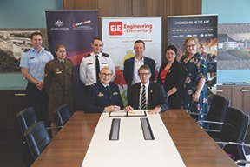

Technology Partner

Samsung and Questacon have worked in partnership since 2014 to inspire and motivate the next generation of Australian technology creators and entrepreneurs. In 2018, Samsung and Questacon renewed this partnership for a further two years.
As Questacon’s Technology Partner, Samsung’s support allows Questacon to incorporate the latest technology into the Questacon Smart Skills touring program, which includes both teacher workshops and in-school programs for high school students. By blending technology with hands-on activities, this program encourages students and teachers to engage in STEM in a variety of ways, focusing on innovative design thinking, creative problem solving skills, and improving confidence.
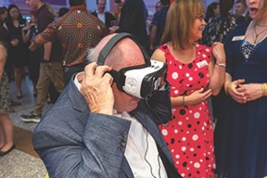

Founding Partner
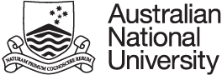
The Australian National University, through the Australian National Centre for the Public Awareness of Science (CPAS), is the Founding Partner of the Shell Questacon Science Circus, which has been delivered for 34 years in collaboration with Questacon and Shell Australia.
While completing a one-year Master of Science Communication Outreach at The Australian National University, 16 graduate students deliver the Shell Questacon Science Circus program across Australia. This practical fieldwork component of the course allows students to develop skills in science communication with the public, the media and online, along with science communication project design and delivery.
Having worked together since 1985, Questacon and The Australian National University have seen more than 450 students graduate from this program and go on to contribute to the national and international capacity of science communication professionals.
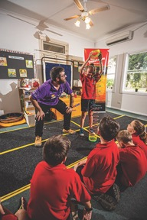

Supporting Partner

In 2019, INPEX and Questacon entered into a four-year partnership to engage young Australians in a conversation about energy, its use, and the role it will play in the future.
Through this partnership, Questacon and INPEX aim to raise awareness of energy-related topics and increase energy literacy within Australian and Japanese communities. This partnership will enable the delivery of a package of exciting and engaging activities including Energy Shows at Questacon, the Young Persons’ Energy Dialogue youth forum, Questacon STEM Futures teacher workshops in Perth and the Northern Territory, and a Science Circus tour to Japan.
Through these events and programs, Questacon and INPEX will champion the United Nations’ Sustainable Development Goals, SDG 7 – ensuring access to affordable, reliable, sustainable and modern energy for all to highlight the sustainable development challenges faced by the global community as we head towards 2030.
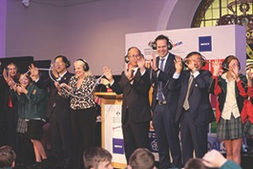

Corporate Supporter
In June 2019, Questacon partnered with the Toyota Community Trust to present Questacon STEM Futures, an intensive STEM professional learning workshop series for teachers and school leaders in West Melbourne. Sixty-six participants from 31 different schools attended the workshops, along with representatives from Scienceworks science centre in Melbourne.
The Questacon STEM Futures program, co-developed with Scienceworks and Simon Taylor from Victoria University, equips teachers with the resources, skills and confidence to effectively implement STEM experiences within their classrooms, schools and broader networks.
The program focuses on strengthening individual teacher capacity to deliver STEM in the classroom alongside using STEM processes as a tool for school improvement.
Following the initial success of the workshops, Questacon continued to work with collaborators to develop a local community of STEM leaders in West Melbourne. In November 2019, Questacon returned to Scienceworks to host a follow-up workshop for Questacon STEM Futures participants.
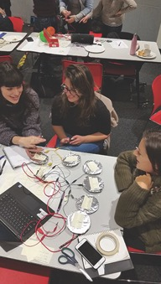

Collaborative Partner

In April 2019, Minister the Hon Karen Andrews MP announced $6 million to establish the Australian Space Discovery Centre where the Australian community, students and visitors will have a unique opportunity to engage with the latest innovations in space technologies and expand their understanding of Australia’s role in national and global space activities and missions. The Centre will be located in Adelaide, South Australia.
Using expertise from across our organisation, Questacon will deliver the functional aspects of the Centre, including a space exhibition, a digital theatrette, and a careers and information hub. The Centre is expected to open in late-2021.
This opportunity provides an excellent vehicle for the nation to continue to inspire young Australians in STEM careers and increase community awareness and engagement in Australia’s emerging space agenda and industry.
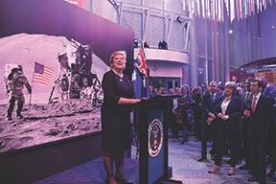

Corporate Supporter

With the support of Australia’s national science and research agency, CSIRO, as Corporate Supporter, Questacon developed an exhibition to celebrate the 50th anniversary of the Apollo 11 Moon landing.
The Apollo 11 50th anniversary exhibition was on display from July to December 2019, and explored the engineering, computing and mathematics principles that supported the historic Moon landing. The special anniversary display featured individuals who had a crucial part in enabling this amazing feat, celebrating the work of the mathematicians, engineers and scientists who achieved what many thought was impossible.
This exhibition was an opportunity for Questacon to showcase how STEM skills were integral to the Apollo mission, inspiring future careers in the STEM and space sectors.
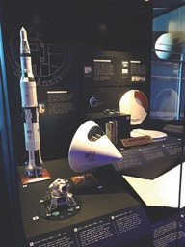
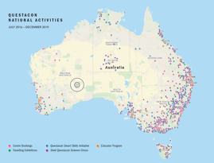

National Programs
Questacon’s national programs operate out of The Ian Potter Foundation Technology Learning Centre and travel all across Australia to regional and remote communities. Whether students are travelling to Canberra for hands-on innovation workshops or Questacon teams are travelling to schools and communities across Australia, Questacon national programs inspire tomorrow’s entrepreneurs, scientists and innovators.
In 2019, Questacon delivered programs in partnership with local institutions, teachers, universities, researchers and the Inspiring Australia network to reach every Australian state and territory. These important collaborations support Questacon to transform moments of inspiration into an enduring legacy of engagement with science, technology and innovation.

Questacon Smart Skills Initiative
The world of work is changing, and with it, the demands on Australia’s future workforce. To address the challenges of tomorrow, young Australians must be equipped with foundation skills in STEM as well as enterprise skills including critical thinking, creativity and problem solving. The Questacon Smart Skills Initiative delivers programs that support young Australians to build these essential skills.
The Questacon Smart Skills Initiative delivers hands-on, inquiry-based workshops to students across Australia, creating supportive environments that invite students to generate and test out their own original ideas and explore the process of design thinking. It also supports teachers to explore these concepts and processes in their own classrooms through accredited teacher workshops.
Regional engagement is a cornerstone of the Questacon Smart Skills Initiative. Questacon aims to foster STEM activity in regional and remote areas, inspiring students and the wider community to see how STEM fits into their everyday lives, and supporting young people to recognise the diversity of exciting STEM careers available to them, no matter their location.
This was the fifth and final year of the Questacon Smart Skills Initiative, which was made possible through support from Principal Partner, The Ian Potter Foundation and funding from the Australian Government. Since its inception in 2015, the Initiative has engaged 65 128 students and 6446 teachers in hands-on, skill building activities delivered in regional locations across every state and territory.
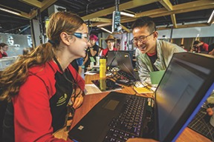

Student workshops
Questacon Smart Skills delivers free workshops in high schools across regional Australia, challenging students to stretch their creativity, design thinking and problem solving skills. Students explore the process of innovation as they engage with new technologies and familiar materials to prototype solutions through a hands-on design process.
By encouraging play and exploration within set challenges, the workshops equip students with the confidence to test and refine ideas through digital and physical prototyping. Students work together to develop logical and creative thinking skills needed to tackle problems across the curriculum and beyond.
In 2019 Questacon Smart Skills student workshops engaged 7859 young Australians across Victoria, South Australia, New South Wales and Queensland.
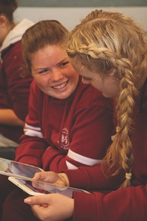
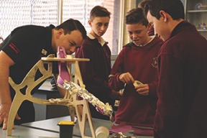

Teacher professional learning workshops
Questacon staff can inspire hundreds of students during a school visit, but a teacher will inspire thousands throughout their career. Questacon Smart Skills Teacher Workshops build on the student workshop experiences to motivate and support teachers to implement inquiry-based activities in their classroom.
The three-part workshop series encourages teachers to draw inspiration from across the curriculum to incorporate design thinking processes in their STEM lessons. By combining digital technology with hands-on learning, teachers are equipped with the tools, knowledge and support networks to bring innovative STEM lessons into the classroom.
In 2019, Questacon Smart Skills Teacher Workshops engaged 386 teachers across Victoria, South Australia, New South Wales and Queensland through face-to-face and video-conference workshops.
Questacon Smart Skills Student and Teacher Workshops are supported by Technology Partner, Samsung Australia. Samsung technology has been integrated into the workshops, providing an opportunity for teachers and students to learn how to harness the power of smartphones and tablets to innovate, design and experiment.
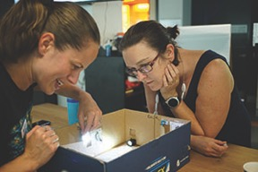

Questacon Invention Convention
Questacon Invention Conventions are intensive, multi-day workshops that give secondary students a practical insight into innovation. Working with Questacon facilitators and STEM professionals, students are supported to prototype creative solutions to real-world problems using a combination of technology and simple materials. These immersive experiences support students to turn their ideas into reality and make connections between STEM skills, career opportunities and local and global challenges.
In 2019, Questacon delivered regional Invention Conventions in Mildura (Victoria), Albury (New South Wales) and Gladstone (Queensland) through the support of delivery partners, Sunraysia Institute of TAFE, Charles Sturt University and Central Queensland University. A variety of local STEM professionals including engineers, ecologists and entrepreneur app developers attended as mentors, sharing insights about their own work and passions, and highlighting what a STEM career in a regional location can look like.
In 2019, 77 students participated in Questacon Invention Conventions, developing skills and confidence that will support them to innovate and solve problems for their communities into the future.
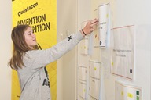

2019 National Questacon Invention Convention
The National Questacon Invention Convention in January 2019 brought together 25 delegates and three student ambassadors from six states and territories across Australia. The week-long event supported delegates to develop and prototype an original idea around the theme ‘Liveable Communities’. The theme prompted delegates to consider problems and solutions around environment, connectivity or wellbeing that were relevant to their own communities that they could continue to develop at home.
Twenty-four external professionals volunteered to share their skills and expertise with the delegates throughout the week’s activities. These professionals represented organisations including the Canberra Innovation Network (CBRIN), Inspiring Australia, IP Australia and The Australian National University, and provided delegates with valuable insights into real-world innovation in action.
To conclude the week, the delegates exhibited their finished prototypes at a showcase event, which was attended by His Excellency General the Honourable Sir Peter Cosgrove AK MC (Retd) as well as a large number of parents, grandparents and siblings who enjoyed the opportunity to witness the delegates’ transformation and newfound confidence first-hand.
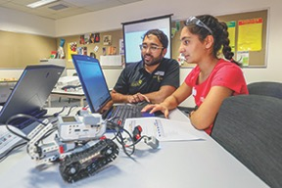
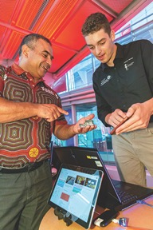
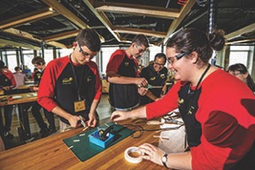

STEM Network Showcase
Questacon has delivered 15 regional Invention Conventions since 2015, each in collaboration with regional hosts. Through these collaborations, Questacon has built a large network of STEM activity providers across the country. In 2019, 16 different organisations that have contributed to regional Invention Conventions attended a STEM Network Showcase hosted by the Questacon Smart Skills Initiative. This annual event provides an opportunity for the network to share experiences, identify opportunities and enhance capability in regional STEM providers.

Questacon Maker Project
Questacon Maker Project workshops explore creative thinking and hands-on problem solving using simple tools, materials and emerging technology. Each workshop promotes the exploration of the innovation principles of need, think, make, try and refine, while building student confidence and resilience through embracing the concept of failure.
These free, two-hour workshops are tailored to engage school students in Years 6 to 12 and support further classroom education through strong links to the Australian Curriculum.
Each workshop is delivered in the multipurpose Maker Space at The Ian Potter Foundation Technology Learning Centre. In 2019 participants of the Maker Project ranged from every Australian state and territory, with 92.7 per cent of participants visiting from outside the ACT.
The Maker Project also offers innovation-based Holiday Workshops for young people aged 10 to 15 years old. These workshops provide participants with a great opportunity to meet like-minded individuals, while using equipment and emerging technologies to work on projects in a supportive and encouraging environment.
Maker Project workshops extend to students beyond The Ian Potter Foundation Technology Learning Centre with Maker Project Virtual Excursions. These free, one-hour digital workshops allow students from across Australia access to hands-on STEM workshops in their classrooms via videoconference, if they are unable to visit in person.
In 2019, the Maker Project engaged 7743 students and 807 teachers in hands-on workshops and virtual excursions, with a total 29 332 students and 2788 teachers engaged since 2014.
“Students had an opportunity to share dialogue, negotiate and solve problems. They also were able to be critical thinkers giving rise to opportunities to change, adjust and create an end product.”
Maker Project Participant (Teacher)
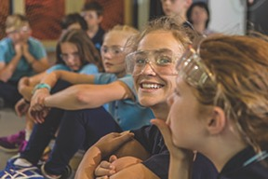
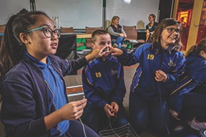
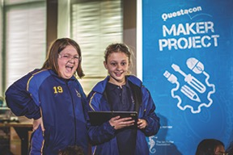

Enterprising Australians

Enterprising Australians is about discovery. This initiative uses a digital platform to showcase stories of Australian makers, creators and innovators to help young people discover the real-world innovation that is happening all around them.
Enterprising Australians showcases contemporary and relatable examples of innovation in the form of short videos featured on the Questacon website, and in digital and social media. The digital format raises community awareness and highlights how everyday Australians experience the innovation process as they work to creatively solve unique and interesting problems relevant to their community.
Since the Enterprising Australians digital platform was launched in September 2016, the stories have registered more than 73 579 online views.
Some Australian innovators featured in 2019:

Kim Khor, Snap Trap (Bacchus Marsh, Victoria)
Need to keep fruit fly in check throughout your family farm? There is an app for that! Kim Khor has combined traditional farming practices with digital technology to create a remote-operated fruit fly monitoring system. With real-time data wirelessly transmitted to their phone, farmers can now analyse insect behaviour and plan for more effective pest control.


Alon Ilsar and Mark Havryliv, Airsticks (Sydney, New South Wales)
Making music out of thin air. Together, drummer Alon and computer programmer Mark invented Airsticks, a motion-based electronic musical instrument that allows composers to express themselves in 3D space as well as through the sounds they create.

Dr Vanessa Pirotta, Whale Snot (Sydney, New South Wales)
How does one monitor the health of Australia’s largest living mammals? Using snot and drones of course! Vanessa researches whales and uses snot samples as a diagnostic tool to evaluate their health. In order to collect it, Vanessa collaborated with Heliguy Scientific to create an innovative custom-fitted drone to withstand the elements and collect samples with minimal intrusion on the whales themselves.

Ben Gilbert, Agency of Sculpture (Yakandanda, Victoria)
Playgrounds are more than static pieces of entertainment for children. Ben designs playgrounds and sculptures that interact with the landscape and have a social message relevant to the place they are built in. Ben’s playgrounds are found across Australia, including the Acorn Play Space at the National Arboretum in Canberra.
The full details of these and other Enterprising Australians can be found online at www.questacon.edu.au/outreach/programmes/questacon-smart-skills-initiative/enterprising-australians

Shell Questacon Science Circus
The Shell Questacon Science Circus is one of the most widely travelled and recognised science outreach programs in the world. For the past 34 years, the Science Circus has travelled throughout regional and remote Australia, bringing science to local communities.
The Shell Questacon Science Circus strives to inspire and engage all Australians through interactive pop-up science centres, school incursions, professional learning workshops for teachers, and specialist programs for Indigenous audiences.
It also forms a major component of the Australian National Centre for the Public Awareness of Science’s Master of Science Communication Outreach. In 2019, 16 graduates took part in the Shell Questacon Science Circus to complete their Master’s degrees. The qualification offers students the opportunity to develop their science communication skills through practical experience. Shell Questacon Science Circus presenters have gone on to work with science centres, research and development organisations, media organisations, government and industry in Australia and overseas.
In 2019, the Shell Questacon Science Circus toured to the Australian Capital Territory, New South Wales, Queensland and the Northern Territory, visiting 305 schools, attracting 36 944 students, and engaging a total of 56 453 people.
The Australian National University and Shell Australia, Questacon’s longest standing partners, have supported the Shell Questacon Science Circus for more than three decades. One of the most enduring corporate sponsorships in Australian history, the Shell partnership underlines our shared vision of investing over the long-term in critical skills for Australian industry by inspiring generations of young Australians and their communities in science. The Shell Questacon Science Circus is now looking to 2020 and beyond, continuing to build strong relationships with partners and redesigning its offerings to remain the gold standard in science outreach for decades to come.
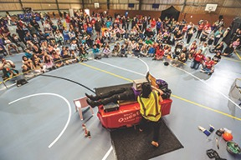
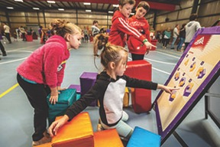
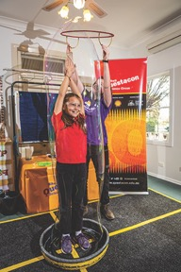


Teacher Support Activities
Questacon recognises that while our staff and presenters inspire hundreds of students each year, a teacher can inspire thousands of students throughout their career.
The Questacon Educator Program delivers quality teacher professional learning in STEM, available to teachers both with and without specialised skills in science, technology, engineering and mathematics. Supporting teachers to build their skills in delivering STEM, means their students will have opportunities to be excited and engaged by STEM like never before.
The Questacon Educator Program team takes a ‘hands-on, minds-on’ approach to STEM education. Teachers are led through practical inquiry and design challenges, which expand their lateral and logical thinking and increase their ability to work through problems to reach a solution.
With a view to delivering long-term legacy and impact, in 2019 the Questacon Educator Program extended the focus to include school leaders for the first time. Working with both teachers and school leaders means that schools become STEM experts within the community, driving innovation locally and cultivating 21st century skills in students now and into the future.
Our partnerships have provided the opportunity to innovate and extend the reach and impact of our programs. This year saw the Questacon Educator Program continue work with Australian Science Teachers Association (ASTA), the University of Canberra, CSIRO and the Museum of Science, Boston. The team also developed new partnerships with the Toyota Community Trust and The Australian Defence Force. Throughout the year we worked with state and territory Education Departments to identify their local challenges and how Questacon could collaborate with them to reach more underserved areas.
“It was a positive experience and allowed us to think about engineering in a classroom context using everyday and easily accessible materials... It was great to see how we can use these concepts in our classroom and teach children how they can be engineers.”
Canberra Teacher, September 2019
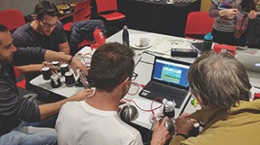
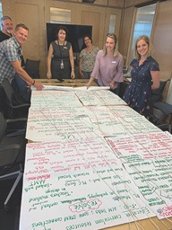

Engineering is Elementary
Engineering is Elementary is a rigorously researched, classroom-tested collection of resources that increases students’ interest in, and confidence about, engineering. Developed by the Museum of Science, Boston, the program is a whole-of-school approach for teachers who specialise in science, engineering and mathematics as well as those who don’t. Using engineering design challenges to engage students, the program builds confidence, skills and content knowledge to enable teachers to deliver STEM lessons. Engineering is Elementary provides real-world examples of STEM content and showcases potential workforce opportunities for primary school students.
After a successful pilot in 2018, the Questacon Educator Program received funding from the Australian Defence Force to expand the program nationally. As a part of the rollout, the team developed supplementary material that contextualises Engineering is Elementary for Australian teachers. The Australian supplement highlights links to the Australian Curriculum and encourages teachers to apply Engineering is Elementary theoretical underpinnings across other learning areas. In conjunction with professional learning workshops, teachers build their confidence and capability to deliver project-based STEM lessons.
In 2019, Engineering is Elementary professional learning workshops engaged 77 participants in the Australian Capital Territory, New South Wales, Tasmania, and the Northern Territory.
After the workshop, over 90 per cent of teachers were confident to teach the Engineering is Elementary unit and integrate it into their curriculum and lesson planning.
Engineering is Elementary aims to remove as many barriers as possible to teaching STEM. Thanks to the generous support of the Australian Defence Force, Questacon can offer free Engineering is Elementary professional learning workshops to Australian teachers. All participating teachers also receive a resource kit with the materials they would need to teach the unit in their own classroom. This allows all children, including those from under-represented groups, to have access to high-quality STEM education and to envision themselves as potential engineers.
“I learned how easy it is to introduce engineering and technology concepts to kids without overwhelming them! So excited to see what they come up with!”
Primary School Teacher
“I found most useful the connection between technology, engineering, maths, science and how this can be approached.”
Primary School Teacher
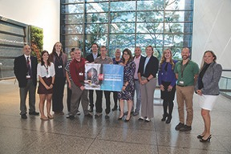

STEM X Academy
The STEM X Academy (STEM X) is a five-day residential professional learning program for primary and secondary teachers, delivered in partnership between the Australian Science Teachers Association (ASTA), CSIRO and Questacon. In January 2019, 70 teachers from all states and territories in Australia participated in the five-day program. This year’s program also welcomed back four ‘alumni’ – former participants, who returned to the event to share their experience as STEM leaders in their school communities.
Questacon’s focus for STEM X Academy 2019 was to give teachers a ‘toolkit’ of practices that would help them implement STEM in their classroom and across their school community. Teachers also had the opportunity to address real-world problems they encountered in their own schools, using STEM practices such as design thinking to solve them.
STEM X believes that teachers shouldn’t work in isolation, and so actively encourages teachers to connect as a network of STEM experts across the nation. Teachers from the academy swap ideas and collaboratively brainstorm content over social media. This dynamic network is for sharing ideas, resources, experience, encouragement and engagement with innovative teaching tools that are relevant to the world of science today.
Minister for Industry, Science and Technology, the Hon Karen Andrews MP, mentioned in parliament that she had received a letter from one participant who stated that STEM X was ‘the most enriching and inspiring personal development opportunity I’ve been involved in during my teaching career’. The winner of the 2019 Prime Minister’s Prize for Excellence in Science Teaching in Primary Schools, Sarah Finney, talked about how valuable her time at STEM X was during her acceptance speech.
STEM X Academy continues to be highly sought after as a place for teachers to connect with science and technology organisations and with each other.
“The best thing about STEM X was collaboration between different teachers from different schools in different states for a real, authentic purpose.”
STEM X 2019 Participant
“Having a go with STEM activities like Makey Makey identified that I can think creatively to solve problems and build my confidence in areas in which I never would have thought I’d experience success.”
STEM X 2019 Participant
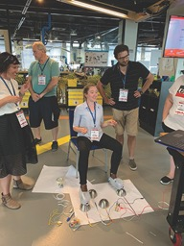
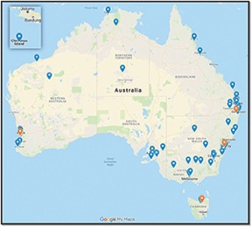

Questacon STEM Futures
In June 2019, Questacon partnered with the Toyota Community Trust to present Questacon STEM Futures, a week of intensive STEM professional learning workshop series for teachers and school leaders in West Melbourne. The program, co-developed with Scienceworks and Victoria University, was held at Scienceworks in June 2019.
The workshops equipped teachers with the resources, skills and confidence to effectively implement STEM experiences within their classrooms, schools and broader networks. Recognising that ongoing, successful change within a school cannot be driven by teachers alone, Questacon STEM Futures incorporated a full day of professional learning for school leaders.
The Questacon STEM Futures workshops had four key features:
STEM pedagogy – Teachers and school leaders explored STEM as a process and an approach to problem solving.
Capacity building – Questacon STEM Futures built participants’ confidence in STEM and their ability to apply it across different contexts. The workshops encouraged teachers and school leaders to identify as STEM experts within their community.
Strengthening networks – This component recognised that educators often find it easy to communicate with each other within schools, but not across schools.
Collaboration and partnership – Collaboration was a key feature of the program, with the workshops a catalyst for creating a local network of like-minded educators and STEM professionals.
In total, 66 participants from 31 different schools attended the workshops. Additionally, less typical learning environments, including the Royal Children’s Hospital School, the Western English Language School, and the Maribyrnong and Moonee Valley Local Learning Employment Network, also attended the workshops.
“This was the first time that I have really understood what is meant by STEM learning, and how it is inextricably linked with inquiry and professional based learning. The idea of ‘making’ has been clarified for me as the tangible output of students who are proving their learning in a meaningful, context-appropriate way.”
Primary Teacher, STEM Futures 2019 workshops
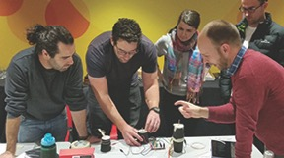
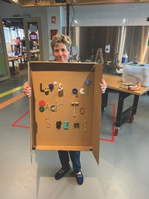
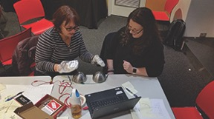

Questacon’s National Presence — 2020 and Beyond
Throughout 2019, Questacon welcomed Lieutenant Colonel Jennifer Harris, CSC, of the Australian Army on a 12 month placement to develop a decadal strategy for Questacon’s national presence and engagement. Working collaboratively with STEM engagement stakeholders, the strategy brings together Questacon’s Centre activities and national outreach programs, as a new integrated approach to deliver STEM engagement directly into communities across Australia. The strategy seeks to cultivate a network of locally led STEM learning ecosystems, to strengthen the future workforce and enrich the lives of all Australians.
Questacon’s focus on teachers and students increases capacity and professional ability to teach integrated, inquiry-based projects in schools. This in turn, leads to better uptake of STEM concepts, skills and behaviours in local communities.
From 2020, with the launch of the National Presence Strategy, these collaborations with industry, academia, education and government will pave the way to build a better future for all Australians through science, technology and innovation.
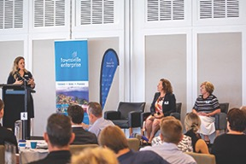

Supporting Schools and Community
The Questacon Educator Program continued to support local schools through 2019, cementing itself as a team that supports STEM development across the community, delivering professional learning to local schools and students at the University of Canberra. The team has also contributed to developing strong STEM communities by presenting at multiple conferences including:
- National Science Education Conference of the Australian Science Teachers Association (CONASTA);
- Conference for Science Teachers Association of Tasmania (CONSTAT);
- STEM Education (STEMEd);
- Australian Curriculum Studies Association (ACSA);
- Australian Association of Mathematics Teachers (AAMT); and
- Australian School Library Association (ASLA).
In 2019, the Educator Program formed the STEM ACTion Professional Learning Community, consisting of STEM education providers across the Canberra region. The STEM ACTion Professional Learning Community aims to create stronger networks among STEM providers, working on the understanding that a strong network between providers will result in better support for teachers.
“It was great to have a considerable amount of time set aside to reflect, audit and assess where we’re at as a school, and to identify what our next steps are.
Your time and effort is much appreciated!”
Secondary Teacher,
STEM Futures 2019 workshops
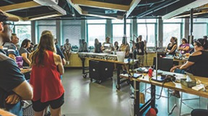

Questacon’s Centre Activities
Questacon – The National Science and Technology Centre is located in Canberra’s Parliamentary Triangle. Attracting more than 12 million visitors since opening in 1988, Questacon has welcomed at least three generations of Australians to be inspired and engaged with hands-on learning, enquiry and wonder.
The Centre showcases and brings to life the fundamental phenomena that make up our world through exhibitions, presentations and workshops, science shows, demonstrations and special events. Questacon is a leading Australian tourism destination, as well as a much-loved school excursion highlight for hundreds of thousands of Australian students who travel to Canberra each year.
The Centre is open 364 days a year, with an average visitor satisfaction rating of 91 per cent. The dedicated staff and volunteers who work in the Centre every day look forward to welcoming generations to come.

Visitor Experiences
This year, Questacon attracted 511 673 visitors to the Centre. Visitors are fascinated by Questacon, not only for an educational experience, but also to become immersed in the interactive galleries and inspirational science shows. Questacon’s visitor services staff have excelled at delivering great science engagement with friendly customer service. We have consistently achieved high visitor satisfaction ratings across all our feedback channels.
Our Centre team coordinated a record number of events, activities and programs in 2019, with a particular focus on attracting new audiences, offering new and unique experiences and encouraging strong community engagement.
Our busy program of events kicked off in February with the launch of our latest exhibition Born or Built? Our Robotic Future. This exhibition is distinctly different to previous exhibitions and interactive exhibits. Questacon’s teams involved in the design, construction and facilitation of exhibits, always strive to provide experiences that provoke curiosity and thought, and this exhibition takes a new approach designed to promote discussion through exploring the changing interfaces between science, technology and society. This exhibition is resonating well across all of our audience ages.
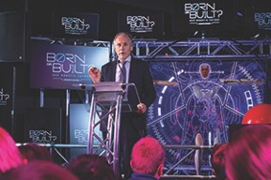
In October 2019, Questacon installed the Earth Observations exhibition, a collaboration with Geoscience Australia.
This exhibit is a graphic installation that celebrates how Earth observations help us understand our planet and improve the lives of everyday Australians. It showcases amazing and beautiful images including satellite observations, bathymetric (studying and mapping of the sea floor) and seismographic maps (measuring earthquake waves).
These images tell the stories of how Earth observations can keep the planet safe, help manage our land and resources, and let us explore our planet through a new lens. A digital version of the exhibition was displayed at GEO Week, with Geoscience Australia’s Chief Scientist, Dr Steve Hill. Earth Observations is on display until May 2020.
Each year Questacon participates in a range of award categories in the Canberra region, nationally and internationally. This year, Questacon won the category for Best Educational Attraction for Families in Australia, in the Out & About with Kids 2019 Readers’ Choice Awards.
In December 2019, Questacon was a joint winner with partner organisation, LEAD Disability Services, for the Inclusion Award in Public Sector Employment, at the ACT Chief Minister’s Inclusion Awards ceremony. Nominated by LEAD, Questacon celebrated this recognition towards evolving into a disability confident organisation, highlighting staff of all varying skill levels, attributes, perspectives and richness that an inclusive environment with neurodiversity encompasses. Through these awards, Questacon is better recognised for its commitment to increasing employment opportunities for people with disabilities.
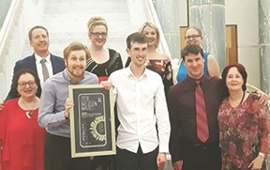
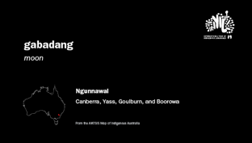
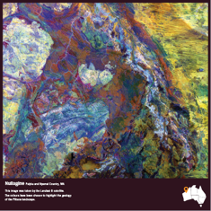
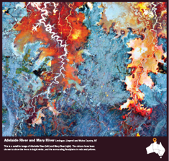
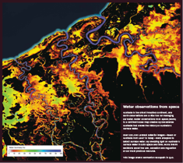

Questacon Retail
With another successful year of trade, the Q Shop continues to provide exceptional STEM products to all visitors. An ever-growing, revolving and evolving range of products has been key to this success. We cater for both school groups and families, and the products sold reflect Questacon’s overall high quality standards, which contribute to fun and exciting learning experiences.
This year, the Q Shop was transformed into a Moon and Space theme, as a tribute to the anniversary of the Apollo 11 Moon landing, acquiring space-enthusiast merchandise such as telescopes, graphic Moon T-shirts, and space themed confectionery. Since this transformation the Q Shop has sold more than 8500 space-themed items to customers and school groups.
The Q Shop is very proud of this year’s collaboration with the Australian Space Agency, with the introduction of official Space Agency merchandise, providing the opportunity to promote and sell these product lines as the exclusive reseller. All proceeds from the sales of official Australian Space Agency merchandise fund educational space activities within Questacon.
The Q Shop, and the Q Online Shop, promote hands-on science activities by leveraging Questacon’s ability to reach and engage with more people in science and technology, at home and in the classroom. This is achieved through the ongoing development of the Questacon-branded merchandise designed in-house, combined with the successes of the e-commerce platform. Throughout 2019, an additional 42 products were designed and developed by Questacon’s design and production teams on a new range of Moon merchandise, Born or Built? exhibition merchandise, and Questacon souvenirs.
Visit us at shop.questacon.edu.au
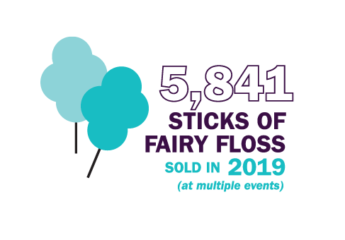
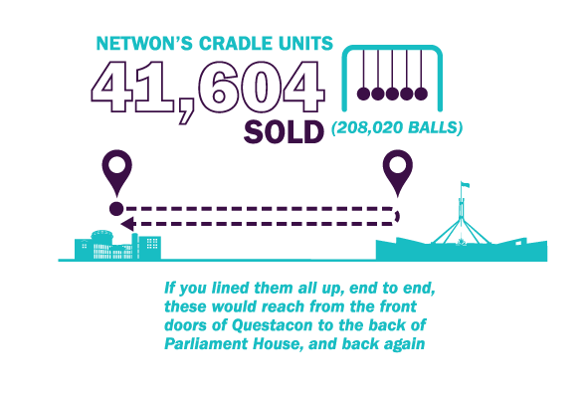

Q Members
During 2019, 17 221 Members made more than 50 000 visits to the Centre.
Questacon’s membership program (Q Club) was launched in September 1989 by the ACT Chief Minister, Ms Rosemary Follett MLA. The membership program enables Questacon to acknowledge our members and their support for, and contribution to the Centre, by offering exclusive opportunities for members to experience a deeper engagement with science and technology.
Membership provides unlimited entry to Questacon, discounts at the shop and café, entry to a range of reciprocal partners both in Australia and overseas, a complimentary free pass to Questacon, exclusive invitations to members-only events, and news updates about upcoming events and activities at Questacon.
Members enjoyed a varied program of events in 2019 designed to appeal to different interests and ages including:
- Fish Aren’t Real with Rob Desalle;
- Lee Constable from Channel 10 on STEM careers and launching her book, How to Save the Whole Stinkin’ Planet;
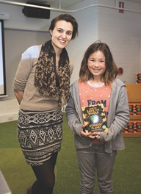
- Big Cat Tales movie night;
- Family STEM Workshop – build a hydraulic arm;
- Moon Colony – LEGO Robotics workshop;
- The launch of Dr Karl Kruszelnicki’s new book, Random Road Trip Through Science.
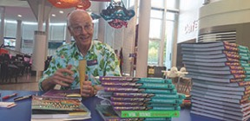
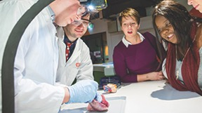
Highlights included the biology workshop Fish Aren’t Real, with Questacon Mind in Residence, Professor Rob Desalle, and the Spiders Alive! Show, where more than 100 members had a large spider crawl across their (gloved) hand.
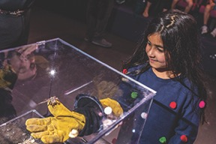
Questacon’s members also strongly supported Little Explorers Day, Mid-Winter Nights and the various Apollo 11 events on offer within the Centre.

Born or Built? Our Robotic Future

The line between humans and technology is blurring. We are creating machines that are increasingly human-like. At the same time we embrace technology into our bodies and lives, making us more like the machines we build. Questacon’s newest exhibition for 2019, Born or Built? Our Robotic Future examines the similarities and differences between humans and machines, explores our shared future, and questions the choices we will make to get there. Born or Built? officially launched in March 2019, with guest speakers, Australia’s Chief Scientist, Dr Alan Finkel AO, and Questacon Advisory Council member, Professor Elanor Huntington.
Born or Built? is an innovative style of exhibition for Questacon, designed to promote discussion and debate. It asks questions that society will grapple with as technologies evolve and become more widespread. The exhibition is not designed to answer these questions. Instead it encourages visitors to engage with the underlying ideas and come to their own conclusions.
Fifteen interactive exhibits are presented to visitors as provocations such as ‘Who should be in charge of robots?’, ‘Should we reprogram life?’ and ‘Can machines make art?’. Six interactive kiosks pose hundreds of ethical and philosophical questions for visitors to explore. Visitor responses are compiled and displayed on a digital wall.
Another exhibit provides visitors with an opportunity to ask questions of their own, which are then answered by subsequent visitors. The innovative style of interaction has been a hit with visitors who have been enjoying the unique format. So far, visitors have contributed more than 500 000 responses to questions and posed over 6000 questions of their own.
This data has been made available to universities, industry and government. It is providing novel insights into public opinion on technology in our lives, and is even being considered in policy development. Undergraduate and master’s classes have visited the exhibition to discuss public opinions and concerns around artificial intelligence and the ethics of technology.
In developing Born or Built? Questacon formed many productive relationships with government, industry, academic and artistic partners, including:
- University of Canberra
- The Academy of Interactive Entertainment
- The Australian National University
- Ottobock
- Cochlear Limited
- Australian performance artist Stelarc
These partnerships provided content, objects and graphical assets as well as whole exhibits. Questacon continues to work with the University of Canberra to develop and evolve the Articulated Head, a robotic art installation. The University of Canberra will conduct research into human-robot interactions using the exhibit.
Exhibition evaluation has seen visitors dwell 40 per cent longer in Born or Built? than in previous similar exhibitions.
Observational data suggests this is due to prolonged conversations and debate. Born or Built? will be at Questacon until late 2020, and will then tour Australia with Questacon’s Travelling Exhibitions program.
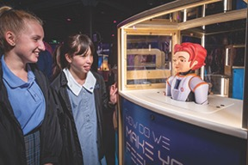
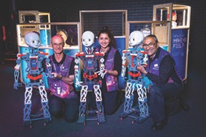
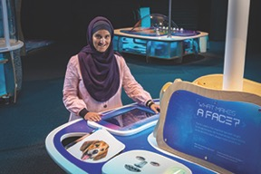

50th Anniversary of Apollo 11

Half a century has passed since the Apollo 11 Moon landing. On 20 July 1969, Commander Neil Armstrong, Dr Buzz Aldrin and Michael Collins made history.
Now, 50 years on, we look back at the remarkable achievements accomplished on that day. In November 2018, Questacon celebrated the 50th anniversary of the Apollo 11 mission with the installation of the Moon exhibition, a seven-metre wide inflatable object suspended from the ceiling.
Since then, Questacon has added a number of interactive hands-on exhibits, video projections of the landing, and authentic artefacts unique to the 1960s. These artefacts were used as part of Australia’s participation of the Apollo 11 mission and have been generously loaned to Questacon from Honeysuckle Creek and Canberra Deep Space Tracking Station.
The exhibition, with corporate support from CSIRO, demonstrates the power of science and maths as told through the journey of the Apollo program that landed humanity on the Moon, while prompting visitors to consider the effects of gravity, thrust and balance. The 50th anniversary of Apollo 11 marks the moment science took us to the Moon and back, with the power of science and maths as a tool on full display.
Questacon, as well as a number of other Canberra institutions, participated in the Moon Rock trail, which highlighted Canberra’s involvement in the Apollo 11 mission. Questacon now has on display a fragment of genuine Moon rock collected by Astronauts Neil Armstrong and Buzz Aldrin during the first Moon landing. The Moon rock is on loan from the National Archives of Australia.
Alongside the Moon rock is an Australian flag that the Apollo 11 crew took with them on their 1.5 million kilometre journey.
As part of the events to celebrate Apollo 11, Questacon hosted a retro 1969 event, A Blast from the Past, attracting an older generation to Questacon for an after-hours night, dancing to some favourite 60s tunes and participating in 60s-themed trivia.
Questacon also invited families to enjoy the Centre for Lunar Family Day. Visitors were delighted to see and engage in space-themed activities, space science demonstrations and science shows, in acknowledgement of this 50th anniversary.
In partnership with resident Professors at the Department of Industry, Innovation and Science, Questacon initiated the Moonlighting Scientists Speaker Series, with a special Moon-lit dinner under the Moon exhibit. Guest speakers included Professor Fred Watson AM and Dr Bruce Warrington for an entertaining presentation on space and time.


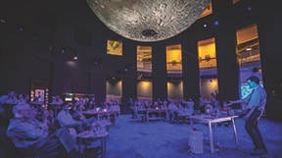
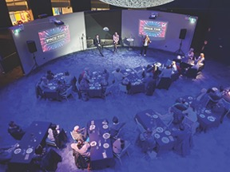

International Engagement
As Australia’s National Science and Technology Centre, Questacon showcases Australian science excellence and innovation on the international stage, sharing best practice and the capabilities of Australian science communication with the global science centre sector.
Questacon has a role in cultural diplomacy, with our international events facilitating people-to-people, institution-to-institution and country-to-country interactions through popular hands-on science exhibits and science shows as well as science communicator and teacher workshops. As a leader in the science centre sector, Questacon makes a significant contribution to the sector’s global development and is an active member of the sector’s peak body, the Association of Science Technology Centers (ASTC). Questacon has also cultivated strong relationships with science centres across the Indo-Pacific region. For more than two decades, Questacon has supported the ongoing development of the Asia Pacific Network of Science and Technology Centres (ASPAC), with Questacon’s Director, Professor Graham Durant serving as the Vice-President for ASPAC for a number of years.
Questacon welcomes many international delegations from all continents to its Centre in Parkes each year. The wide-ranging groups including ambassadors, teachers, museum association representatives, government officials, science centre staff and university professors tour Questacon to learn why and how Questacon’s programs and operations are delivered.

International Agreements
Questacon engages with other science centres and international institutions across the globe through Memorandums of Understanding (MoU). These non-binding agreements provide Questacon with the opportunity to assist in the development of emerging science centres, and facilitate cross-cultural idea and knowledge exchanges. Collaborative activities include the exchange of public engagement programs to develop audience knowledge and skills by learning how science and technology can enhance everyday life, and opportunities for knowledge exchanges through conferences, seminars, exhibitions and publications.
Throughout 2019, Questacon maintained MoUs with:
- Australian National University and the China Science and Technology Museum, Beijing;
- Busan National Science Museum, through the Ministry of Science, ICT and Future Planning, South Korea;
- The National Museum of Australia, and Italy’s Fondazione Museo Nazionale della Scienza e della Technologia Leonardo da Vinci, Milan;
- Japan Aerospace Exploration Agency; and
- Science Centre Board of the Government of Singapore.
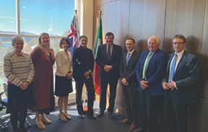
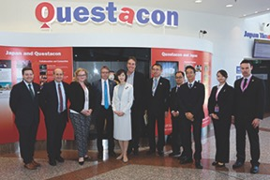

Young Persons’ Plan for the Planet
During 2019, Questacon supported the Young Persons’ Plan for the Planet program (YPPP) for the third consecutive year. YPPP first piloted in Australia in 2016, connecting secondary and senior school students to develop a strategic plan addressing global issues.
The program is led and directed by Ian Chambers, YPPP Program Director from The Crawford School of Public Policy at the Australian National University. The program is structured around the United Nations’ 17 Sustainable Development Goals and aims to engage, connect, empower and harness the enthusiasm of senior school students through the development of strategic plans addressing global issues in local, regional and international contexts.
In 2019, the YPPP connected with over 300 students from more than 40 schools across Australia, Mauritius, India and Singapore through live broadcasting sessions filmed in Questacon’s Schmidt Studio.
During the year, students from participating schools embraced the program as future designers and implementers of our sustainable future Earth, developing and implementing plans against the Sustainable Development Goals for each Australian state and territory, as well as national plans for Singapore, Mauritius and India.
In December 2019, the program’s annual international conference, It’s Our Future Earth, and UN SDG Challenge 3.0, was hosted by the Singapore Science Centre, and Curtin University campus in Singapore. The three-day conference brought together over 80 students from 13 schools from Australia, India, Mauritius and Singapore.
Questacon Director, Professor Graham Durant, presented the keynote speech at the conference on the topic Earth Week 2020: Science centre leadership delivering the UN SDGs.
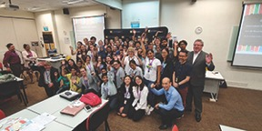

International Delegation Visits and Highlights
5 February: Questacon welcomed delegates from the United Kingdom Space Agency, Rebecca Evernden, International Director and Gary Martin, Head of Cyber and Space Policy, Ministry of Defence, along with the Acting British High Commissioner (Canberra), Ingrid Southwell.
27 February: the Japanese Ambassador Extraordinary and Plenipotentiary to Australia, Mr Reiichiro Takahashi and his wife, Mrs Masako Takahashi, visited Questacon to meet with our Executive, as his first visit to Questacon as Ambassador.
6 March: senior delegates from the Japan Aerospace Exploration Agency (JAXA), Associate Senior Engineers, Mr Fumiaki Tanigaki and Mr Kazuo Umezawa, with Mr Kyouichi Arakane, Associate Director of JAXA’s Advances Engineering Services.
18 March: Tohoku Youth Program participants visited Questacon – the program assists young Japanese students who lost one or both parents in the disastrous earthquake and tsunami of March 2011 by bringing them to Canberra for a brief respite and educational experience.
2 May: Questacon welcomed Dr Akiko Yoshioka, Osaka Science Museum, Japan.
21 May: Professor Otlogetswe Totolois, Vice-Chancellor of Botswana International University of Science and Technology (BIUST).
24 May: Mr Yoshio Tokaku, Director for International Strategy and Coordination, Institute of Space and Astronautical Science and Ms Hiroko Asakura of the Hayabusa 2 Project Team, JAXA.
7 June: the Hon Thomas Pata’aku, Minister for Education, Autonomous Bougainville Government, hosted by Charles Darwin University.
1 August: Dr Ken Silburn, Global Teacher Ambassador, hosted 12 South Korean professors, researchers, and educators in a STEM content and development discussion forum.
9 August: the Asia Education Foundation hosted a delegation of principals from Papua New Guinea’s high performing schools in a STEM Futures workshop at The Ian Potter Foundation Technology Learning Centre.
13 August: the Australian Science Teachers Association (ASTA) hosted a Japanese delegation of eight elementary school teachers, principals, and official staff for a week-long exchange in Canberra, including a workshop at The Ian Potter Foundation Technology Learning Centre.
13 August: Questacon welcomed delegates from the Italian Embassy, Canberra accompanying Professor Fiorenzo Galli, General-Director of Italy’s Fondazione Museo Nazionale della Scienza e della Technologia Leonardo da Vinci.
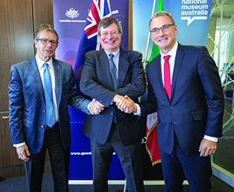
21-23 August: delegates of the Daegu National Science Museum, South Korea, visited Questacon to discuss its exhibition concept design and development, and suite of annual public events.
9 September: delegates from the Busan National Science Museum, South Korea, visited Questacon for a tour of the facility and to discuss exhibition installations, galleries, and the design and concept process.
23 September: the State Secretary for Science and Education, Ms Sanja Putica, Ministry for Science and Education, Government of Croatia, met with Questacon’s senior managers for a tour of the Centre.
2 October: Questacon welcomed Ms Ruriko Nagashima, a PhD student from the Graduate Schol of Advanced Integrated Studies, University of Kyoto, Japan, to intern with Questacon’s Visitor Programs.
5 November: Dr Jim Reilly, United States Geological Survey Director, delivered an engaging presentation for high school students streamed on YouTube to promote GEOWeek 2019.
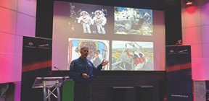
7 November 2019: Japanese Parliamentary Vice-Minister of Education, Culture, Sports, Science and Technology, Ms Sayaka Sasaki toured Questacon to discuss support for science literacy in Australia and Japan.
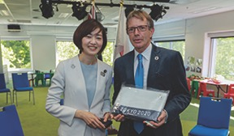
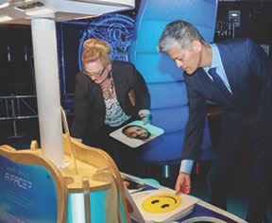

International Science Centre and Science Museum Day
Each year on 10 November, Questacon participates in International Science Centre and Science Museum Day (ISCSMD). ISCSMD was launched in 2015 as a result of the United Nations adopting the 2030 Agenda for Sustainable Development. ISCSMD is themed around the United Nations’ 17 Sustainable Development Goals, and is the largest annual joint project delivered by the world’s science learning institutions.
In 2019, Questacon offered a 50 per cent discount to all visitors to the Centre, as well as encouraging visitors of all ages to dress up as their favourite scientist. On the day, Questacon’s Excited Particles offered special live theatre shows and science activities throughout the centre.
The first 500 visitors also received a free rainbow slinky spring, and competed in numerous slinky spring-challenges in the Centre’s galleries, including The Great Spring Drop and The Great Spring Race.
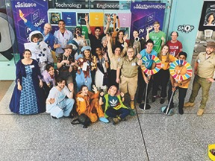
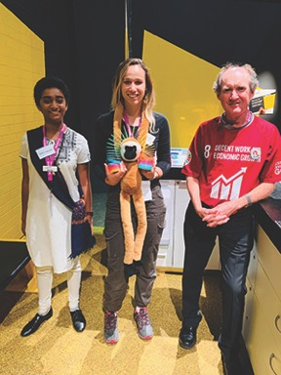
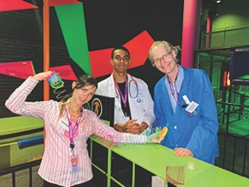

Digital Engagement
Questacon continues to engage a growing audience and is leading the way in areas of digital engagement, with multi-disciplinary capability in videoconferencing, along with expanding communication via online and social media platforms.
Questacon also facilitates access for our partners to industry leading video production and online services, with a mission to develop digital media and online content – supporting Questacon’s activities and outreach programs to enhance science engagement.
Questacon complements face-to-face experiences with activities delivered online and through digital media technology. We offer interactive workshops and programs via videoconference to schools across Australia, and the Questacon website contains educational materials to supplement exhibitions and programs.
Throughout 2019, Questacon’s Facebook and Twitter followers were very active on social media. We surpassed 2.8 million views on YouTube, with more than 4.16 million minutes of watch-time, connecting to 597 new subscribers.
This year, Questacon’s Digital Engagement team also supported a wide range of internal and external coordinated events in our Japan Theatre including:
- Do-It-Yourself videos;
- Enterprising Australian stories;
- videos to accompany the Born or Built? exhibition;
- Science in First Language video production;
- the Governor-General’s Design Challenge, for National Science Week;
- Women in STEM podcasts; and
- Karakuri Puppet restoration video.
As well as supporting many theatre events and video conferences in the Schmidt Studio, Questacon also facilitates a live-broadcasting session each month for the Young Person’s Plan for the Planet program, to primary schools across Australia. Through the support of The Australian National University and the United Nations Information Centre (Canberra), the program focuses on promoting the United Nations’ Sustainable Development Goals nationally and internationally and to countries currently developing their program strategies.
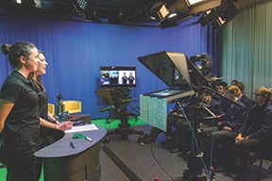
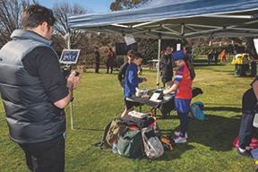
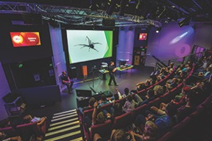

Inspiring Australia
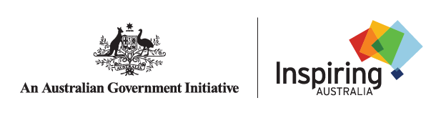
The National Science Statement sets out the Government’s vision for an Australian society engaged in and enriched by science. Inspiring Australia plays a key leadership role in this vision and in supporting coordinated and consistent science engagement activities at a national level.
Since 2010, Questacon has had a pivotal role in implementing the Inspiring Australia’s national framework for the delivery of local initiatives nationwide. Now, through the Inspiring Australia – Science Engagement Programme, Questacon provides national coordination of one of the flagship elements, National Science Week, and the Inspiring Australia Manager Network.
Together with local communities, science and research agencies, education providers, industry and business sectors, cultural and community organisations and many others, Questacon has supported Inspiring Australia in facilitating opportunities for millions of Australians to get involved in STEM activities.
Inspiring Australia seeks to support effective, systematic, high impact and coordinated science engagement activities. Harnessing the strengths of the science engagement community, Inspiring Australia builds on existing achievements and addresses the challenges of national coordination to reduce duplication of effort across Australia.

National Science Week 2019
Questacon proudly flew National Science Week flags in August 2019, marking a celebration of science across the nation.
More than 1.5 million people took part in 2077 events, including Coffee in Space across Victoria, the Innovator’s Tea Party in Perth, and Science in the Swamp in Centennial Park, Sydney.
Minister for Industry, Science and Technology, the Hon Karen Andrews MP, launched National Science Week on the Gold Coast with astrophysicist and Questacon Advisory Council member Professor Alan Duffy, saying that ‘science and maths are my life and have been since I was eight or nine’.
The Governor-General’s Design Challenge, held at Government House during National Science Week, was hosted by His Excellency General the Hon David Hurley AC DSC (Retd) and Her Excellency Mrs Linda Hurley. School students designed and constructed lunar-landing modules, in a critical-thinking STEM engagement workshop.
More than 2000 scientists and STEM entrepreneurs shared their career story by using #STEMgotmehere and #thisismylab tags on Twitter. A diverse range of comments and images from varying STEM-focused organisations and industries included posts from diverse environments and locations such as Antarctica and Africa, from entrepreneurs to artists and on topics ranging from neuroscience to nanotechnology.
Science Week ambassadors including astronaut, Dr Andy Thomas AO, forensic scientists, Dr Maiken Ueland and Dr Paola Magni, bushfire propagation mathematician, Associate Professor Jason Sharples, and quantum physicist, Professor Michelle Simmons AO, completed 30 interviews and appeared in community announcements that were broadcast more than 12 900 times.
In the 2019 Year of Indigenous Languages, the sharing of traditional knowledge featured at many events, including stargazing in Hermannsburg in the Northern Territory, building an 11-metre long eel trap in Footscray, Victoria and taking a celestial navigation cruise on Sydney Harbour. As well, Indigi Hack in Redfern gave Indigenous youth the chance to develop apps to help revitalise and retain Indigenous languages.
National Science Week published an Early Childhood Activity booklet that was downloaded more than 3000 times. There were many wonderful opportunities for tiny scientists to get involved, including with scientist and author, Dr Rina Fu reading her children’s book My Mad Mummy Scientist at daycare, the Young Explorer’s program at the South Australian Museum, and online via the special content on the ABC’s Kids Listen app.
The school theme of Destination Moon was enthusiastically received by teachers, who staged imaginative events celebrating the achievements of Apollo and looking forward to the missions being planned to return to the Moon.
The Australian Science Teachers Association (ASTA) awarded grants to 291 schools for their Science Week events, and hundreds more schools and pre-schools also joined in the week’s events.
More than 11 000 people contributed their brain power to The Aha! Challenge citizen science project by the ABC. The research team led by Professor Simon Cropper at the University of Melbourne is looking for insights into the memories that people have of their own eureka moments.
They have already found that insights happen most commonly (42 per cent) when people are in nature, like walking in the countryside or sitting in a park.
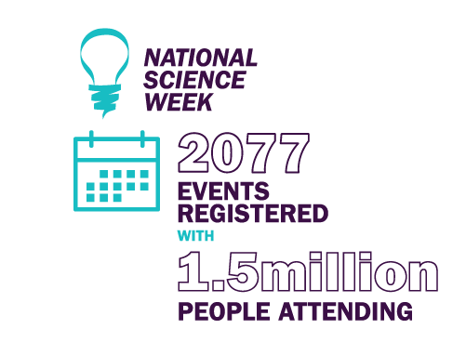
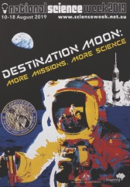

Inspiring Australia National Networks
The national Inspiring Australia – Science Engagement Programme is supported by an effective national network of Inspiring Australia Managers. Questacon’s National Networks team provides national leadership and coordination for the network, focusing on stakeholder engagement and support. The team of Inspiring Australia Managers— experts in community engagement and well-connected to state-based STEM and cultural networks—are employed in a variety of organisations, partnering with the Australian and state and territory governments to deliver the Programme.
As part of a dynamic, expanding STEM engagement landscape, the National Networks team leverages the greater Inspiring Australia Network to facilitate and advocate for an informed, connected and collaborative approach to STEM engagement across Australia.
Questacon is well placed to connect with a range of stakeholders across education, informal learning, science centres and museums, cultural, research organisations, tertiary organisations, community organisations and throughout government. The connections are multi-directional. We learn from our stakeholders, gathering their experiences and expertise, and we aim to build capability by sharing best practice and developing legacy.
In 2019, host organisations in seven states and territories signed new three-year agreements and, as such, Inspiring Australia Managers are located in these states and territories supporting the delivery of year-round science engagement activities, including National Science Week.
Questacon hosted two meetings with the Inspiring Australia National Network and teams from the Department of Industry, Science, Energy and Resources to discuss and plan the next steps in supporting STEM engagement through Inspiring Australia.
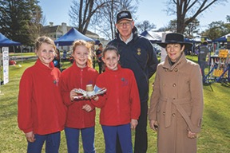
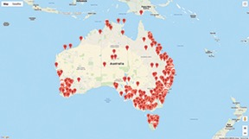
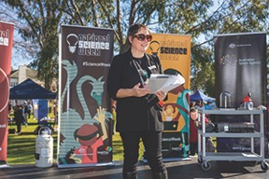

Indigenous Engagement
In 2019, the global celebration of the United Nations International Year of Indigenous Languages provided an opportunity for Questacon to highlight the value of Australian Indigenous languages and knowledge to science and learning experiences, for both staff and visitors.
Recognising the scientific knowledge embedded in Australian Indigenous languages, we worked with First Languages Australia to identify Indigenous words including 28 words and phrases for the Moon in our Moon exhibit. Questacon’s new Earth Observation exhibition, developed for International GEO Week, highlights how Aboriginal rangers across remote areas of Northern Australia are combining satellite mapping data with traditional knowledge to better manage fires within Northern Australia.
Throughout 2019, Questacon staff learnt many Indigenous words including the Yolngu word Nik Nik or ‘bush rat’. The word Nik Nik, translates to busy creatures running around, speaking to many people and arranging important meetings and ceremonies. We also presented prizes to staff across our department who successfully completed a cryptic puzzle in Waanyi language, developed by the Australian Computational and Linguistics Olympiad.
Questacon also celebrated NAIDOC Week, Reconciliation Day and National Science Week through events and social media activities highlighting Indigenous knowledge and languages.
Recognising that Questacon is on the traditional lands of the Ngunnawal peoples, Questacon staff were trained by Ngunnawal Traditional Owners Tyrone and Jai Bell, to deliver an Acknowledgement of Country in Ngunnawal language. We will continue this training in 2020 including using Ngunnawal language to welcome visitors to the Centre.
To celebrate this important year, Questacon invited Indigenous Australians to create a science video presented in an Indigenous language for our Science in First Languages project. Visit Questacon’s YouTube channel to see the five inspiring videos in this collection.
In 2019, we hosted our second annual visit by seven Arrernte students and community members from the Alice Springs Language Centre. With The Australian National University, Questacon hosted 35 Indigenous students from across Australia attending the 2019 National Indigenous Summer School.
Questacon also hosted the inaugural Indigi-Cyber Camp for Kids. The Indigi-Cyber Camp, a collaboration between the Australian Strategic Policy Institute, a local Aboriginal business leader and 2018 ACT Australian of the Year Dion Devow, and SecuriDay security professionals. The cyber security workshop was attended by 15 Indigenous students and their families from the local region.
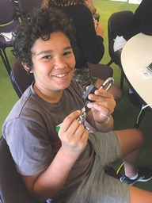
In August, the Shell Questacon Science Circus visited 18 Indigenous communities around Alice Springs, Northern Territory delivering STEM workshops to over 400 students, plus skills training for teachers to help them incorporate STEM activities in their teaching. The tour was presented by The Australian National University students as part of their training for a Master in Science Communication, Outreach – continuing a partnership of over 34 years between Questacon and The Australian National University. Questacon also visited Elcho Island at the invitation of The Australian National University Indigenous Genome Project to provide STEM workshops to the local community and training to Australian National University researchers.
In 2019 Questacon contributed to the Reconciliation Action Plan for the Department of Industry, Science, Energy and Resources. This is an important document which will assist us to work with our department, ensuring greater engagement of Indigenous Australians in STEM.
“The interest and engagement of staff and students was palpable. The enthusiasm of presenters and ability to engage with such a wide range of age groups was brilliant. They are a credit to ANU and Questacon. Well organised, stimulating, hands-on, student-centred sessions.”
Teaching Principal, Imanpa School,Northern Territory
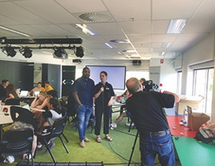
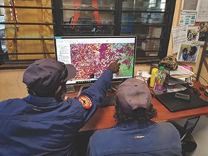

Key Events 2019

STEM X Academy, 7–11 January
The STEM X Academy is a joint initiative of the Australian Science Teachers Association, Questacon and CSIRO. In 2019, 70 teachers attended the five-day residential, professional development workshop, increasing their confidence and ability in teaching of STEM education in the classroom.

National Questacon Invention Convention 14–18 January
The Questacon Smart Skills Initiative delivered the 2019 Questacon National Invention Convention. A total of 25 delegates received training and mentoring over a five-day program from Questacon staff, entrepreneurs, researchers and local business people who shared their skills, experiences and stories. This annual event culminated with a final showcase, to demonstrate participants’ inventions and prototypes.

Avalon Airshow, 26 February – 3 March
The Australian International Airshow and Aerospace and Defence Exposition (Avalon Airshow), is one of Asia-Pacific’s most prestigious aviation and aerospace events and the most comprehensive aviation, aerospace and defence exposition in the Southern Hemisphere. The Australian Space Agency and Questacon shared an exhibition stand, presenting the national civil space priorities, including inspiring the next generation in STEM.
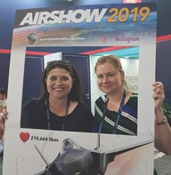

Enlighten Canberra 1–11 March
To coincide with the 50th anniversary of the Apollo 11 Moon landing, Questacon was the official launch site for Enlighten Canberra 2019, with projections on the Centre’s external walls of a rocket launching into space. Questacon also projected images of the periodic table to acknowledge 2019 as the International Year of the Periodic Table. Questacon hosted a number of special events including The Moon is Made of Cheese, a special event under the Moon exhibit, and Dr Phil Dooley’s Poet’s Guide to Science, in the Japan Theatre.

Autism Access Day 2 March
Questacon welcomed 50 visitors who identified having Autism or being on the spectrum. Questacon provides this opportunity for visitors to experience the Centre without the noise and bustle during normal business hours, with our friendly Front of House staff tailoring each experience to accommodate the needs of our visitors.
“It was the best day we have spent as a family for a long time.”
Questacon Visitor at Autism Access Day

STEM Network Showcase, 18–19 March
The Showcase bought together partners from the previous four years of regional Questacon Invention Conventions (2016–2019), for a combined learning experience delivering STEM programs to Australians. The showcase strengthened the network of like-minded organisations and provided the opportunity to improve individual STEM engagement outcomes.

Born or Built? exhibition launch, 28 March
Questacon’s newest exhibition, Born or Built? Our Robotic Future was official launched by Questacon Director, Professor Graham Durant AM, Australia’s Chief Scientist, Dr Alan Finkel AO, and Questacon Advisory Council member, Professor Elanor Huntington. Schools students from Karabar High School and Cranleigh School participated in a robot vacuum cleaner race, provided by Questacon’s Technology Partner, Samsung.

Little Explorer’s Day, 6 May
Questacon dedicated a day for our youngest visitors aged 0–6 years. A total of 886 visitors explored the Centre without the ‘bigger kids’. Several community groups attended including St John’s, who spent the morning teaching first aid to toddlers, parents and carers.

AusSMC: Trust in Science, 13 June
Questacon, in partnership with The Australia Science Media Centre (AusSMC), hosted a panel briefing and discussion, followed by Q&A, on the topic of Trust in Science.
Panel members included:
- Sarah Brown, Chief of Staff at the Office of Australia’s Chief Scientist;
- Daryl Karp AM, Director of the Museum of Australian Democracy;
- Professor Joan Leach, Director of the Centre for the Public Awareness of Science, Australia National University;
- Anna-Maria Arabia, Chief Executive Officer of the Australian Academy of Science; and
- Dr Susannah Eliott, CEO of the AusSMC.
The discussion looked at how the media struggles to preserve and report trust in science, while fighting to capture the attention of the public, avoiding distortion and misinterpretation of information.

St Vinnies CEO Sleepout, 20 June
Professor Graham Durant AM, Questacon’s Director, participated in the St Vinnies CEO Sleepout, sleeping on cold concrete, with just cardboard and a sleeping bag for comfort. He raised more than $3100 for St Vinnies, to raise awareness of homelessness and poverty in Canberra, and all across Australia.

Natural History of Beer, 28 June
Questacon’s visiting Fulbright scholar, Professor Rob DeSalle, and BentSpoke brewer, Richard Watkins, presented a show to launch the book A Natural History of Beer. The show took the audience through a historical and scientific journey about beer, while they enjoyed a range of beers throughout the night.

Pathways to STEM Equity, Tour to Western Australia, 30 June – 8 July
Five of Questacon’s staff formed a working group in an exploratory and planning expedition to Western Australia’s Goldfields region, in partnership with the CoRE Learning Foundation. The trip was a career development opportunity and a chance for the group to develop Questacon’s ongoing Women in STEM Strategy. The tour was hosted by Suzy Urbaniak, previous Prime Minister’s Prizes for Science winner and Western Australia Local Hero Australian of the Year 2020, alongside Australian Government’s Women in STEM Ambassador, Professor Lisa Harvey-Smith.
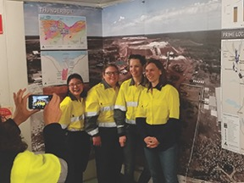

United States Embassy, 4th of July Reception, 2 July
Questacon hosted the United States Embassy (Canberra) 4th of July Reception, with more than 600 invited guests enjoying the Centre’s galleries and activities. Questacon’s LEDusa displayed the United States flag through impressive illuminated red, white and blue led lights. United States Ambassador, Arthur B. Culvahouse Jr. noted special guests for the reception, including NASA Deputy Administrator, Badri Younes and Head of Australian Space Agency, Dr Megan Clark AC.
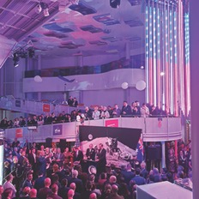

NASA’s Badri Younes presentation, 3 July
The Australian Space Agency and Questacon welcomed NASA Deputy Administrator for Space Communications and Navigations, Mr Badri Younes, to present A Journey of Exploration and Discoveries in the Japan Theatre, and live broadcast through Questacon’s YouTube channel.

Mid-Winter Nights, 10–13 July
Operating for its third year, Mid-Winter Nights is the ultimate family friendly activity during the July school holidays. Questacon’s eight action-packed galleries were open with Moon and space-themed activities. Across the three nights, 6075 visitors viewed a number of spectacular science shows, were amazed by circus performers, enjoyed flashing fairy floss and dined in a glowing food court.

Institute of Public Admin Australia Inc. (IPAA) Awards, 31 July
The Ian Potter Foundation Technology Learning Centre hosted the presentation ceremony and showcase event for the IPAA Innovation Awards. These awards were created to recognise and celebrate the innovative work that occurs in the public space, and share innovative approaches across the Australian and Australian Capital Territory governments. Again this year, the trophies were designed and made by Questacon’s production team.
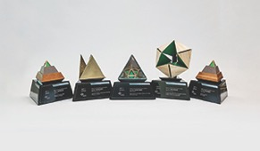

INPEX Partnership Launch, 2 August
Questacon’s partnership with INPEX was launched with an event at the Sydney State Library, including both Portfolio Ministers, the Hon Karen Andrews MP and Senator the Hon Matt Canavan. Also in attendance were INPEX’s Chief Executive Officer, Mr Takayuki Ueda, and Chairman,Mr Toshiaki Kitamura, with the INPEX Board. Questacon’s Excited Particles performed a number of energy-themed science demonstrations with hydrogen and oxygen flashing tubes. The event focused on the United Nations’ Sustainable Development Goal #7, to ensure access to affordable, reliable, sustainable and modern energy for all.
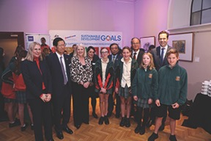

Leonardo 500: Science Before Science, 13 August
In partnership with the National Museum of Australia, the Fondazione Museo Nazionale della Scienza e della Technologia Leonardo da Vinci of Milan, and the Italian Embassy (Canberra), Questacon presented a free public show to mark the 500th anniversary of Leonardo da Vinci’s death.

Governor-General’s Design Challenge, 16 August
For the second year, the Governor-General’s Design Challenge was held at Government House during National Science Week 2019. His Excellency General the Hon David Hurley AC DSC (Retd) and Her Excellency Mrs Linda Hurley, hosted 100 Year 5 and 6 school students from 26 Canberra region schools to innovate, design and construct lunar-landing modules, in a critical-thinking STEM engagement workshop.
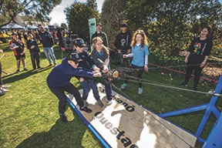

EuroScience Week, 7–11 October
Questacon celebrated the annual EuroScience week for the fifth consecutive year in 2019. The event is a collaboration between delegates within the European Union and Questacon, with the focus on inspiring visitors through educational and informative European-themed experiences and presentations. This year the theme was Space and Energy.

GEO Week 2019, 4–9 November
On 4 November, world-renowned science presenter, Dr Karl Kruszelnicki AM presented his new book, Random Road Trip Through Science, complete with book-signing. On 5 November, Dr Jim Reilly, the Director of United States Geological Survey, presented to school students and the public, exploring significant moments of his STEM career and his experiences as a NASA Astronaut. Questacon also welcomed Alice Bowman, NASA’s New Horizons Mission Operations Manager, to talk about the historical voyage to Pluto and the Kuiper Belt. Larry James, Deputy Director of NASA’s Jet Propulsion Lab and Dr Linda Spilker, NASA’s Planetary Scientist, presented on the wonders of the solar system in two educational and exciting public lectures.

Their Excellencies visit to Questacon, 19 November
His Excellency General the Hon David Hurley AC DSC (Retd) and Her Excellency Mrs Linda Hurley, made their debut visit to Questacon in their vice regal capacity (returning many years after frequent visits as parents) their Excellencies had a tour of the Centre to learn more about the programs, activities and facilities,and to meet the Executive, Senior Managers, staff, volunteers and visitors.
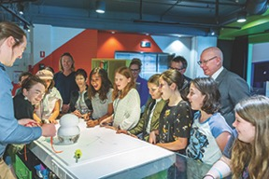

International Year of the Periodic Table
Questacon recognised the International Year of the Periodic Table by highlighting elements throughout the year through social media. These stories explored the familiarity and history behind an individual element every week. Questacon’s Elements exhibit was upgraded with four new elements, 113 – Nh Nihonium, 115 – Mc Moscovium, 117 – Ts Tennessine and 118 – Og, Oganesson.

Adults-Only Boutique Events

10 and 17 May
Questacon’s Visitor Programs team held two sessions for Pure ImaGINation. Visitors experienced a selection of five fine gins, while the team’s botanical aficionados explored the science of gin and its history.

9 and 16 August
This second series of After-Dark events, Tequila! The Science of Mezcal, was held over two nights for the exploration of tequila. Visitors enjoyed a selection of tequila tastings while exploring agave-based spirits, separating fact from the fiction.
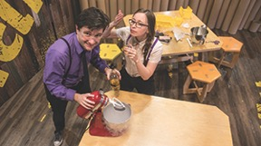

2 September
The Australian Academy of Science held an adults-only event inviting astrophysicists, Nobel Prize winner Professor Brian Schmidt AC and ‘The Bachelor’ Dr Matt Agnew, in conversation. Also 30 of Australia’s best and brightest young scientists and researchers, all Alumni of the Lindau Nobel Conferences in Germany, roamed the galleries to talk about their work with visitors at the event.
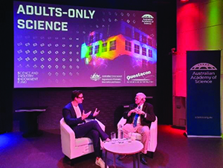

25 October
Questacon opened late for another adults-only session, offering special guided tours including several demonstrations, and a pop-up bar under the Moon.

Questacon People

Volunteers
Questacon’s modest beginnings, as a volunteer-run project, helped create a team that stands out for their enthusiasm, creativity and diversity. Volunteers underpinned Questacon’s early days at the Ainslie Primary School, developing and building exhibits while also helping visitors to understand the science behind the displays. Their knowledge and experience helped shape the new Questacon – The National Science and Technology Centre that opened in 1988, and they remain a vital part of Questacon today.
Questacon’s dedicated team of 65 volunteers, who in 2019 contributed a total of 8778 hours, provide exhibit explanations and science demonstrations to visitors, including the Centre’s mobile Explainer trolleys, Curiosity Corner, Science Time, Robotic team and Outreach Program. Volunteers also contributed to a number of special events throughout the year including:
celebrating the 50th anniversary of the Apollo Moon landing and sharing their memories via social media about where they were – from Australia to Chile to South Africa – and what they remembered about the historic moment;
providing memorabilia and running 60s themed trivia during the A Blast from the Past event held during the Moon celebration month;
constructing a 1:5 scale replica model of the Apollo Lunar Rover by CAD design, 3D files and printing – a project that took 18 weeks to complete.
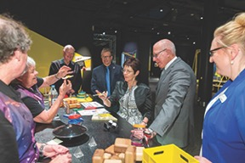
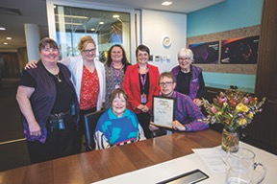
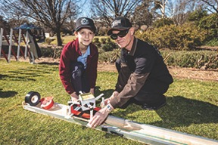

Building an Inclusive Culture
All Australians should be able to see themselves visiting Questacon, engaging in the experience and even working at Questacon. To meet this objective of engagement, we need a workforce that reflects the diversity of our audience and a workforce that has a high level of confidence delivering services and working with diverse colleagues and customers.
Questacon has been building an inclusive culture by providing access, engagement and employment opportunities for people with disabilities. We started with a goal to provide better access to Questacon for people with disabilities with the long-term vision of providing pathways to employment.
Questacon’s Disability Confidence Champions group works with internal and external partners. The group has delivered a number of initiatives to enhance access to Questacon and build disability confidence in staff. This included the Autism Access program, where Questacon opened the Centre early from 8–9am exclusively for people on the Autism spectrum. A number of Questacon teams worked with external experts to create the best experience for our visitors with Autism. This involved staff training, creating sensory maps, developing a tailored science show and modifying some of the exhibits.
To enhance the diversity of our workforce, Questacon created an affirmative measures register for people with disability. Hiring people with disability is a great way to build disability confidence in staff and better understand the needs of visitors with disability.
With the support from local disability support provider, LEAD, Questacon has hired three people with disability in our Visitor Services team and two people with disability in the Questacon café through this new program.
“We have chosen Questacon as our preferred partner in this activity as (besides being great fun and a terrific learning experience) we know Questacon works hard on being accessible to people of all ages and abilities.”
Cerebral Palsy Alliance
“Working at Questacon has been a very rewarding experience, being able to come into work and being able to work with a wonderful team of people has been a joy for me. Having the opportunity as an employee at Questacon has helped me with my independence financially, but also in problem-solving, gaining confidence, in learning new skills and the ability to feel I am contributing to the community.”
Shane Haby, Questacon Employee
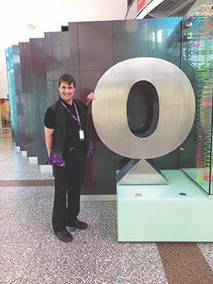

Minds Residence
Established in 2016, Questacon’s Mind in Residence (MIR) program brings experts and thinkers to Questacon to provide an intellectual spark for continual improvement and development as staff explore new ideas and pathways.
Questacon’s first MIR, Emeritus Professor Hans Bachor AM, continued to work with Questacon in 2019, leading and supporting the development of new shows and demonstrations including: Lasers can do anything, (watched by 7800 people); How Big is a Photon?, developed for the United Nations International Day of Light; and Power Without the Puff, exploring the concept of power and energy. Professor Bachor also developed a workshop for Questacon staff, volunteers and Science Circus students, Hype in Science, on how to de-bunk and critically analyse trending science debate issues.
In 2019 Questacon hosted Professor Robert DeSalle, a distinguished scientist and curator from the American Museum of Natural History. Professor DeSalle was in Australia as the 70th Anniversary Distinguished Chair for the Australian - American Fulbright Commission, and spent much of his time with Questacon’s staff. Professor DeSalle critically reviewed many of our shows and demonstrations, and presented several of his own including A Natural History of Beer, Astrobiology ‘Life in Space’ Panel Presentation and Q Lab Exclusive Workshops for Questacon’s members. His extensive experience and knowledge facilitated a number of reviews and assessments of Questacon’s activities and programs, including shows held in The Shed, Q Lab, and science demonstrations in the Japan Theatre. Professor DeSalle was active in the evaluation process of the Born or Built? exhibition, and continues to work with staff on analysis of visitor survey data that includes more than 500 000 responses to questions at the exhibition’s visitor kiosks.
During 2019 Questacon also continued to build on the work of our 2018 MIR, Professor Ross Thompson from the University of Canberra. Ross was instrumental in building connections to support our Memorandum of Understanding with the University of Canberra and we look forward to confirming collaborative research projects and future staff exchanges.
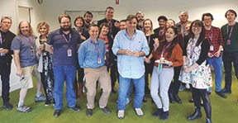
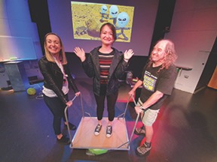

Student Training Program
Questacon provides science communication training on presentation skills, teamwork and customer service to secondary students through the Questacon Student Training Program. In 2019, 37 students from 10 Canberra senior high schools participated in the program, earning credit for their Year 12 Certificates. The students volunteered in two streams, contributing a total of 1480 hours of their time.

Trainees and Apprenticeships

Electro-Technology Trainee: Australian School Based Apprenticeship (ASBA) Program
The importance of a sound future for a trade skill-based workforce within the Australian manufacturing sector is vital to Questacon’s continued ability to produce world-class science orientated interactive exhibits. Without those skills and knowledge, we would not be able to develop and maintain the extensive collection of exhibits and associated teaching aids that make Questacon so unique.
Recognising this as a key factor for continued successful deliverables, over recent years Questacon’s Production team has developed and trialled an apprenticeship program using a combination of internal mentoring and external training facilities. The new Electro-Technology Traineeship is a continuation of this program and important to Questacon for succession planning, with the aim of passing on unique skills and knowledge required to develop and maintain Questacon’s technical capabilities both now and into the future.
Following a week-long engagement as an enthusiastic and very capable School Work Experience student, Zeke Turner was identified as a potential candidate to be engaged through the ASBA Program as an Electro-Technology Trainee. The 18-month program is funded by the Department of Industry, Science, Energy and Research through the Australian Training Company (ATC), with both organisations showing tremendous support in establishing the program.
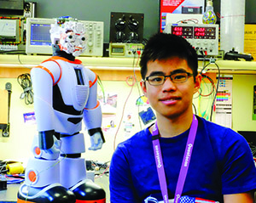

Digital Trainee
Questacon is delighted to provide traineeships to students of Indigenous background to assist their education within their chosen areas of study. This year, we welcomed Tia Rosevear, who is Questacon’s first Indigenous trainee in digital STEM engagement. She is completing a Certificate III in Media Production at CIT, Canberra, and has joined Questacon to provide mentoring and technical knowledge to help develop her technical capabilities. As part of Questacon’s Digital STEM Engagement team, Tia is upskilling in a range of hands-on activities in all aspects of media production.
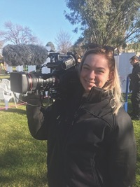
Our expertise in directing, facilitating and producing live-broadcast streaming services, and professionally created video content, provides the perfect training ground for digital trainees to be successful in future career opportunities in the industry. Questacon’s Digital team also provides technical understanding and guidance of the hardware supporting the range of systems and key components necessary to be proficient in the sector.

Staff Awards 2019
Anita Beck for her leadership and advocacy for women in STEM at Questacon, particularly with respect to the delivery of Questacon’s Women in STEM Strategy.
Ian Perry for always going above and beyond to support the Executive team, consistently delivering a flexible and reliable customer service.
Jessica Ward for her commitment to early childhood education and visitor satisfaction, developing engaging ideas and experiences for Questacon events.
Jessica Brosnan and Lawrence Menz for supporting the Smart Skills team to be more culturally inclusive and aligned with the department’s Reconciliation Action Plan.
Rachel Ball for leading the innovative, original and creative designs of the IPAA Awards.
Mark Gledhill, Ella Cameron, Vincent Robinson, Glen Goggin, Rodney Pfeiffer, Jason Judd, Tim Jacques, Chris Robertson, Frank Valeri, Russell Galloway, Angela Mitchell, Tony Lemerle, Gosia Sikorski for enhancing the visitor arrival experience through the development and implementation of a visually intriguing, mechanically complex and engaging kinetic exhibit.
Carolyn-Moore Crouch for championing an inclusive, supportive culture within her team, ensuring current and past colleagues and visitors are well taken care of.
Logan Davis and Adrian Hindes for leading the development and implementation of a new experience for mid-winter nights, creating a fun, engaging and educational activity, enhancing the visitor experience leading to a record breaking 6075 visitors.
Tammy Sattler for maintaining a positive leadership approach to deliver key outcomes for Questacon’s partnerships while managing competing priorities and deadlines in an environment with reduced human resources.
Josh Kelly for his demonstrated leadership in going above and beyond to help get the job done. Josh regularly puts his hand up for additional work on top of his own to ensure a quality outcome for Questacon.
Janet Berenyi for her advocacy for an inclusive workplace. Janet recognises the value of diversity and inclusion and works to drive positive change at Questacon, leading on-the-ground initiatives to support an inclusive workplace.
Brett Hoppenbrouwer for their advocacy of an inclusive workplace through providing support to the Science Circus students in managing chronic illness or disability. Brett has also led initiatives to make trans and non-binary participants in the Circus program feel fully supported and is working to increase awareness and understanding of these important topics across Questacon.
Eddie Aloise-King for her leadership and advocacy in supporting the Smart Skills team transition to the national presence strategy through cultivating a positive team culture to drive sustained motivation and engagement to continue to deliver high quality program outcomes during a complex time of change.
Hayley Bromham and Steph Hodge for their leadership in working collaboratively across Questacon to facilitate high quality outcomes and demonstrating the value of collaboration through achieving strong revenue and commercial outcomes.
Dr Milli Styles for going above and beyond the expectations of her role, consistently leading the team to deliver results in a complex and changing environment. Milli provides considered, strategic advice and always looks to the future.
Matthew Riches for implementing continuous improvement opportunities for Questacon’s emergency management and environmental systems. Matt’s work has seen the environmental management system integrated into business process, translating to sustainable outcomes for Questacon.

Length of Service

Questacon Staff

30 years
Sally D’Addio

20 years
Barbara Setnicar

15 years
Matthew Cracknell, Max Gambale, John Richardson, Timothy Jacques

10 years
Dr Milli Styles, Alex Chapman, Vincent Robinson, Jared Wilkins, Aiden Lynch

5 years
Jeremy Arbaut-Zaalen, Michaela Ripper, Kate Driver, Caitlin Setnicar, Mark Gledhill, Rey Hopkins, Michael Wright, Bree-Anna Masliah, Robert Parr, Henry Xu, Patrick Armstrong, Jerrod Watson, Elisha Adams, Eddie Aloise-King, Kristen Mahoney, Claire O’Connor, Sarah Simmonds

Questacon Volunteers

15 years
Luis Bonilla

10 years
Patrick Downey

5 years
Imogen Brown

Emeritus Award
Jenny Wanless
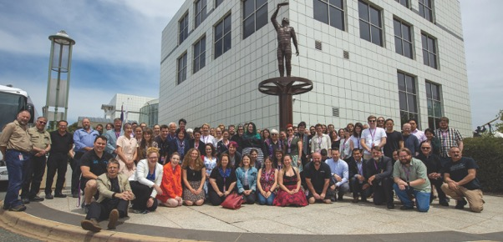

Questacon Partners and Supporters

Principal Partners

Technology Partner

Supporting Partner

Founding Partner

Collaborative Partner

Corporate Supporters



