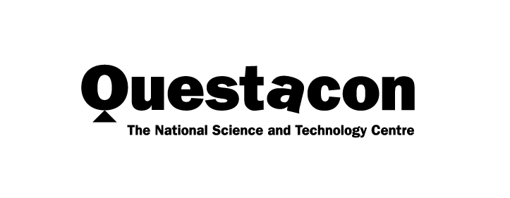

Year in Review 2020

Creativity in a Crisis

A better future for all Australians through engagement with science, technology and innovation.

Contents
Questacon Overview 1
Minister’s Introduction 3
Chairman’s Introduction 5
Director’s Update 7
Questacon Governance 9
Powered by Partnerships 16
2020 Questacon National Activities 20
Australian Space Discovery Centre: A Collaboration with the Australian Space Agency 22
Educator Programs 25
Expanding Questacon’s National Presence 28
Inspiring Australia 39
Indigenous Engagement 45
The Online Experience 49
Centre Activities 53
International Engagement 72
Questacon People 76

QR Codes
Look out for QR codes throughout this review to access extra videos, sound and images. During the COVID-19 pandemic, we used QR codes to enable contactless methods of interacting with our exhibits and to enable rich online experiences at home.
View a website
Watch a video

Questacon Overview
Our vision is for a better future for all Australians through engagement with science, technology and innovation. As Australia’s National Science and Technology Centre, Questacon plays a key role in helping to build a foundation of science knowledge and understanding in the Australian community.
Questacon operates as a specialist division of the Department of Industry, Science, Energy and Resources. As a critical asset of the Australian Government, Questacon provides programs and activities for individuals, schools and communities focused on science, technology, engineering and mathematics (STEM) to support economic development and science literacy. We engage, connect and inspire Australians with innovative learning experiences and increased awareness of the importance of STEM skills and careers. In particular, we encourage young Australians to participate in STEM disciplines to help build the workforce of the future.
We connect the nation’s complex STEM ecosystem by working with partners, collaborators, supporters, communities, researchers, industry, innovators, educators and communicators to deliver programs and activities in person and virtually to hundreds of thousands of Australians each year. As an influential voice in the global science centre community, we also promote awareness of the United Nations’ Sustainable Development Goals.
In 2020 we closed Questacon’s physical doors to the public for the first time in our history. Our Centre lay quiet. We missed welcoming half a million visitors through the doors in Canberra and the chatter of excited school groups moving through the galleries. We missed our junior scientists coming through the Mini Q exhibition and the rich discussions about machines and technology in our Born or Built? Our Robotic Future exhibition. While at The Ian Potter Foundation Technology Learning Centre, we missed the delighted laughter of teachers as they built confidence and new skills to inspire our future generations in their classrooms. We missed witnessing our enthusiastic teen entrepreneurs as they experienced their ‘light bulb’ moments, realising they could play an important role in our future world. We missed setting off on the road to present shows, programs and exhibitions to individuals, families, students and teachers in their local communities.
As with similar organisations across the world, Questacon faced challenging questions during 2020. How do you run a hands-on learning model without touching anything? How do you bring generations of families, friends, schools and communities together without congregating? However, this was a once-in-a-century opportunity to reimagine the fundamentals of what we do, and how we do it. Like millions across the globe, we turned to science to understand how to respond to, and recover from, the COVID-19 pandemic.
Our passion for science engagement, for curiosity and learning, and for realising our vision remains as true now as the day we opened our doors in 1988. We created new content and redesigned a decades-long visitor experience model, augmenting it with innovative digital engagement and virtual tours. We focused on building a better physical experience in anticipation of our visitors’ return, while staying true to our core principles – creativity, positivity, a passion for lifelong learning, but most importantly, curiosity.
As we continue our road to recovery from 2020, we will continue to engage, connect and inspire Australians of all ages. We will rebuild visitation and re-establish our national presence through progressive reintroduction of Questacon teams on the ground in regional Australia. We will help build the STEM skills needed nationally and improve teacher confidence, particularly for those teaching outside their discipline. We will continue to adapt our programs and activities to meet the needs of students, teachers, families and communities of Australia, inspiring curiosity about the diverse and exciting world of science, technology and innovation.
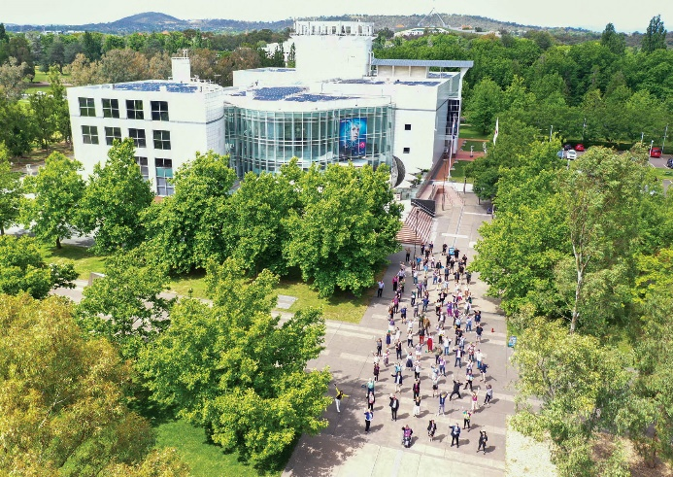

Minister’s Introduction
In our increasingly globalised and digital world, skills and knowledge in STEM are crucial for supporting innovation and economic growth, and for our health and wellbeing. The events of 2020 emphasised the importance of STEM-skilled young people to build our future workforce. Questacon plays a key role in inspiring the next generation in STEM, fuelling imagination and curiosity in young people and helping improve STEM teacher skills and confidence.
Problem-solving, design, innovation and critical thinking have been central to my career. I would like to see more young people studying STEM subjects and pursuing the diverse opportunities that are available. It is so important to foster creativity and hands-on learning in our children, and spark interest in the world around them from an early age.
Despite being closed to the public for several months in 2020 due to bushfire smoke and COVID-19, Questacon continued to inspire and engage communities across Australia through digital offerings and activities. Questacon at Home helped a good number of parents in lockdown, through online worksheets, activites and videos to promote STEM learning at home. I am grateful to the Questacon staff who stepped up to meet national needs by temporarily transferring to Services Australia.
The gradual and safe return of visitors to Questacon following the Centre’s closure due to COVID-19, and the re-establishment of Questacon’s national activities in line with physical distancing and public health guidelines, will be a priority for 2021. The Questacon Mission to Mars guided tour experience was a creative way to blend exhibits, demonstrations and theatrical performance allowing small groups of visitors to safely have a Questacon experience as a first step on the post COVID-19 road to recovery.
Energy, cyber security and space are national priorities and it is pleasing to see Questacon activity in these areas. In partnerhsip with INPEX, Questacon is developing a national energy literacy program that aims to increase awareness and understanding of energy topics in the community and engage young Australians in conversations about energy. The program will promote awareness of the United Nations’ Sustainable Development Goals, particularly SDG 7: Affordable and clean energy.
As part of Australia’s Cyber Security Strategy 2020, the Australian Government is investing $14.9 million to enable Questacon to develop and deliver programs and activities to support and implement STEM learning in classrooms and to prepare primary, secondary and tertiary students for careers in cyber security.
I was delighted to launch the Australian Space Discovery Centre project, a partnership between the Australian Space Agency and Questacon. This centre will act as a focus for a national endeavour in building a strong space industry for Australia. It will highlight the diverse career opportunities in the space sector. The Mission Control Centre will provide facilities for businesses and researchers to control satellite and space missions.
Skills in STEM have never been more critical for Australia’s future. These skills will propel us forward as we rebuild our economy and recover from the impact of COVID-19. In so many ways, even in the most challenging of years, Questacon has continued to help young people reach for the stars.
The Hon Minister Karen Andrews MP
Minister for Industry, Science
and Technology
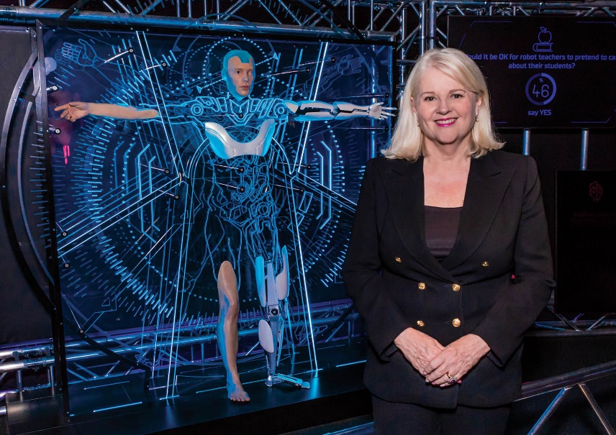

Chairman’s Introduction
Questacon’s operating environment during 2020 was significantly different to anything encountered before. With the support of the Department of Industry, Science, Energy and Resources, and Questacon’s excellent advisors, partners and collaborators, Questacon demonstrated strength, perseverance and creativity in moving through the various challenges from bushfire smoke, hailstorm damage and COVID-19 closure.
I would like to acknowledge the department’s significant advice and support to Questacon in all areas of business, legal, financial and safety operations. This assistance enabled Questacon to continue offering inspiring STEM activities during the year, including a COVID-safe return of visitors. The wider department has been critical in supporting the nation through the pandemic, providing essential thinking and planning to maintain crucial manufacturing, health, social, and technology research and industry services for Australia. I would like to thank Questacon staff who, through secondment arrangements, supported the work of Services Australia at a time of national need.
The year saw a significant drop in Questacon’s visitor numbers and travel restrictions curtailed outreach activities. Questacon fast-tracked its digital engagement strategy, moving to online program and workshop delivery to reach individuals and communities across Australia. Additionally, the implementation of the National Presence Strategy has seen locally relevant collaborations established, to address community STEM engagement needs.
Communication, connection, inclusivity and diversity are so important in Questacon’s work. In 2020 there was a particular focus on developing Questacon’s Indigenous Engagement Strategy, aligning with the targets in the department’s Reconciliation Action Plan. Questacon acknowledges the enormous value of the millennia-old knowledge and practice of science by Aboriginal and Torres Strait Islander peoples, and the work of Indigenous and non-Indigenous leaders and scientists to develop two-way knowledge systems. Questacon’s Indigenous Engagement Strategy will strengthen the participation of Aboriginal and Torres Strait Islander peoples in Questacon’s workforce and activities.
While the pandemic required many adjustments, I am greatly appreciative of Questacon’s efforts to continue to offer high quality STEM programs and activities throughout 2020. I would like to thank Questacon’s Director, Professor Graham Durant AM, Deputy Directors Ms Kate Driver and Dr Bobby Cerini, the leadership team, staff and volunteers for their continued enthusiasm and commitment to STEM learning during such a challenging and uncertain year.
Questacon’s role in inspiring the next generation to pursue careers in science and technology was highlighted in 2020, as the need for a strong STEM-skilled workforce continued to grow. I am greatly appreciative of The Q Australia Foundation Chair and Deputy Chair of the Questacon Advisory Council, Mr Eddie Kutner AM, for his continued work to build philanthropic support for Questacon through The Q Australia Foundation. I would also like to thank Questacon’s enabling and knowledge partners for their contributions and support throughout 2020.
I would like to extend my gratitude to the Members of Council, Mr Eddie Kutner AM, Dr Gregory Clark AC, Professor Alan Duffy, Dr Ken Dutton-Regester, Ms Jamila Gordon, Professor Elanor Huntington and Ms Elizabeth Kelly PSM, for their valued recommendations and support during the year.
The Hon Karen Andrews MP, Ministerfor Industry, Science and Technology
is a wonderful role model and advocate for gender equality in STEM. I would like to take this opportunity to acknowledge Minister Andrews’s passion and commitment to increasing the participation of women in careers in STEM.
In response to COVID-19 and with so many important science and technology issues, Questacon has never been a more important national asset for Australians, as a bridge between the community and economic recovery.
Mr Leon Kempler AM
Chairman, Questacon Advisory Council
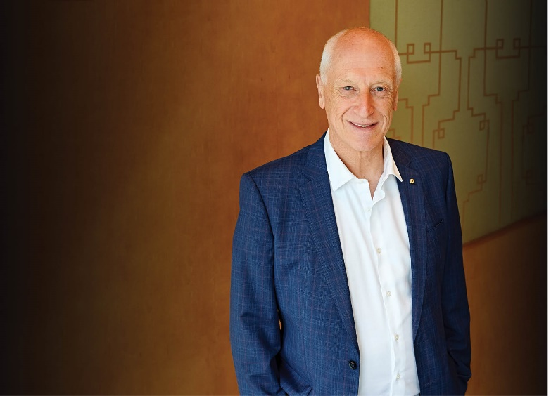

Director’s Update
There is no doubt 2020 was a tough year for Australia and the world but Questacon staff stood up and stood together to demonstrate creativity in a crisis. In the end we had a good ‘bad’ year.
Questacon was significantly impacted by several events. On 1 January 2020, smoke from the devastating summer bushfires caused Canberra’s air quality to plummet, forcing the Centre’s closure for 5 and a half days. Since opening in 1988, Questacon had only ever closed to visitors on Christmas Day. The teacher professional learning experience, STEM X Academy, and the National Questacon Invention Convention had to be postponed. On the days we were open, free entry was offered to holidaymakers displaced by the south coast bushfires, a gesture gratefully received by approximately 1,000 visitors.
On 20 January, a fierce hailstorm caused extensive damage to Questacon’s building, outdoor exhibits, and cars belonging to staff, volunteers and visitors. As we were recovering from the hailstorm, large bushfires came close to the city, resulting in a tense couple of weeks for staff and visitors alike. The arrival of COVID-19 changed everything, requiring pandemic planning and new safety protocols. As the virus spread throughout Australia, school group visits were cancelled, we ceased program delivery in regional areas and Questacon closed to the public on 20 March.
With schools closed and families being told to stay home, we promoted new and existing digital content through Questacon at Home on the website and replaced face-to-face activities with virtual offerings. Many casual staff stepped up to provide surge support for the Australian Government’s COVID-19 response teams. Staff adjusted to working from home and learned how to navigate the new world of online meetings. We continued to collaborate with other science centres in the Asia Pacific region and museums across Australia and New Zealand, making use of digital technologies to build connections. These networks were invaluable, as we shared insights and knowledge to deal with the unpredictable situation we were all faced with.
Even as we forged a path through those extraordinary times, we began planning our road to recovery. Our Questacon Mission to Mars guided tours were developed to offer a safe theatrical experience enabling the Centre to reopen to the public in July. By December, most galleries had re-opened with modifications to meet COVID safety requirements, and visitor numbers started to grow in line with public health restrictions. A national award for ‘Creativity in a Crisis’ acknowledged a strong response during a difficult year when Questacon staff displayed resilience, teamwork and creativity.
Towards the end of 2020 it was pleasing to note that former Questacon Advisory Council Member Dr Cathy Foley AO was appointed to the role of Australia’s Chief Scientist. Advice and support from Council throughout the year has been greatly appreciated. The valuable support from The Q Australia Foundation and various partners has enabled Questacon to scale up activities and deliver greater outcomes. The collegiality of national institution partners has been vital to navigating the complexities of such an unprecedented year.
As Questacon Director, I am fortunate to work with such a passionate, hard-working and diverse group of staff with amazing abilities, skills, creativity and boundless enthusiasm. Together we will continue to strongly support the development of STEM skills for Australia’s future workforce, contributing to a strong economy. We are looking forward to 2021 with a spirit of optimism and will bounce back strongly after a protracted road to recovery.
Professor Graham Durant AM
Director, Questacon
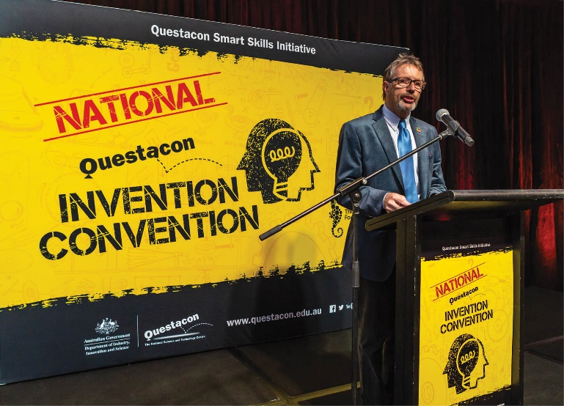

Questacon Governance

The Questacon Advisory Council
Questacon is supported by an Advisory Council appointed by the Prime Minister on advice from the Portfolio Minister. The Council provides a crucial connection to the wider STEM and industry communities, to support and advocate Questacon’s remit, and to advise Questacon’s Director and department officers. Membership is drawn from eminent scientists, academics, business leaders and philanthropists who all share a passion for Questacon’s vision and mission, and to serve as a source of independent advice and to raise the profile and brand of Questacon.
Following the declaration of the COVID-19 pandemic, the Council met virtually each month to provide strategic advice to Questacon. In 2020 the Council increased Questacon’s access to, and work with, sectors including space, data and cyber, artificial intelligence (AI), technology advancement, engineering and STEM engagement. The Council supported Questacon through the evolving digital landscape, promoting and advocating for Questacon’s national presence through new digital outreach activities.
Throughout 2020, at the invitation of the Chair and the Questacon Director, the Council was also joined by advisors and observers including: Ms Elizabeth Kelly PSM, Deputy Secretary at the Department of Industry, Science, Energy and Resources; Ms Margaret Leggett, Assistant Secretary at the Department of Education, Skills and Employment; and Dr Cathy Foley AO, Chief Scientist at CSIRO and Australia’s Chief Scientist (from January 2021).
Council Member Ms Jamila Gordon was the recipient of the 2020 NSW Pearcey Entrepreneur of the Year. The Award recognises established and successful tech entrepreneurs, who are top achievers in key competencies such as analysed risk taking, making a powerful impact, and being an inspiration to others. This Award recognised Jamila as one of Australia’s most respected digital and technology leaders. Jamila’s expertise in ethical and environmentally sustainable IT and technology will support Questacon’s emerging cyber program.
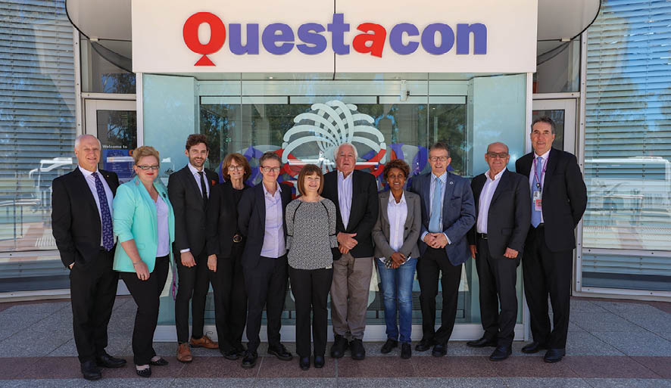
Figure 1: Left to right: Mr Leon Kempler AM, Ms Kate Driver, Dr Ken Dutton-Regester, Dr Cathy Foley AO, Professor Elanor Huntington, Ms Margaret Leggett, Dr Gregory Clark AC, Ms Jamila Gordon, Professor Graham Durant AM, Mr Eddie Kutner AM, and Dr Rod Kennett (November, 2019).

2020 reflections from our council
Venture capitalist Mr Marc Andreessen correctly predicted back in 2011, that ‘software would eat the world’ and that everything that could be digitised, would be digitised. The same thing can be said about AI today; everything that can have AI algorithms applied to it, will.
As CEO and Founder of Lumachain, I recognise that AI is the core mechanism to ensuring food products are ethically produced, opening global markets to producers in a developing world. With most of our customers’ facilities closed during the COVID-19 lockdown, we used the opportunity to triple-down on product development, making sure our platform was ‘ready for prime-time’ once the world reopened. As the economy is now coming back to life, we have seen enormous demand in AI applications, in areas ranging from social distancing to food tracking, with that trend only set to accelerate. AI right now is like the start of the mobile phone trend in 2007 when Apple first released the iPhone; its impact on the world is just starting. I expect AI to drive global innovation for the next decade, with 2020 being a pivotal moment on that journey.
Ms Jamila Gordan, Questacon Council Member and CEO and Founder of Lumachain

Standing at the start of 2021 and looking back, it’s easy to forget
that 2020 started in a haze of smoke, anxiety and devastation as Australia’s ‘Black Summer’ entered its most ferocious phase. Destructive hailstorms and then COVID-19 quickly followed. It might be easy to write 2020 as a year best off forgotten, but I think that we can do better than that.
The year also saw the rise, or perhaps return, of the expert in Australia. Questacon can claim its share in laying the foundations for that. Every year, tens of thousands of young people and their parents walk through the doors of Questacon. Every year, they encounter the idea that we live in a world that is understandable, and that we gain some measure of agency through understanding it.
Well, almost every year. Questacon had to shut its doors and quickly pivot to online engagement. We too have had our experiential learning moment. We’ve learnt that there is great power in unlocking time and space, and we also were reminded that humans crave embodied experiences.
As we move into 2021, we need to work out how many online experiences to carry forward into the future. And we should reflect on what seeds Questacon needs to lay so that Australians continue to engage with science and technology. I’m confident that Questacon and its people will continue to rise to the challenge.
Professor Elanor Huntington, Questacon Council Member, and Dean of the College of Engineering and Computer Science at The Australian National University
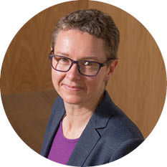
As it was, 2020 was already shaping up to be a special year for my family. Then a global pandemic hit. Having my first child just prior to a pandemic was both challenging and inspiring.
In March, the pandemic had just started to accelerate across the country, with our new family excited for a trip to Tasmania. There was a sense of uneasiness and anxiety among the other passengers, as we prepared to depart. The world as we knew it had changed forever. The return trip was difficult, as each state’s circumstances and restrictions continued to evolve. Although I was not working full time, COVID-19 presented some challenges in my ability to continue producing and collaborating on material with the SBS. Transitioning to remote and virtual working enabled me to develop my presentation and communication skills, and spend quality time engaging in STEM subjects.
As the months passed by, the fear of the unknown was replaced with feelings of awe at our society’s ability to come together, organise, invent, adapt and overcome the external threat. The welfare of the community was put ahead of individual interests. Best of all, I had a strong sense of pride at seeing the general public’s growing trust in science and scientists.
Ms Lily Serna, Questacon Council Member, and SBS Mathematician-Science Communicator

COVID-19 has been a disruption beyond anything I have experienced in my life, and I know I’m not alone!
Although a small example, I am fortunate to receive frequent opportunities to speak about breaking scientific discoveries on TV, which presented a challenge early on in the pandemic as studios closed their doors almost immediately. The answer? Very 2020 DIY… a lot of research, and a little investment into a simple system for LED lighting, a lapel mic for audio, and my phone as a camera, which turned a corner of my garage into my own studio.
This was then used as the backdrop as I hosted this year’s Prime Minister’s Prizes for Science, entirely virtually, and with a green-screen draped over my washing machine. This DIY solution didn’t take away from the pride I felt in being a part of the celebration of science, industry, and the professionals who have made possible an evidence-informed and technologically-supported response to this pandemic.
The isolation I felt in lockdown in Melbourne was helped by this connection to the outside world by sustaining my public communication efforts. To all of those who watched these appearances (and certainly those who contacted me after!) I really cannot thank you enough. This year of enforced isolation has made me value ever more the interactions that my role at the Royal Institution of Australia affords me.
Professor Alan Duffy, Questacon Council Member, and Lead Scientist of The Royal Institute of Australia


The Q Australia Foundation

I have been extremely pleased to continue my work as Chair of The Q Australia Foundation in 2020. The Foundation has ambitious goals to support projects with purpose, with a vision of advancing science education and engagement in Australia.
The Q Australia Foundation is unified by a Board of Directors with big ambitions to make a difference. It does this by seeking and gathering philanthropic support for Questacon, to create smart and sustainable science, technology, engineering and mathematic opportunities for young Australians and the influencers in their lives, in order to foster creativity and critical thinking skills needed for the next generation.
The Foundation recognises Questacon’s proven record of delivering exceptional, informal science engagement programs, exhibitions and experiences to thousands of Australians, locally, nationally and internationally. As a result, we are proud to continue supporting Questacon to deliver programs that will grow in value and impact.
The expertise and generosity of our Board of Directors, and the backing of our networks, ensures the Foundation is well on its way to achieve its vision. In October 2020, we welcomed Questacon Director, Professor Graham Durant and Deputy Director and General Manager, Ms Kate Driver to observe and contribute to our Board meeting, wherein the Board reaffirmed its commitment for ongoing support for Questacon.
The Q Australia Foundation is thrilled to continue its work to build networks and philanthropic support for Questacon to ensure it continues to spark creativity and innovation in all young Australians for many years into the future.
Mr Eddie Kutner AM
Chairman, The Q Australia Foundation
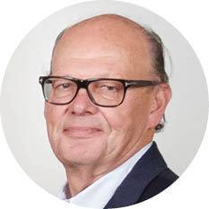
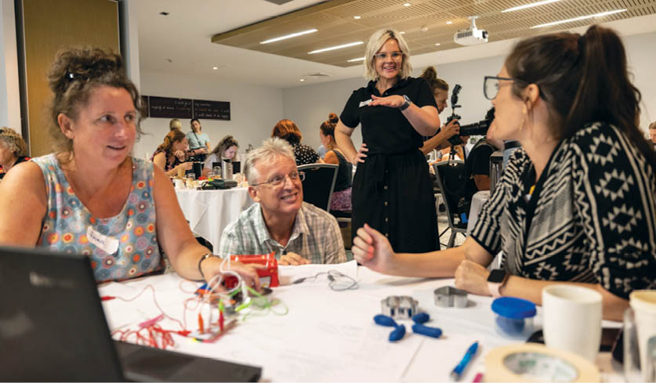
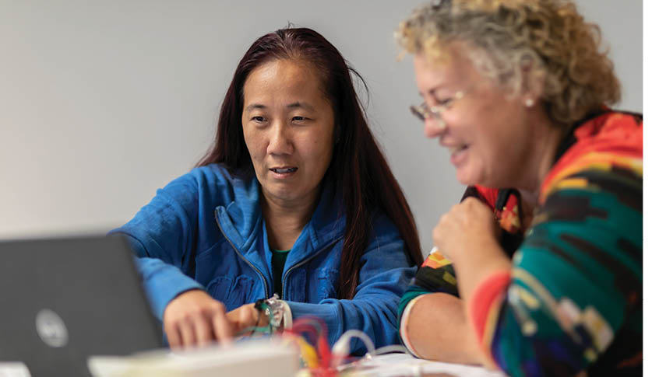
Figure 2: Top and bottom: Educators engaging in Questacon professional learning programs

Powered by Partnerships

Principal Partner

Shell is Questacon’s longest standing corporate partner, having worked with us for 35 years to deliver the Shell Questacon Science Circus across regional and remote Australia with support from The Australian National University. This program is one of the world’s longest running science education and learning programs, engaging and inspiring young people and their communities in STEM through science shows, workshops and teacher professional development opportunities.
This partnership has allowed the Shell Questacon Science Circus to flourish. The program has reached more than 2.5 million Australians in more than 600 towns and 110 remote Indigenous communities over its lifetime. As Principal Partner, Shell’s funding has supported the growth and development of the program, as well as supporting Questacon’s coordination and bookings teams to ensure the students are able to travel to all metro, remote and regional areas of Australia.
In 2021, Shell and Questacon will continue their partnership with a new program, delivering STEM engagement activities in regional communities in the Northern Territory and Queensland to build on local capability and capacity.

Principal Partner

The Australian Defence Force and Questacon entered into a partnership to deliver a professional learning program for primary school teachers, Engineering is Elementary. This innovative program was developed by EiE, a division of the Museum of Science, Boston, to equip teachers with tools and skills to enable the delivery of fun, interactive and engaging STEM content in the classroom. Australia’s future as a knowledge economy depends on emerging generations being engaged with foundation skills in STEM. By creating awareness of the application of STEM to real world problems, Engineering is Elementary aims to inspire students to consider future careers in a range of STEM fields.
With the support of The Australian Defence Force as Principal Partner, Questacon will deliver Engineering is Elementary workshops to 1,000 primary school teachers in approximately 500 schools across Australia over 3 years from 2019 to 2022. Despite the challenges of 2020, we connected with 478 teachers from 273 schools across every state and territory, using digital technologies to deliver workshops when travel was not possible. Teachers are provided with high quality and accessible teaching resources and materials, together with online support, to enable them to deliver the units in their classrooms.

Principal Partner
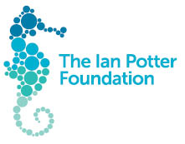
The Ian Potter Foundation has been a Principal Partner of Questacon since 2014. The flagship offering, the Questacon Smart Skills Initiative, has inspired and empowered thousands of Australians through a suite of programs. We have reached more than 72,000 people across the nation through exciting, hands-on challenges, projects and workshops. Innovation, technology, engineering and design thinking are at the heart of the Questacon Smart Skills Initiative. The past year was no exception as we adapted our program delivery to engage young people during the revised virtual National Questacon Invention Convention in April, held as a digital event.
As we approached the end of this partnership, with the last activity being a successful final National Questacon Invention Convention in January 2021, the legacy of this $7.8 million grant will remain. Questacon’s second facility will continue to be known as The Ian Potter Foundation Technology Learning Centre, in recognition of the generous grant. This building in Deakin, Canberra, will continue to be the hub for our education and learning activities for Australian students and teachers, along with exhibition development and production.

Founding Partner

The Australian National University, through The Australian National Centre for the Public Awareness of Science, is the Founding Partner of the Shell Questacon Science Circus, delivered for 35 years in collaboration with Questacon and Shell.
While completing a Master of Science Communication Outreach, up to 16 graduate students deliver the Shell Questacon Science Circus program to schools and communities across Australia. The practical fieldwork component of the course allows students to develop skills in science communication with the public, the media and digital platforms, along with science communication project design and delivery.
Having worked together since 1985, Questacon and The Australian National University have seen 488 students graduate from this program and go on to contribute to the national and international capacity of science communication professionals.

Supporting Partner

In 2019, INPEX and Questacon began a four-year partnership to engage young Australians in a conversation about energy, how to use energy, and how crucial energy will be as a resource for Australia in the future. Through this partnership, Questacon and INPEX aim to raise awareness of energy-related topics and increase energy literacy within Australian and Japanese communities. This partnership will deliver a suite of exciting and engaging activities including energy shows at Questacon, the Young Persons’ Energy Dialogue youth forum, Questacon STEM Futures teacher workshops, and a Science Circus tour to Japan with new energy exhibits in 2022.
Through these events and programs, Questacon and INPEX will champion the United Nations’ Sustainable Development Goals, specifically SDG 7: Affordable and clean energy, to highlight the sustainable development challenges faced by the global community as we head towards 2030.

Supporting ARC Centres of Excellence
Questacon is a partner in 2 Australian Research Council (ARC) Centres of Excellence – The ARC Centre of Excellence for Transformative Meta-Optical Systems and The ARC Centre of Excellence for Innovations in Peptide and Protein Science. These new partners are excited to work with Questacon to improve public awareness and impact of their research. Questacon staff will provide science communication training and support to researchers and students. Reciprocally, Questacon staff will participate in cutting edge research, and work directly with researchers to create exciting new STEM stories.

2020 Questacon National Activities
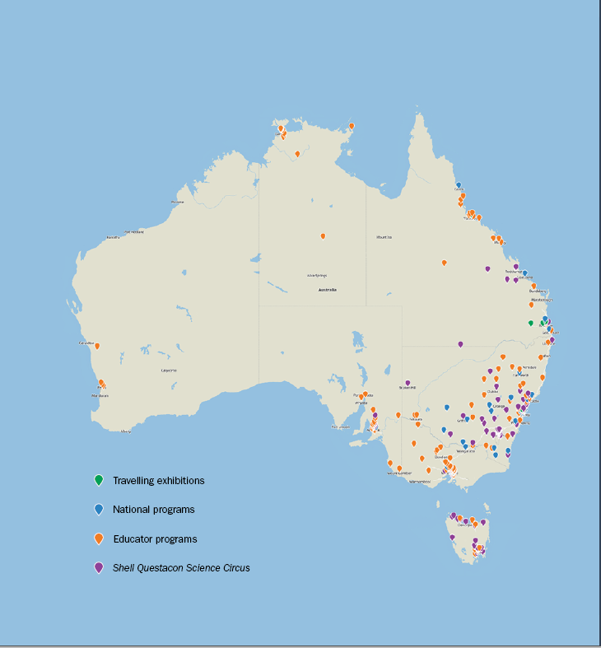
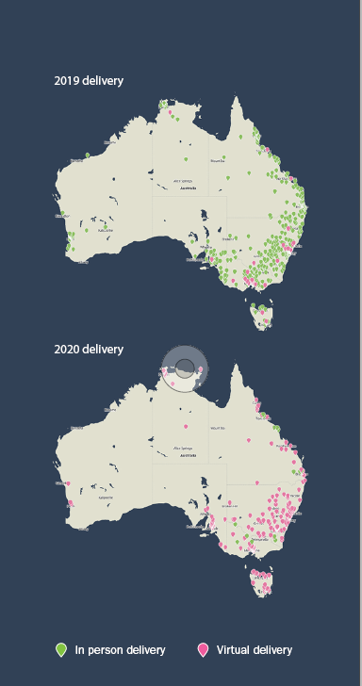

Australian Space Discovery Centre: A Collaboration with the Australian Space Agency

In 2020, Questacon continued to collaborate with the Australian Space Agency to deliver the Australian Space Discovery Centre in Adelaide. As a division of the Department of Industry, Science, Energy and Resources, the Australian Space Agency will predominantly operate from the McEwin Building located in Adelaide’s innovation precinct, Lot Fourteen. It will be supported by staff in Canberra to research, explore and inspire the Australian space sector.
In December 2020, Dr Megan Clark AC, Head of the Australian Space Agency, stood down from the top job to take up the role of Chair of the Australian Space Agency Advisory Board. In a joint statement, Prime Minister Scott Morrison MP and Minister for Industry, Science and Technology, the Hon Karen Andrews MP announced that Mr Enrico Palermo would become the new Head of the Agency from January 2021.
The Australian Space Discovery Centre is a joint government-funded project through the South Australian Space Industry Centre and the South Australian Government. It will be Australia’s first interactive space centre, which will also house a state-of-the-art Mission Control Centre with a live link to the International Space Station. Visitors will engage with the latest innovations in space technologies and expand their understanding of Australia’s role in national and global space activities and missions.
The Centre, opening in the first quarter of 2021, will encompass space learning experiences in the Space Gallery using interactive exhibits and programs. The Australian Space Discovery Centre will also house a Mission Control theatre with views into the Responsive Space Operational Centre operated by Saber Astronautics, a careers and information hub, and the Endeavour Room. The Centre will inspire the next generation of the workforce with stories of innovation, curiosity and technology.
The exhibition within the Centre is being developed from concept stage, through 2D and 3D design and construction, by Questacon. Development of the exhibition was based on the national civil space priority areas in consultation with the Australian Space Agency. Knowledge Partners from the space and science fields provided valuable input and expertise throughout the exhibition development process.
The exhibition will be divided into 4 zones, each exploring a different realm of Australia’s activities in the space sector. Visitors will explore Australia’s work in propulsion and aerospace technologies, discover the challenges of operating in orbit, and learn about Australian innovations that take advantage of the opportunities space presents. The exhibition will also explore how Australia’s expertise in remote operations will benefit the next phase of human spaceflight and how Australia’s location and expertise is advantageous.
Figure 3: Below images: Development of the exhibition at the Australian Space Discovery Centre in Adelaide.
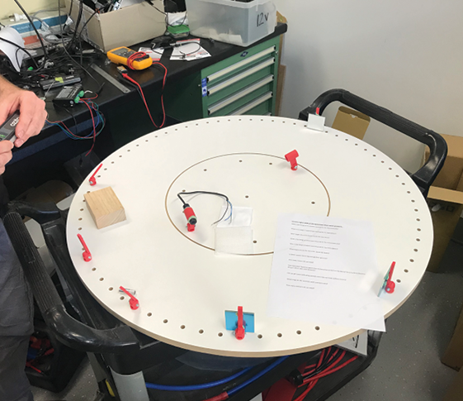
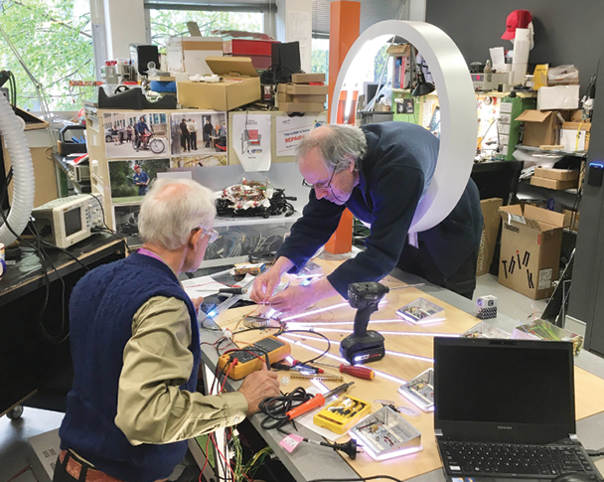
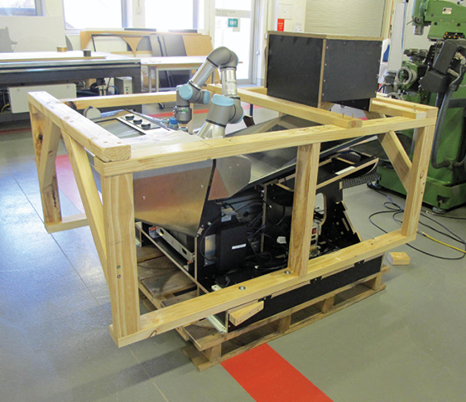
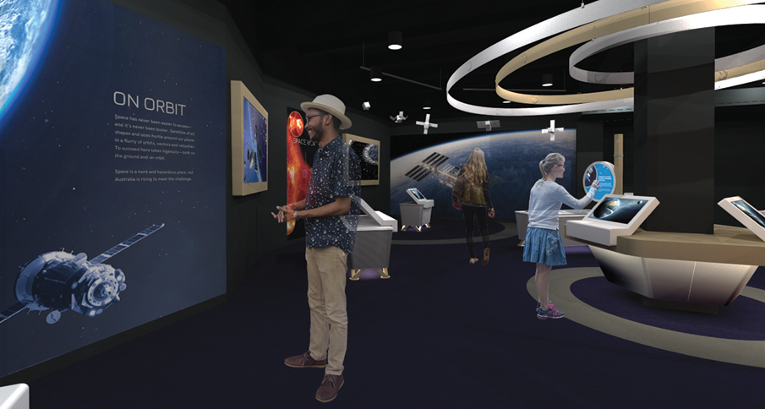
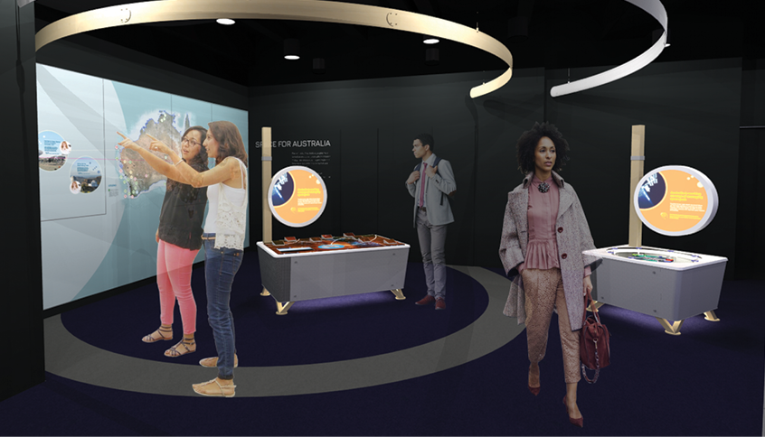

Educator Programs
Throughout a year of uncertainty, Questacon developed and delivered professional learning experiences for teachers across Australia, including through the STEM X Academy program and Engineering is Elementary.
Early in the year, the STEM X Academy program, which is delivered collaboratively with CSIRO and the Australian Science Teachers Association, was interrupted by the encroaching bushfires. We adapted and redeveloped the program to deliver impactful sessions virtually. The STEM X Academy program equips primary and secondary teachers with tools to plan and embed a STEM culture in their schools.
Engineering is Elementary is a rigorously researched teacher professional development program that helps build teacher confidence and capability in delivering STEM education. This highly successful program was developed by EiE, a division of the Museum of Science, Boston. By implementing a philosophy of ‘learning by doing’, the program takes a ‘hands-on, minds-on’ approach to STEM education for primary school teachers of all levels of experience. Teachers work through practical inquiry and design challenges while engaging in professional discussions about their application in the classroom.
With the support of Principal Partner, The Australian Defence Force, in 2020 Questacon delivered Engineering is Elementary to 478 educators in all states and territories through 22 digital and 8 face-to-face workshops. Face-to-face touring began in January with 2-day workshops delivered in Callala Bay, Mt Isa, Townsville and Mackay. The touring schedule was interrupted by the COVID-19 pandemic, with digital workshops commencing in May. Since then, we have delivered 22 digital workshop programs, consisting of 3 90-minute sessions each, and have influenced the STEM education of thousands of young Australians.
The overwhelming response from teachers across Australia has been extremely positive. Many teachers implemented Engineering is Elementary units of work in their classrooms almost immediately, using the resource kits provided at the end of each workshop. Digital delivery also allowed whole-school participation, furthering our drive to inspire whole-school change regarding STEM and inquiry learning in Australian schools.
We also delivered workshops to pre-service educators from the University of Canberra, Central Queensland University and the 2021 cohort of the Teach for Australia program, building their capacity to be transformative STEM educators.
In 2021, we will continue to build on the knowledge gained from these experiences, developing even more multi-disciplinary units of work, new programs and workshops to roll out across Australia. Digital delivery continues to support professional learning for teachers in remote schools not typically serviced by professional learning providers.
Every person I know working in science and industry always tells the story of the teacher that was their inspiration. We need more of these teachers.
Dr Cathy Foley AO,
2021 Chief Scientist of Australia
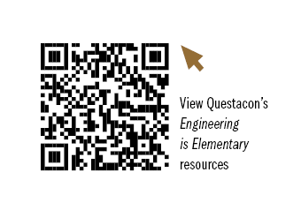
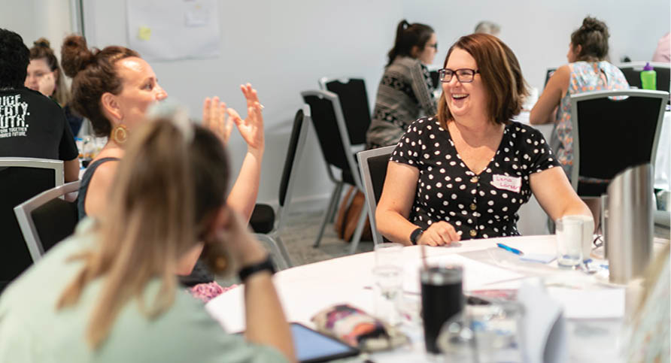
Figure 4: Educators engaging in hands-on professional learning programs
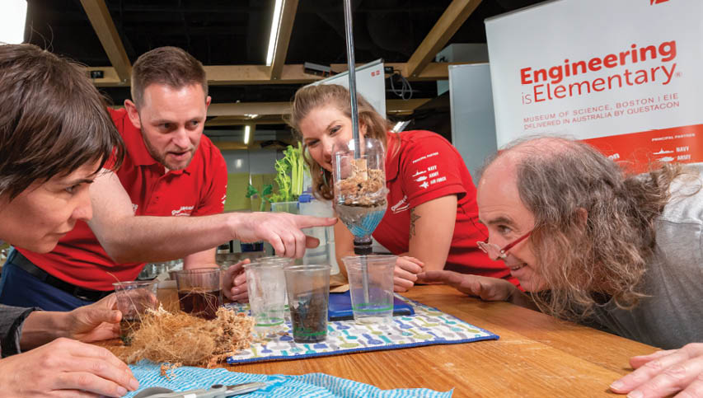
Figure 5: Educators engaging in hands-on professional learning programs
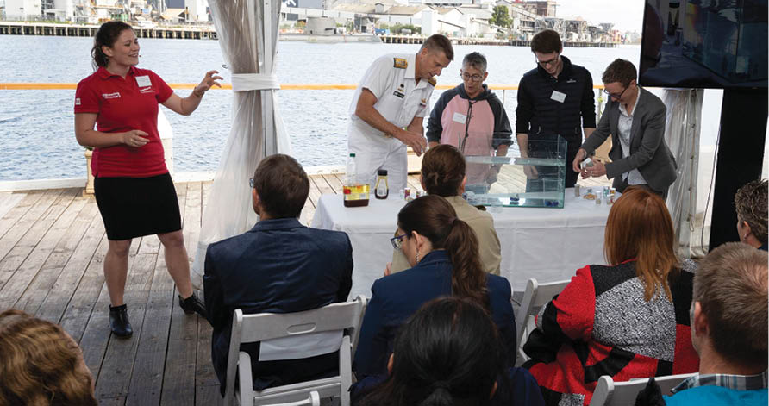
Figure 6: Engineering is Elementary partnership and program launch event (February, 2020).
I loved the clear explanations about how to do the activity and then how to apply it in a classroom with students at different levels.
Primary teacher, Australian Capital Territory
The importance of critical thinking and collaborating with teams to redesign and problem solve is something that I need to implement in the classroom.
Primary teacher, New South Wales

Expanding Questacon’s National Presence
Despite 2020 being a year we could not have planned for, it positioned us well to launch Questacon’s National Presence Strategy 2020–30. The new Strategy was developed with assistance of then Lieutenant Colonel Jen Harris of the Australian Army on an official posting at Questacon. The Strategy represents an evolution in our 32-year approach to science communication, STEM engagement and learning as we strive to continue to meet the needs of the Australian people. The Strategy guides our national activities with a focus on increased collaboration, connection and capacity-building. It introduces a sustained, place-based and cooperative approach to enable us to make a greater contribution to STEM capability in specific regions of identified need and help achieve enduring impact. This will better position the work of our Centres and programs in response to Australia’s evolving STEM engagement landscape.
The goal is to maintain and extend our national reach while cultivating a network of locally led, STEM learning ecosystems that strengthen the future workforce. An integrated approach to delivery involves working collaboratively internally and across government, and alongside other STEM organisations, to exchange knowledge, share skills and deliver activities.
The Strategy covers activities including the Science Circus, Questacon Invention Conventions, workshops on AI, virtual excursions and professional learning workshops for educators.
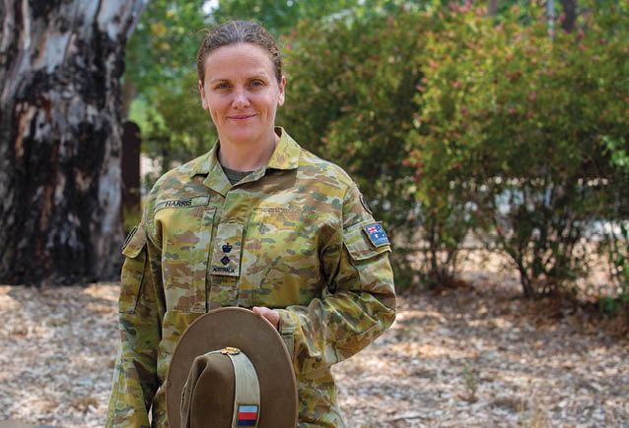
Figure 7: Former Lieutenant Colonel Jen Harris of the Australian Army
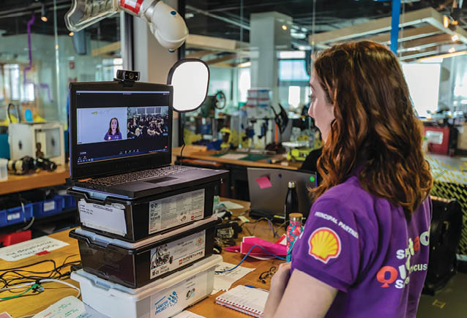
Figure 8: 2020 Science Circus presenter delivering a virtual excursion.

AI Dialogue workshop
In 2020 we developed a novel way to engage high school audiences, with a dialogue workshop allowing students to discuss the morality and ethics of a STEM-related topic. Drawing on research and provocations developed for Questacon’s Born or Built? Our Robotic Future exhibition, we created a dialogue workshop to discuss AI. A pilot workshop was held with 372 students and 21 teachers from 9 secondary schools from the Australian Capital Territory. The aim was for students to share their fears, excitement or uncertainty about AI, build critical thinking skills, and give them a space to formulate their attitude and values to evaluate new information. Dialogue workshops allow students to engage in uncommon topics such as AI, and provide the opportunity to demonstrate direct relevance to their own lives. The discussion is driven by their interests, experiences and feelings, using their own language and humour.
In early feedback, 93% of students agreed the workshop was relevant and interesting to them, and 94% said the workshop made them think about their opinions in greater depth. An enhanced program for more dialogue workshops will be launched nationally from 2021.

National Questacon Invention Convention
Each year, the National Questacon Invention Convention invites 25 young innovators to the Maker Space at The Ian Potter Foundation Technology Learning Centre, to meet some of Australia’s brightest minds and entrepreneurs, as part of a week-long residential experience. Alumni from previous National Invention Conventions are invited back to support the group as ambassadors and mentors. Ambassadors also learn leadership skills, which they can take back and champion in their home region. When it became clear in January 2020 that we would be unable to host the annual residential program, the program was redesigned for a digital delivery.
I enjoyed thinking about something that I’d never thought about before, and listening to opinions I hadn’t heard of. It was very interesting and broadened my perspective.
Student feedback,
2020 Dialogue Workshop
The most important thing I gained from being an ambassador was the leadership skills that came with helping the delegates and learning about facilitation. It was also incredibly valuable to learn how to be a role model and facilitate in unusual and unfamiliar situations.
Participant feedback, 2020 National Questacon Invention Convention
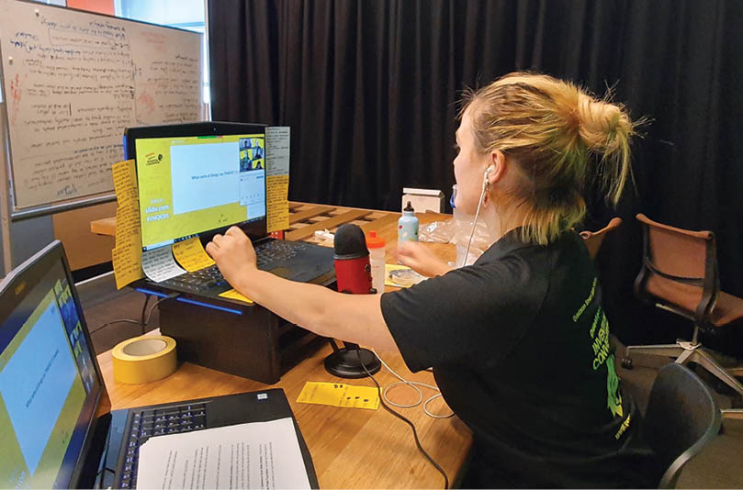
Figure 9: National Questacon Invention Convention facilitator, Ms Bec Szabadai, supporting participants virtually.

Shell Questacon Science Circus
For the past 35 years, the Shell Questacon Science Circus has travelled throughout regional and remote Australia, bringing science to local communities.
The Science Circus inspires and engages individuals, families and schools through dynamic science shows, interactive public exhibitions, hands-on school workshops, and professional development activities for teachers.
This program also provides a distinct educational experience for students of The Australian National University’s Master of Science Communication Outreach. Each year, successful applicants are selected, through a rigorous process, to form the Science Circus to complete their degree. Students gain skills in scientific presentation, communicating science with the public, exhibition design, media relations, and digital content creation and delivery, and have the opportunity to work in regional and remote areas around Australia.
In 2020, the program was forced to cancel its first series of tours, one week before departure. Thirteen enthusiastic presenters swiftly reimagined what the Science Circus could offer. An all-digital tour was created and over the year, more than 6,200 students took part in a Science Circus virtual excursion.
This included the tried and tested Foldable Flight workshop (where students design paper aeroplanes) as well as new workshops designed by the presenters. As restrictions eased in the Australian Capital Territory and New South Wales, the Science Circus returned to local schools, bringing Questacon’s trademark, high-energy and high-impact science shows to over 14,500 students, in 51 schools in the region.
In 2020, we celebrated a milestone as Australia’s flagship science outreach program, the Shell Questacon Science Circus, reached 35 continuous years of operation. The end of 2020 also saw a significant change for the program, with the involvement of Shell as partner of the Science Circus coming to an end after 35 years.
While the Science Circus will continue, 2020 provided an opportunity to examine how lessons learnt from such an unpredictable year, including trialling new digital platforms and fresh ways of working, can strengthen engagement with communities across Australia in 2021 and beyond.
Science communication is not limited by how far you can travel, only how far your imagination can reach.
Jin Kato, 2020 Science Circus presenter
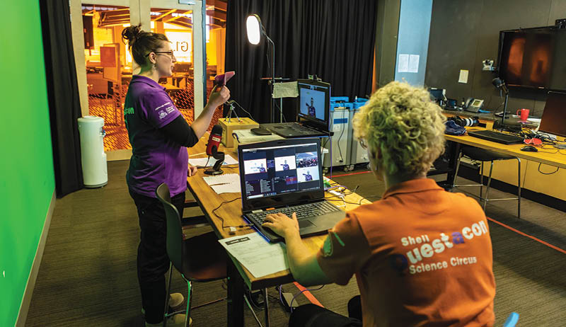
Figure 10: 2020 Science Circus presenters delivering virtual excursions

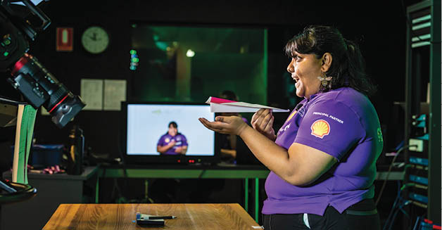
Figure 11: 2020 Science Circus presenters delivering virtual excursions
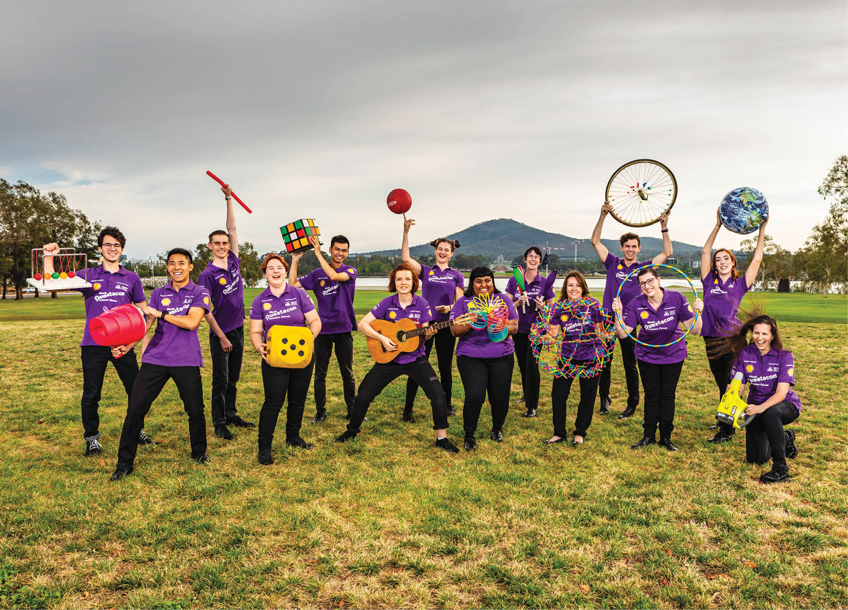
Figure 12: 2020 Science Circus presenters (February, 2020).

Reaching Students Through Virtual Excursions
Since 2009, we have delivered programs and activities through video conferencing to school students across Australia, actively contributing to Virtual Excursions Australia, a network of Australian institutions delivering professional interactive video content. In 2020, the virtual experience became an invaluable tool, as in-person school tours were cancelled and classrooms dispersed to home schooling. We responded to the challenge of maintaining our remit and commitment to regions we could no longer visit, while ensuring the safety of staff working under restricted conditions. Staff were upskilled across multiple delivery platforms with portable, professional quality, pop-up studios to support facilitators to deliver sessions from multiple locations.
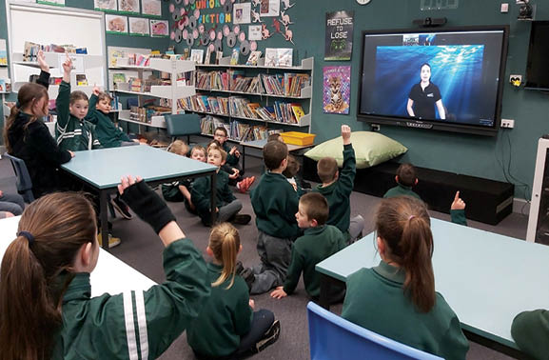
Figure 13: Students from Whitton Murrami Public School in New South Wales participating in a virtual excursion.

Zooming into a new role: remote inductions during the global pandemic
We joined Questacon in April 2020 at a time most staff were working from home. The team was faced with the challenge of how to welcome new members into a group normally specialising in hands-on workshops, while never actually stepping foot into the classroom.
Creativity, openness, and trust are important attributes to engage young people in STEM. The team encouraged us to explore these qualities and invented a digital scavenger hunt as a creative way for us to complete our induction tasks. The scavenger hunt took us on a unique journey. We completed critical induction tasks such as setting up our information technology systems and completing work health and safety inductions, but also engaging in activities designed to jumpstart our creativity. One of these activities was to find household items that could be used to defend ourselves in a zombie apocalypse! We have learned that this is a favourite icebreaker activity to use when connecting with school groups, as the students start problem solving and communicating in an enjoyable way.
On reflection, this experience was a creative way to help us feel welcomed and become contributing team members, despite the inability to meet our team in person!
Ms Louise Soroka and Ms Cat Nielsen Questacon Science Communicators
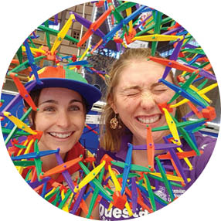

Improving Evaluation and Planning
Comprehensive monitoring and evaluation are essential for our commitment to quality assurance, continuous improvement and making a valuable impact and contribution. We engage and collaborate with external partners and stakeholders to monitor and evaluate data observed and captured from each of our activities and programs.
In 2020, we worked on a Data Core project to enrich understanding of visitation and attendance. Improving our data capability, the Data Core offers a real-time dashboard to enable rapid reporting and evidence-based planning. The dashboard features mapping of our geographic reach and connects to rich data sources such as MySchools. This enables a deeper understanding of the impact of our programs.
We also commenced a baseline study in three focus regions: Darwin, Northern Territory; Gladstone/Rockhampton, Queensland; and Tasmania. The study will establish an in-depth map of the existing STEM learning ecosystem in each region, comprising a variety of organisations, programs, connections and opportunities. The study will support planning and collaboration, inform how Questacon can best contribute to the work and capacity of local organisations to foster an enduring impact, and provide a basis for measuring change over time in focus regions and beyond. The baseline report will be available in 2021.
Survey sample: Inspiring students’ STEM interests
Questacon Maker Project and Questacon Smart Skills participants were surveyed on how the workshops influenced their interest in future STEM studies and careers.
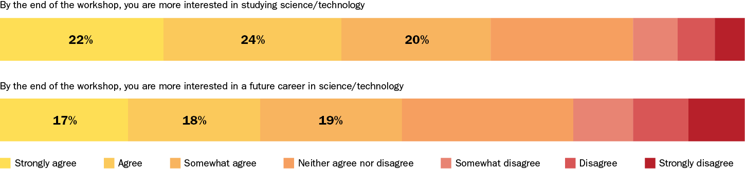
Figure 14: Data from Questacon Maker Project 2018–19 and Questacon Smart Skills 2018; Total responses = 6,791.

Working with libraries
As we launched our National Presence Strategy, we increased our focus on capacity building for informal STEM providers, such as libraries and universities, and the opportunity to engage with a range of new organisations across key ‘build’ regions. While interstate travel restrictions limited our ability to provide on-the-ground support, we developed a series of professional learning workshops via live video conference for local STEM networks.
As program delivery slowed in response to COVID-19, STEM providers took advantage of this time to invest in upskilling through tailored professional development activities. These successful workshops were well received by staff from 10 library venues and one university in Queensland, the Northern Territory and Victoria.
It’s been great to have another group lead us in ways to realign our key messages, with activity-based methods and more deeply consider our individual presentation style, to achieve much more engaging presentations. I really like the challenge and opportunity to connect with young people.’
Participant feedback, CQ University Connect Program 2020

Exhibitions on the road
Questacon showcases Australian science excellence, providing access to exhibitions that deliver tailored, high-quality STEM offerings aimed at building science diplomacy and capacity in regional and remote areas across the nation. We have a number of modular travelling exhibitions varying in size and theme available for hire and purchase. Our newest travelling exhibition, Australia in Space, is currently in production and will be launched in early 2021, and then tour nationally from 2022.
In 2020, Questacon toured exhibitions to four regional centres. Cobb+Co Museum in Toowoomba hosted Science on the Move, while Colour toured to the Ipswich Art Gallery and the Newcastle Museum. A pilot of the Mars pop-up exhibition opened in late December 2020 at the Albury Library Museum, which received high-definition digital files, to engage local suppliers in printing and framing the displays.
During the COVID-19 pandemic, our staff provided risk assessment and operational advice to help regional science centres open their doors with COVID-safe plans. We received an incredible amount of feedback and gratitude from our stakeholders for providing professional and reactive support.
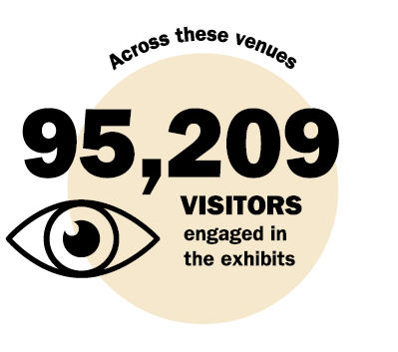
The exhibition was very well researched and designed and well suited for an interactive audience. The technical support was excellent and in particular the support during COVID was very good. There was a requirement for much more detailed instructions and these were provided.
Ms Pauline Gardener, Exhibitions
and Collection Manager,
Ipswich Art Gallery
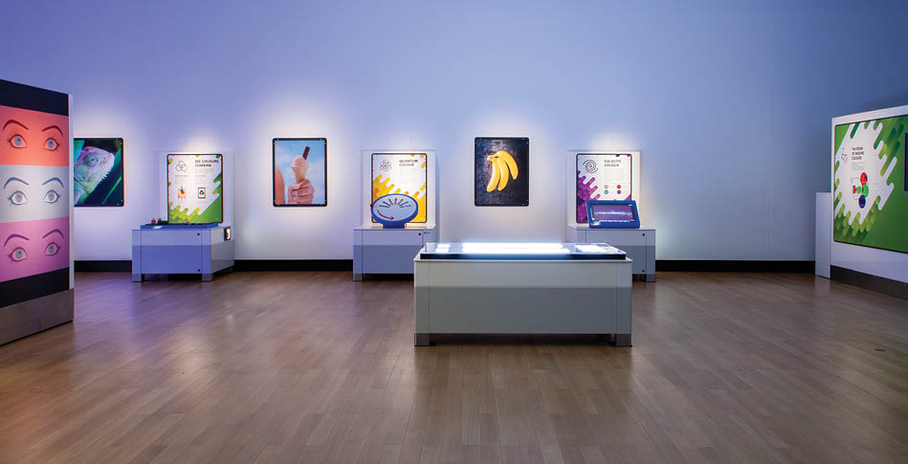
Figure 15: Colour at Ipswich Art Gallery
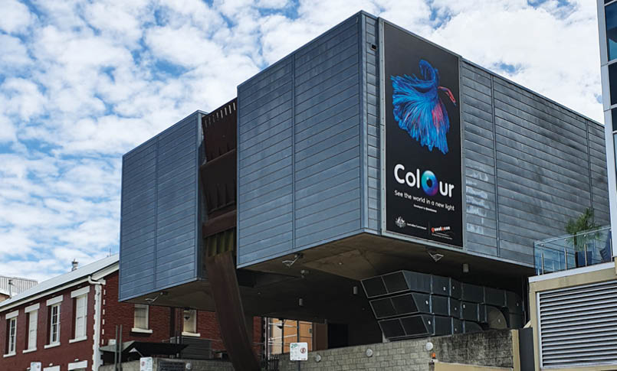
Figure 16: Colour at Ipswich Art Gallery
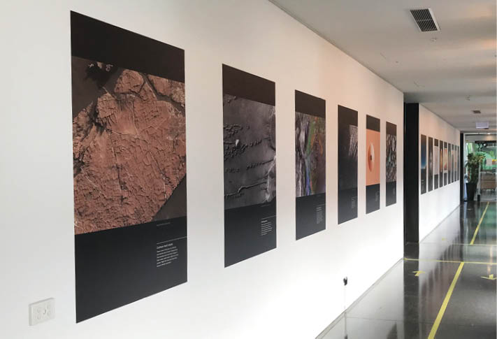
Figure 17: Mars pop-up exhibition at Albury Library Museum.
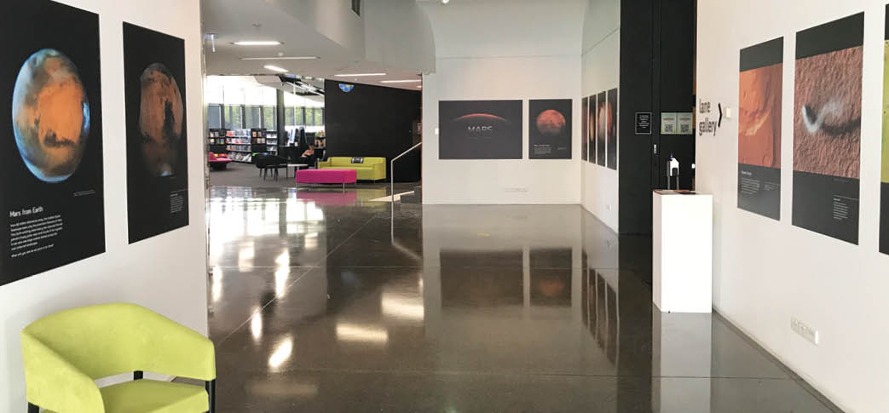
Figure 18: Mars pop-up exhibition at Albury Library Museum.

Inspiring Australia

The global pandemic has highlighted the value of establishing connections, building networks and maintaining communication internally and externally. We continue to connect, collaborate and develop networks with members of the STEM ecosystem, with a strong emphasis on the Network of Inspiring Australia Managers.
Inspiring Australia contributes to the Australian Government’s vision to engage all Australians with science. All states and territories are part of this Network, which is driven by Inspiring Australia Managers embedded in their local community. They share information, administer grants and support the evolution and delivery of state-based programs and events. We play an integral role connecting the Inspiring Australia Managers, facilitating and strengthening the professional Network, and building locally led, self-sustaining capability in the STEM sector.
In 2020, the Inspiring Australia Managers united to focus on ensuring collective impact, including co-funding and developing a successful online virtual excursion training series. Questacon shared knowledge and expertise with the Inspiring Australia Managers and other STEM presenters to direct nationwide traffic to various resources.
Our staff coordinated internal network meetings to support and grow knowledge sharing and collaboration, and to align communications with external stakeholders. This also supports our mission to build alternative engagement strategies. For example, we delivered portable Questacon exhibits to regions in the Northern Territory when we were unable to tour our regular, in-person workshops. With the support of the Inspiring Australia network we delivered professional development activities to various audiences including library staff and local event organisers. Our role as a coordinating body for the Inspiring Australia Network has helped foster a collaborative approach to STEM engagement across the sector amid a challenging year.
The level of interest in science has increased with the outbreak of COVID-19 and the quarantine has left families confined in their houses eager for STEM interactive content.
Ms Carla Eisemberg, Inspired NT 2020
Thanks so much Inspiring Australia – the presentation was very informative with helpful information and the presenters obviously have a lot of experience in this area. I look forward to the next 2 sessions.
Participant at an online presentation by the Inspiring Australia Network

National Science Week 2020
In 2020, National Science Week was launched online for the first time ever. Minister for Industry, Science and Technology, the Hon Karen Andrews MP, launched the week at an event co-hosted by Science and Technology Australia (STA) and Questacon. The Minister, Questacon’s Director, Professor Graham Durant and STA CEO, Ms Misha Schubert, were joined by 5 researchers for ‘Science Saving Lives’, in a 60-minute forum looking behind the scenes of Australia’s COVID-19 response.
National Science Week events in 2020 were mainly registered and hosted online. Between 15 and 23 August, people could participate in an event from home, work, school or in their local neighbourhood. The National Science Week organising committee was amazed by the creative ways event owners celebrated science this year, by hosting virtual tours, webcasts, talks, DIY experiments, quizzes, citizen science and competitions.
A total of 1,211 public and private events were registered. Out of 822 public events, 627 were held online.
National polling indicated that more than 1.1 million people attended a National Science Week event during the year.
National Science Week published 18 DIY science activities, which were accessed more than 60,000 times. Activities included backyard astronomy, weather observations, bio-blitzes, and a rocket-themed coding playground about building applications. The content was developed to encourage hands-on science engagement, when physical events were unable to take place.
The 2020 National Science Week ambassadors included marine science student and test cricketer, Ms Alyssa Healy, Gardening Australia’s, Mr Costa Georgiadis, Professor Emma Johnston, Dr Karl Kruszelnicki, and 3-time space shuttle astronaut and former Administrator of the National Oceanic and Atmospheric Administration, Dr Kathy Sullivan. Each volunteered their time to film a total 48 media interviews, social media spots and radio community service announcements.
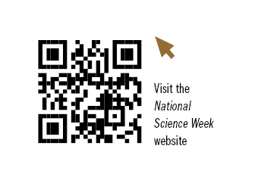
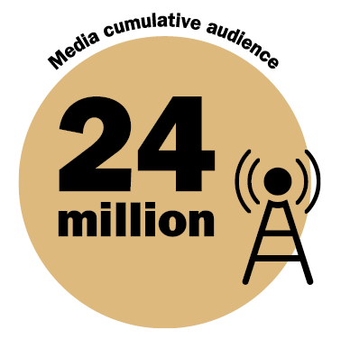
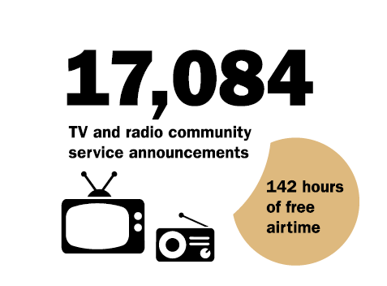
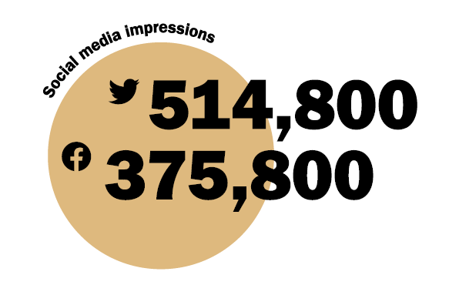
Another successful National Science Week event involved satellite ‘selfies’. The Australian Capital Territory Inspiring Australia team, Questacon and Dr Brad Tucker from The Australian National University, coordinated and promoted the National Satellite Selfie event. This brought together national cultural institutions, universities, science sector organisations and the Office of the Governor-General, to create images photographed from space. Images were uploaded to social media and the Science Week website. Questacon participated at both our Canberra sites by showing off giant Qs and a colourful rocket on the lawns around the buildings.
When COVID-19 prevented the running of the 3rd annual Governor-General’s Design Challenge on the lawns of Government House, His Excellency General the Honourable David Hurley AC DSC (Retd) and Her Excellency, Mrs Linda Hurley were delighted to be able to participate in National Science Week in alternative ways. We collaborated with the Governor-General’s office to produce a video to promote National Science Week and the importance of all Australians engaging with STEM. The video features the Governor-General and Mrs Hurley working with our presenters to explore a colourful water density experiment in the Drawing Room of Government House, and encouraging audiences to participate in National Science Week. The promotional video was filmed and produced by Questacon and shared across our social media platforms.
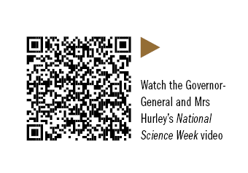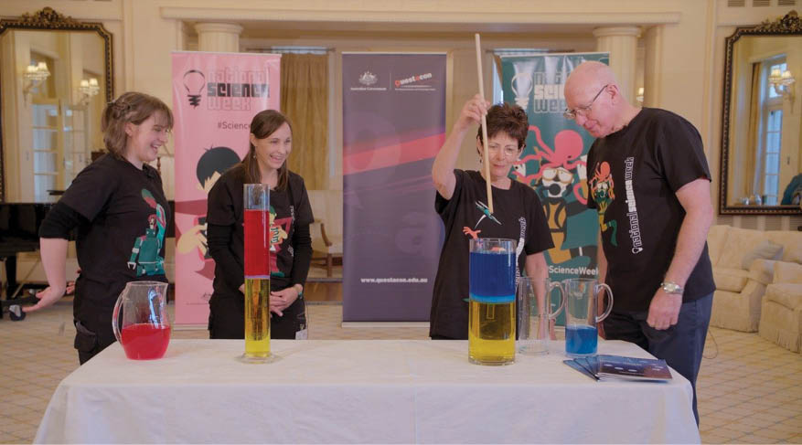
Figure 19: Screenshot from the Governor-General and Mrs Hurley’s National Science Week video.
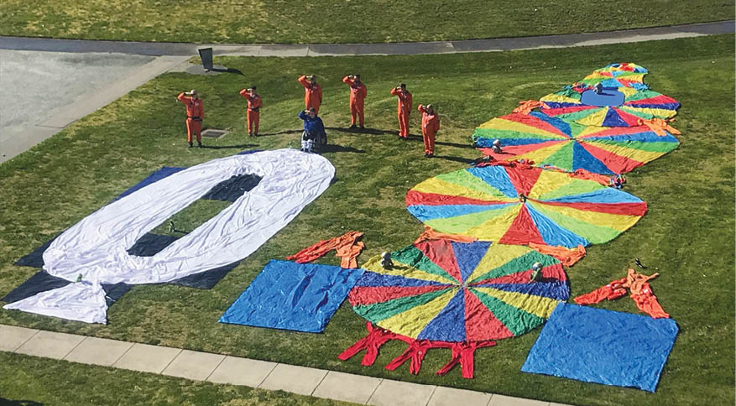
Figure 20: Questacon’s satellite ‘selfie’.

Adapting to Virtual Experiences
Only 6 months prior to the pandemic, founding a newly established creative studio to develop physical science-themed pop-ups was definitely a challenge for Excite Science. In the blink of an eye, the momentum to transition our cancer biology-themed escape room into a sustainable revenue model immediately halted. In response to the pandemic, I focused our attention on developing and launching MalignancyVR, a virtual reality game for National Science Week, and also progressed work for a cancer-themed augmented reality art gallery. While the future is uncertain, Questacon’s amazing agility to respond to the situation has been truly inspiring. I dare say this has strengthened Questacon in unforeseen ways that will reap significant dividends for years to come.
Dr Ken Dutton-Regester Questacon Council Member, and Founder and Creative Director at Excite Science
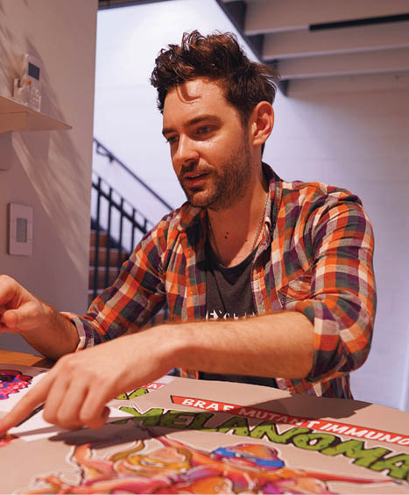
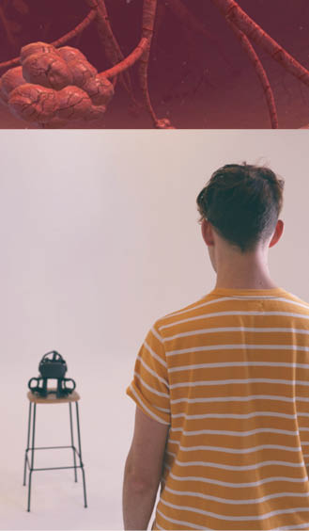
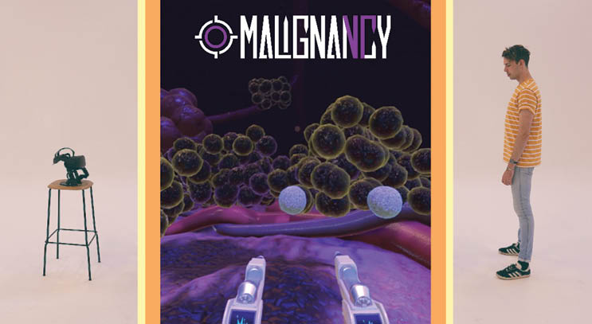

Indigenous Engagement
In 2020, we reaffirmed our ongoing commitment to Indigenous engagement through the Questacon Indigenous Engagement Strategy 2020–2025. The Strategy was informed by ongoing engagement and working relationships with Aboriginal and Torres Strait Islander peoples, and focuses on the strength and knowledge of individuals and social and community networks.
Our Indigenous Engagement Strategy is built on four pillars:
- Presence: Increase the presence of Indigenous language, knowledge and values in all of our content, including our exhibitions, programs, digital platforms, and organisational language.
- Platform: Provide a national platform for Indigenous STEM leadership through our partners, audiences, networks, digital expertise and venues.
- Programs: Increase Indigenous participation in Questacon programs as participants and leaders.
- People: Build a culturally competent, and confident, and diverse workforce.
The Strategy reflects our contribution to efforts across the department and the Australian Government. It underpins our commitment to making a meaningful contribution to Australia’s journey of reconciliation and aligns with the department’s Reconciliation Action Plan.
The Strategy acknowledges and respects the Ngunnawal people as traditional owners of the land on which our Canberra facilities stand. Respectful relationships with the Ngunnawal people provide a platform for Questacon to engage in our national role delivering program offerings to Aboriginal and Torres Strait Islander communities across Australia.
In 2020, we developed our relationships with Mr Tyronne Bell and Mr Jai Bell from Thunderstone Aboriginal Cultural Services on Ngunnawal Language projects, as well as the Australian Institute of Aboriginal and Torres Strait Islander Studies, First Languages Australia, and the Aurora Education Foundation. These projects included producing a Welcome to Questacon in Ngunnawal language, which was used on multiple occasions such as the Mission to Mars visitor experience. We have also implemented several Aboriginal and Torres Strait Islander cultural protocols, including training for our staff to deliver Acknowledgements of Country in Ngunnawal Language at a variety of events, adapting the Acknowledgement of Country for young children in early childhood programs, and displaying an Acknowledgement of Country on the Questacon website.
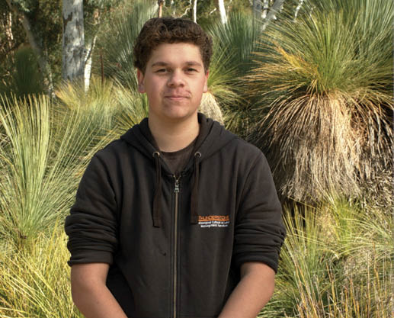
Figure 21: Mr Jai Bell from Thunderstone Aboriginal Cultural Services.
Following the success of the 2019 International Year of Indigenous Languages, Questacon continued to deliver a range of activities and programs to promote Australian First Languages and the associated scientific knowledge embedded in these languages. Our Indigenous engagement champions developed a community for staff to learn a wide range of words and phrases in First Languages – such as budhu (Wiradjuri for stars), yuuruu, gali (Gamilaraay for rain) and jurdad garra (Bilinarra for be together) – through a series of weekly internal communications.
From 27 May to 3 June, we joined National Reconciliation Week events through online activities, including a make-your-own damper workship, staff morning tea, sharing Indigenous artworks on the walls of home offices through Zoom meetings, and social media posts.
During the year, the Shell Questacon Science Circus worked with the Young Men’s Mentoring Group and the Young Women’s Mentoring Group at Gugan Gulwan Youth Aboriginal Corporation. This local youth centre supports young Aboriginal and Torres Strait Islander people and their families in the Australian Capital Territory and surrounding regions. The Science Circus delivered a combination of workshops and shows aligned with the interests of the groups to build self-confidence, self-esteem and resilience, including Take-flight, Kinetics and Meet a Scientist Q&A.
In September, Questacon presenters ran 2 Foldable Flight virtual excursions for the Western Sydney Aurora Education Foundation holiday program for Year 8 and 9 students. The sessions were tailored to incorporate program mentors and Elders to help the students refine their paper plane designs. Students were so excited they continued working on their designs after the workshops had finished.
In 2020, NAIDOC Week was celebrated from 8–15 November, and we released a newly produced Science in First Language video, ‘Yalblinya-dhi (learn about) Legumes’, featuring Wiradjuri woman and molecular plant scientist, Audrey McInnerney.
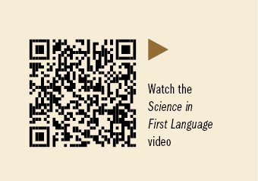
In December, our staff participated in a cultural tour of Mount Majura Nature Reserve, an important Aboriginal cultural landmark in the Australian Capital Territory. A Ngunnawal elder and traditional custodian, Mr Tyronne Bell, shared his cultural knowledge and heritage, such as pointing out scar trees that were used as location markers, and the use of sticky leaves of a cauliflower plant as ‘bush band-aids’. Staff also sampled a variety of native foods and made a soapy lather from the leaves of the soap bush.
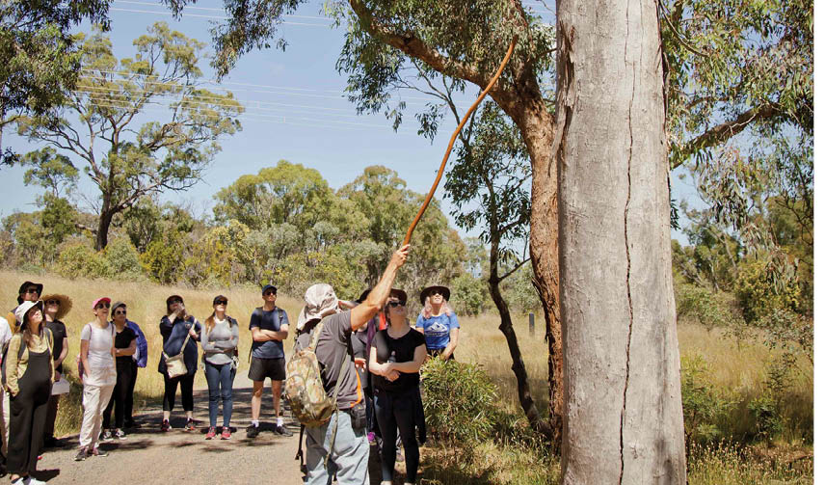
Figure 22: Mr Tyronne Bell and Questacon staff during a cultural tour of Mount Majura Nature Re-serve.
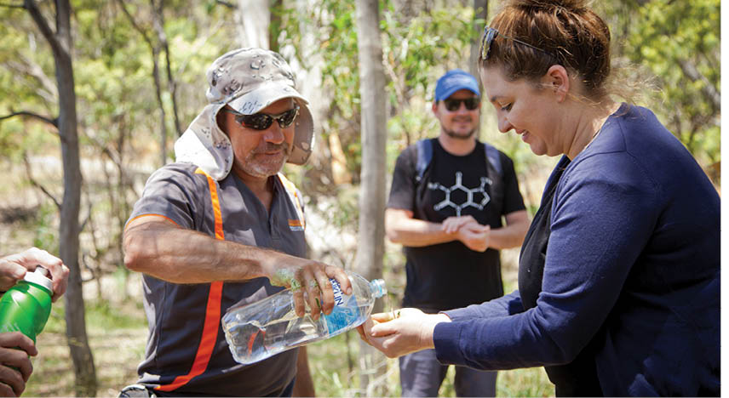
Figure 23: Mr Tyronne Bell and Questacon staff during a cultural tour of Mount Majura Nature Re-serve.

The Online Experience

Questacon at Home
As the COVID-19 pandemic started closing schools, businesses and attractions, many families were spending more time together at home. Questacon identified the importance of providing STEM inspiration to young people and families through online channels. As a result, we developed the Questacon at Home resources website.
We developed more than 35 sets of activity sheets for children of all ages. Many parents and carers transitioned to supporting children with virtual learning while working from home. We designed science engagement activities to be as hands-on as possible, easy to do at home and to require minimal screen time.
The worksheets drew directly on the academic disciplines of our science-engagement staff including ecology, environment, biology, physics and chemistry. Students undertaking studies in citizen science and archaeology also developed a range of backyard adventures and scavenger hunts, as a way to encourage people to get out in their backyard, to explore Australian native wildlife, insects and animals around the house. Other staff filmed short DIY videos on how to create a periodic table, encouraging children to find items around their house to represent the elements.
Videos were shared on social media and linked to the Questacon at Home website, for curious minds to engage in a range of fun and educational experiments. Almost 5,000 worksheets have been downloaded since the Questacon at Home webpage went live in April 2020. The most popular of these included a series of ‘How to make…’ themed videos, which attracted more than 26,000 views.
In 2020, our presenters piloted a ‘Choose Your Own Adventure’ online series, through Questacon’s Instagram account. The online audience actively engaged in the storytelling and potential outcomes. The pilot was launched over the spring school holidays with chapters and puzzles to encourage families to actively engage while at home.

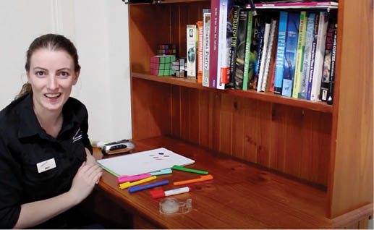
Figure 24: Screenshot from Questacon’s ‘Colour Mixing’ activity video.

Figure 25: Questacon at Home illustration.

Figure 26: Screenshot from Questacon’s ‘How to make your own: Lava Lamp’ video.

Science Time at Home
Young audiences aged 3 to 5 years and their families continued to participate in Questacon Science Time, our popular early childhood program, relaunched in April 2020 in a digital format to members. We created online resources for parents, carers and their young children, supported by Science Time’s pre-existing digital content, including Science Time visits and topic sessions.
Twelve content themes encouraged children to explore the world around them. For example, the series ‘Rolling and Ramps’ was designed to use materials from around the house, accompanied by a parent resource sheet to ignite adult curiosity with their little learners. These resources continue to be available on our website to ensure junior scientists continue exploring.
Thank you! This got another big thumbs up from my 4-year-old. He wasted no time after dinner trying to stage a puppet show against the side of a pop-up tent and a torch in the background.
Parent feedback
[My son] piped up responses to BJ’s questions as he usually would if sat in the Science Time room. The printable parent resource accompanying this were great. All self-contained and most of all, simple.
Parent feedback

Social Media
With the pandemic-related closures, more and more people turned to social media to connect, and for entertainment. Our Facebook page captured the attention of both young and old audiences, as we launched the mini adventure series of ‘Mutty the Muttaburrasaurus and the RoboQ army’. The stories focused on adventure, curiosity, team work and friendship, and linked into the ‘Choose Your Own Adventure’ live Facebook events. In addition, Questacon’s ‘Dinosaur Vs. Robot’ social media posts were released across 3 themed campaigns between April and December. The most popular post reached 36,000 people.
Questacon’s social media activity significantly increased in 2020 during the bushfire and COVID-19 shutdown periods. Between March and September, there was a 34% increase in audience growth and a 4.8% engagement increase across LinkedIn, Instagram, Facebook, Youtube and Twitter.
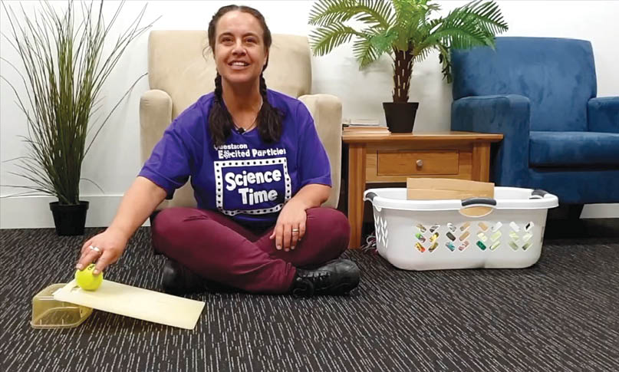
Figure 27: Screenshot from Questacon’s ‘Rolling and Ramps’ video series.
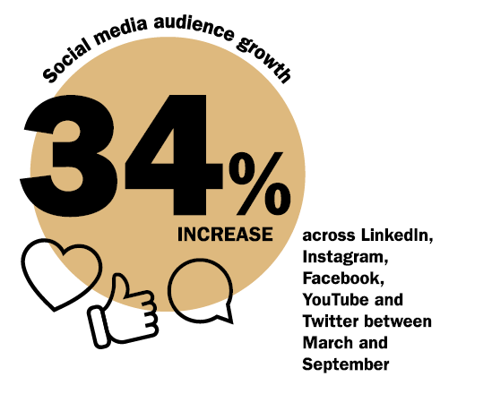

Centre Activities

Visiting Mars

In July 2020, after being closed since 21 March 2020, Questacon reopened with a special guided tour experience – Questacon Mission to Mars. As we reimagined our visitor offering to accommodate COVID-19 restrictions, the installation of a large inflatable Mars globe became the focus of the new visitor experience. The impressive 7-metre Mars globe was created by United Kingdom artist Mr Luke Jerram, using data from NASA’s Mars Reconnaissance Orbiter. At an approximate scale of 1:1 million, each centimetre represents 10 kilometres on the surface of Mars. The globe was designed by arranging hundreds of images taken by the NASA Mars Reconnaissance Orbiter, printed onto fire-resistant nylon. The exhibit inspires visitors to think beyond our blue planet and toward the future of space exploration.
While Questacon is usually a hands-on science centre, Mission to Mars enabled us to transform the visitor offering into an immersive but hands-free experience, allowing visitors to see our building, exhibits and performers like never before. Over 5 months, the COVID-safe experience took 7,363 visitors on a fascinating journey from Earth to the red planet. This innovative visitor experience was a unique science learning offering, which was delivered in an engaging and highly creative way.
From the launch of the rocket to the eventual touch down on the surface of the red planet, visitors were guided through selected Questacon exhibitions and enjoyed a range of immersive learning experiences to gain the skills and knowledge needed to be the first humans on Mars. Visitors were able to stop mid-way through their journey to learn about the atmosphere and landscape of Mars, achieved by interacting with a giant Mars topographic map, developed by the Aldrin Family Foundation (United States). The journey concluded at the impressive Mars globe, suspended in the inner gallery on the ground floor.

Thank you, Questacon, for a fabulous Mars experience. The kids and adults loved it! Thank you for creating this experience and for working so hard to allow us all to continue our scientific learning during these crazy times.
It made Mars feel like a real place – the maps, the descriptions, the staff who knew so much, made it in depth and absorbing.
Visitors to Mission to Mars, 2020
We also developed a version of the tour for younger visitors, Questacon Mission to Mars Junior, which included content specifically designed to engage children aged 3–6 years and their carers. Mission to Mars Junior focused on rocketry and Martian science. Young explorers engaged with custom-designed programming to suit their level, sparking curiosity, exploration and wonder. More than 1,143 children and their carers enjoyed this early childhood experience.
The program was so well thought-out, the kids were kept engaged, the science communicators were enthusiastic, and the social distancing was managed exceptionally well.
The program content was pitched really well for the target audience. My daughter loved it, and I did too. The activities were well planned, and the ‘space luggage’ to take home and continue our experimentation was perfect.
Visitors to Mission to Mars Junior, 2020
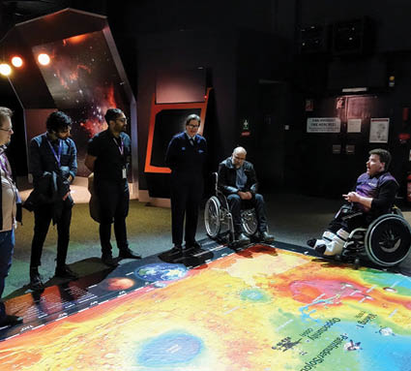
Figure 28: Questacon staff and visitors on a Mission to Mars tour
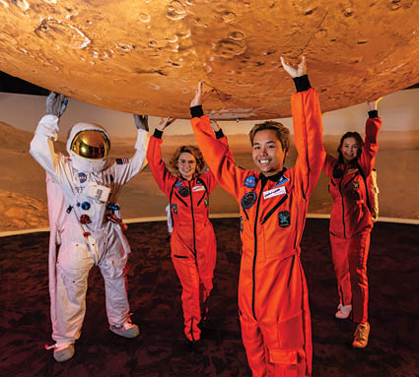
Figure 29: Questacon staff and visitors on a Mission to Mars tour
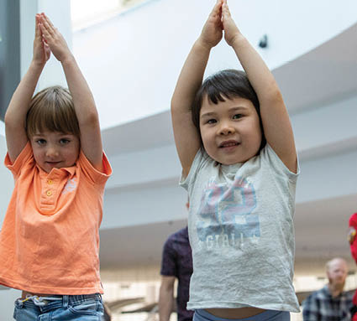
Figure 30: Young visitors on a Mission to Mars Junior tour.
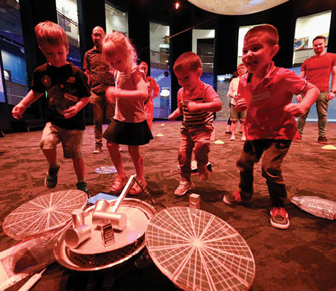
Figure 31: Young visitors on a Mission to Mars Junior tour.
We enhanced the Mars experience with a popular interactive Space Café, where visitors could capture gravity-defying photographs as a fun souvenir. The Space Café was kindly loaned to us by Lockheed Martin Australia to help inspire young people to learn about space.
We also developed a Mars audio app for visitors to download. The Mars audio app has 4 science and Mars-themed tracks, including sounds recorded from the surface of Mars, a Mars history, and a narrated story of the journey to the red planet by Australia’s Astronomer at Large and Questacon Mind in Residence, Professor Fred Watson.
During the year we created a series of 6 videos – Mars & Beyond: Discussing the ethics and curiosities of space exploration. The videos featured some of Australia’s leading space experts answering intriguing questions about Mars, interplanetary travel and the space industry. Our thanks to Ms Karlie Noon, Dr Cassandra Steer, Professor Brian Schmidt, Professor Fred Watson, Mr Anthony Murfett and Professor Alan Duffy for their contributions to these fascinating videos.
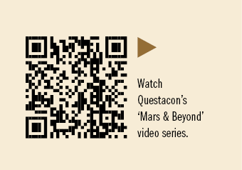
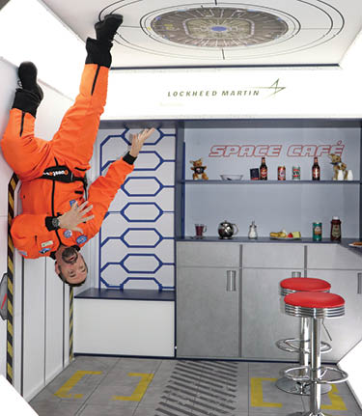
Figure 32: Questacon staff member inside the Space Café.
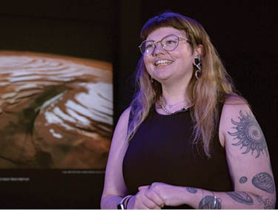
Figure 33: Ms Karlie Noon, Astronomy ambassador, Sydney Observatory.

A Year Like No Other
Dr Gregory Clark AC reflects on two memorable and significant events that occurred in 2020:
The first event was living through and witnessing the devastating effect of COVID-19, both socially and economically, across the world. The second, was bringing my 2 grandsons to see Questacon’s Mars exhibit. The Mars visit was a game-changer for our family. The boys were enchanted by the exhibits and needed to be coaxed away from one to the next. They, and I, were engrossed by the photos of Mars, instantly enquiring about the topography, water, scale and gravity. The Mission to Mars staff were superb with their outgoing personalities, depth of knowledge and ability to answer questions for all visitor levels. Ever since that visit, the subject of Mars has been constant topic in our family with extra reading, online researching, games, and school essays.
My family’s Mission to Mars experience is a perfect example of how Questacon continues to provide educational experiences, while overcoming the pandemic challenges. These Questacon experiences leave an everlasting memory. Questacon is embedded as a crucial influencer and educator within the national institutions. I am so proud to be part of the Questacon community and an Advisory Council Member over the past 5 years.
Dr Gregory Clark AC
Questacon Advisory Council and
The Q Australia Foundation Board
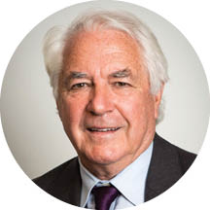

Creativity in a Crisis
The national body Interpretation Australia is dedicated to supporting and advancing the profession of natural and cultural heritage interpretation across Australia. Its annual awards celebrate excellence in the interpretation of engaging, unique and meaningful experiences for visitors to museums, galleries, historical locations and other public spaces. To acknowledge 2020’s challenges, Interpretation Australia introduced a special Creativity in a Crisis award, which recognised the unexpected and surprising measures required to continue sharing Australia’s natural and cultural wonders with the public.
In November, Questacon was honoured to be recognised as the category winner with our Mission to Mars experience. Showcasing our ability to be a leader in museum and tourism business, this award is a testament to how we can develop products for that market, as well as performing our role as Australia’s science engagement agency. This award is one of the most satisfying wins in recent years, recognising a major effort to reimagine a 32-year-long business model in just 8 weeks, and transform an entirely hands-on facility to overcome very challenging and complex pandemic health risks.
The experiments are mesmerising, so too are the looks on the faces of the staff who clearly enjoy what they are doing.
Front of House Coordinator, Ms Hayley Bromham’s favourite comment from the Interpretation Australia judges

Kinectic Sculptures
In late 2019 and early 2020, we designed and produced 2 moving kinetic sculpture exhibits.
The first sculpture was installed at the Ceremonial entrance, greeting visitors as they arrive at the Centre. This sculpture is an automated, continuously rotating mechanical installation, which creates a hypnotic effect through the revolving and intersecting patterns. At a specific moment in the rotation, the Questacon ‘Q’ from our logo briefly appears in focus. The functional drive mechanisms work seamlessly within the design. The drive chains and cog wheels were carefully engineered and finished so viewers can see the moving components through clear acrylic.
The second sculpture was installed inside the Centre underneath the foyer ramp. This sculpture is designed to be interactive and hands-on, allowing visitors to control the rotating elements using a hand-wheel.
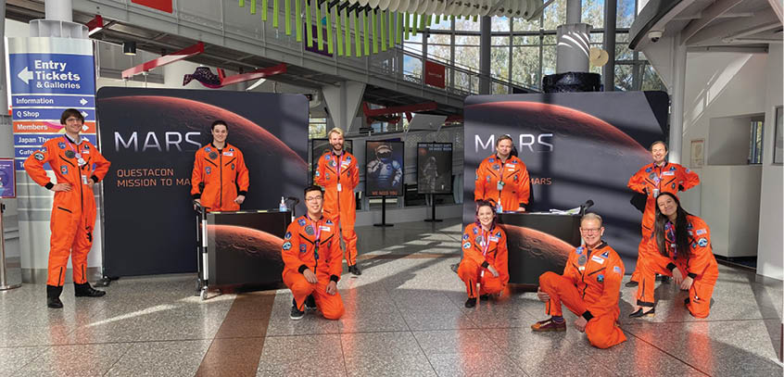
Figure 34: Questacon Mission to Mars staff members in the Centre foyer.
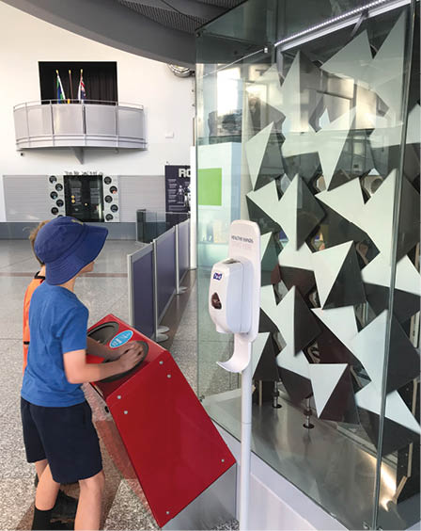
Figure 35: Young visitors engaging with the kinetic sculpture inside the Centre.

Buzzing with activity
In April 2020, Questacon introduced a live beehive exhibit into Q Lab. When they were able to return to the Centre, visitors were treated to a live view of the beehive and learnt facts on the importance of bees to Australian agriculture.
Working with the National Capital Authority, a local wild beehive of European honeybees was relocated to the Centre. One of Questacon’s existing empty beehives was repurposed to welcome the new colony as a living exhibit. Bee keeper Mr Jeff Maten, took the bees and the original hive and honeycomb to southern New South Wales while the installation was built. He then transferred the bees to their new home in the Centre, where he regularly maintains and cares for the hive.
Dr John Roberts from CSIRO worked with our teams to provide interesting bee facts, which were incorporated into the exhibit panels. The exhibit was built and installed by Questacon, using recycled exhibitions in a hexagonal design to complement the honeycomb pattern. A camera and monitors were installed inside the hive and on the landing pad on the external walls of the building. This enables visitors to experience first-hand the buzzing excitement deep within the hive, and observe the working bees landing at the entrance of the hive as they return home from collecting pollen.
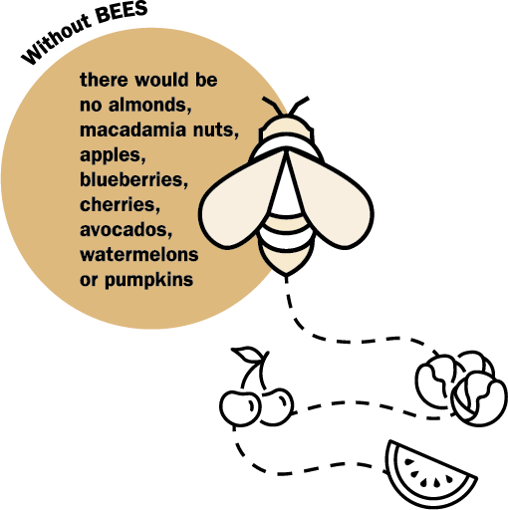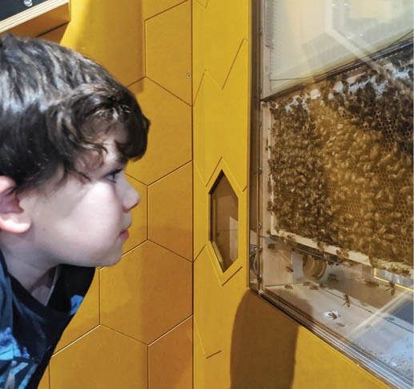
Figure 36: Young visitor at the beehive exhibit inside Q Lab.

Café uplifted
In February, we installed new floor artwork in the refurbished dining and café space. The floor features an image of a section from the Molonglo River corridor near Canberra. The image strategically and subconsciously leads visitors through the café space as a wayfinding tool. The subtle path removed the requirement for physical bollards to define queues and traffic flow. The installed images were taken using drone photography of the area over a stretch of river at differing heights, stitching multiple images together.
Questacon also commissioned and installed a café pod on the Rear Science Terrace, creating a more attractive venue and maximising the overall use of the space for after-hours events and as an effective overflow area during high visitation periods.
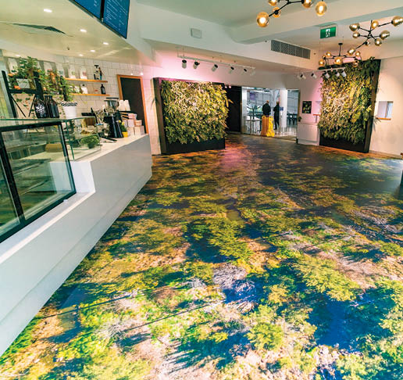
Figure 37: Questacon’s refurbished dining and café space.

Questacon Members
Since our membership program began in 1989, Questacon has provided members with exclusive opportunities and events to experience deeper engagement with science and technology.
While opportunities to visit Questacon were limited throughout 2020, our members’ enthusiasm endured. Members were invited to pilot our Mission to Mars tour, shaping this experience before it officially opened to the general public in July. Our members then continued to show their support throughout the year with 1 in every 5 visitors to Mission to Mars being a present or past member.
We continue to stimulate our members’ interest through our popular newsletter, sharing the best of science, what’s happening at Questacon and the delivery of our national STEM programs.

Q Retail
The Questacon Shop continues to provide STEM-related products that always deliver fun and engaging learning experiences for audiences of all ages. While the global pandemic impacted every aspect of our operations, the online shop was reinvigorated by an unanticipated increase and shift towards online customer purchases. Parents and carers searching for stimulating, educational, fun and exciting products to pique the curiosity of children and students could browse through a vast selection of quality learning experiences, and those tutoring students from home were also able to source training materials from the online shop.
An upgraded digital platform accommodated increased traffic for browsing and improved security for purchases. We also diversified and increased product offerings, exploring new product development opportunities, with several products developed in-house and added to the catalogue. These improvements translated into the highest mid-year trade on record for the online shop.
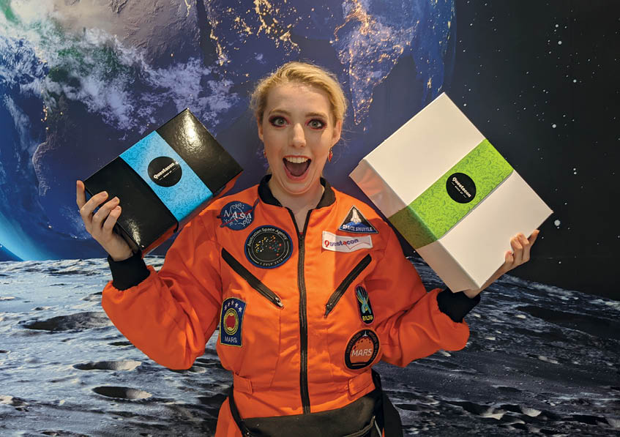
Figure 38: Questacon staff member, Ms Brianna Keys, holding Questacon Shop mystery boxes.

Learning programs and events

STEM Story Time
For World Space Week (4–10 October), we partnered with Australia’s Women in STEM Ambassador, Professor Lisa Harvey Smith, to develop an interactive online space adventure for young space explorers. The experience guided families in a journey to the International Space Station to learn about rockets and discover what astronauts need to survive in space. Participants were encouraged to engage in meaningful discussions about gender and unconscious bias, through clever use of material. Supported and filmed by Questacon, the storytelling includes elements of critical problem solving and stories from astronauts, Ms Christina Koch and Ms Valentina Tereshkova. The videos have been viewed 715 times.
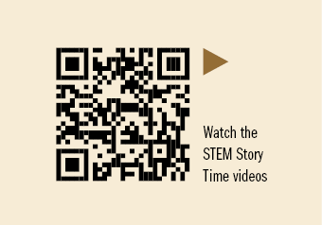

Questacon Science Sprouts
This new early childhood education program was developed as an interactive role-play experience for visitors aged 3–6 years old and their carers. On this guided adventure, ‘little sprouts’ explore the world around them by participating in a live show before jumping into role-playing activities and engaging with hands-on science experiments. During each session, participants experiment, discover, and ask lots of questions in a friendly and inclusive environment. Questacon Science Sprouts was launched in December 2020, completing 12 sessions with 371 participants.
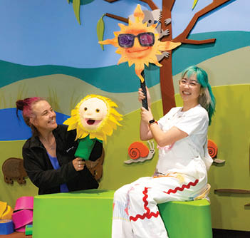
Figure 39: Questacon Science Sprouts presenters during a show

Little Explorers Month
Throughout February, we engaged our youngest visitors, aged 0–6 years old, with Little Explorers Month. During 4 themed days spread over the month, visitors had the chance to investigate flight, music, living things and dinosaurs. We developed special science shows, crafts, Science Time activities, displays from community organisations, and resources for young families. Little Explorers Month attracted 2,101 visitors to the Centre, who were excited to engage with activities focused on early childhood audiences. Local day care organisations were treated to a special day with puppet shows, Science Time activities and crafts, Story Time, and displays from Mulligans Flat and the National Library of Australia.
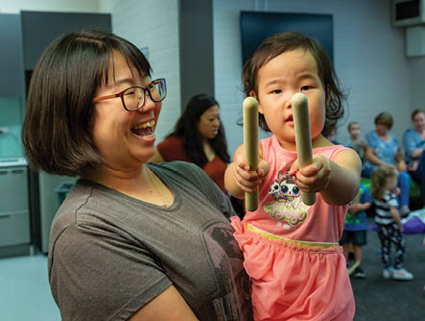
Figure 40: Child and parent participating in Little Explorers Month activities (February, 2020).
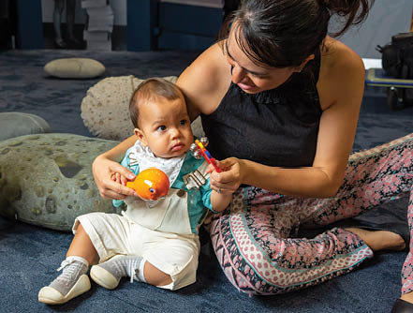
Figure 41: Child and parent participating in Little Explorers Month activities (February, 2020).

STEMaSESH
In May, we connected with the New South Wales Department of Education for its program, STEMaSESH to showcase STEM careers to 100 primary and 40 high school students and teachers across New South Wales, through 2 interactive virtual workshops.

Space Squad
Since 2016, Questacon has engaged in YMCA’s Space Squad program in a week-long, hands-on program for students aged 12–16, to explore the space science industry. During the pandemic, we welcomed 2 groups in late 2020, with a program similar to the successful Questacon Mission to Mars experience. Students experienced a show to explore the science behind surviving on the red planet, ending with a reflective dialogue session under the Mars globe.

Energy Literacy Explained
We launched the Your Energy show in March, aimed at increasing energy literacy for all Australians. The show explores ideas and concepts about energy as a necessary resource in day-to-day living, and explores self-awareness to provoke critical thinking about how much humans know about where energy comes from, and how much energy we consume. The show also promotes and supports the United Nations Sustainable Development Goal 7: Affordable and clean energy, as well as sourcing recommendations and findings from the National Energy Resources Australia Report 2019: Building Australia’s Energy Literacy. The show was developed with feedback from energy sector stakeholders, and is one of the first activities delivered as part of our partnership with INPEX.
Our presenters take the audience on a journey to explore themes including different sources of energy, present and future challenges, and consequences and opportunities in emerging technology. This leads the audience to understand the possible outcomes from the decisions made, and suggest why it is crucial to consider their own energy footprint as the first step in promoting energy literacy. While the Centre was open during the year, Your Energy was delivered to 820 visitors.
We also partnered with the department’s Energy Division and the Office of Australia’s Chief Scientist, for World Energy Week 2020 (7–9 October), through a series of digital content posts on social media. A set of new energy themed activity sheets was also added to the Questacon at Home website.
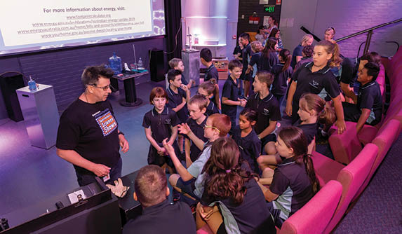
Figure 42: Questacon presenter and young audience during a Your Energy show (February, 2020)
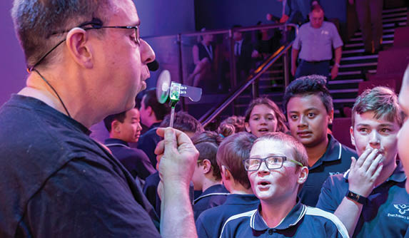
Figure 43: Questacon presenter and young audience during a Your Energy show (February, 2020)
We both really enjoyed it and learned quite a lot about energy too. When I asked [my daughter] what she remembered about it later she said ‘the explosions’ and then ‘a little bit scary’. She also remembered the video about the sun, and over dinner told us about how we get energy from food!
Parent, Your Energy show 2020

IPAA Public Sector Innovation Awards
In July, Questacon hosted our first COVID-safe event – the awards ceremony for the Public Sector Innovation Awards by the Institute of Public Administration Australia (IPAA). The Mars gallery was transformed with a large presentation stage and spaced seating for mandatory social distancing. The awards were presented by Department Secretary, Mr David Fredericks PSM, Deputy Secretary and Chair of the Awards Judging Panel, Ms Elizabeth Kelly PSM, and Mr Mark Nixon, Partner at Ernst & Young. For the fifth year, Questacon designed and sourced local suppliers and makers to produce the IPAA trophies.
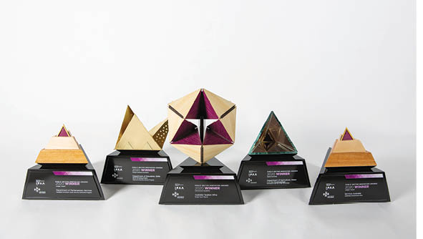
Figure 44: IPAA award trophies.

Supporting Tourism in the ACT

Enlighten Canberra
Between February and March 2020, the Enlighten Festival celebrated its 10th year in Canberra, featuring large-scale architectural projections on the building walls of national institutions. Supporting the Festival and local tourism, we provided a range of new experiences including an illuminated igloo garden, complemented by a unique dining experience. The Centre opened for guided ticketed experiences for families to wander through the interactive galleries and experience unique science shows and demonstrations. Questacon was the official ‘switch on’ site for Enlighten 2020 with Questacon’s Deputy Director, Ms Kate Driver, helping to launch the event with ACT Chief Minister Mr Andrew Barr. They were joined by representatives from ACTEW AGL and one lucky Canberra family who won a competition to kick off the festival.
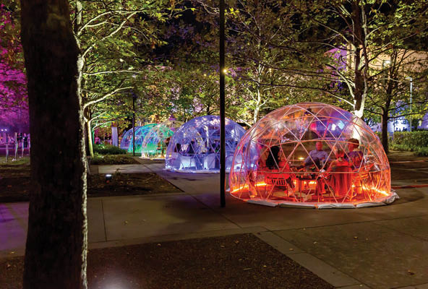
Figure 45: Illuminated igloo garden surrounding the Questacon building during Enlighten (February, 2020).
The projections on Questacon’s building focused on the theme of regeneration. In the aftermath of the devastating bushfire season, a single echidna emerges from a scorched burrow, ready to begin a new life.
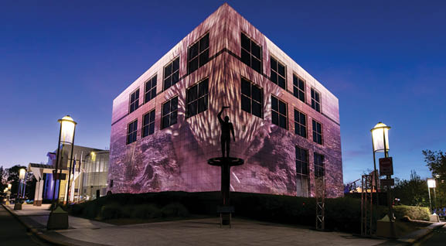
Flowers and plants begin to sprout, a butterfly makes its way to the highest branch, approaching a koala feeding on new greenery.
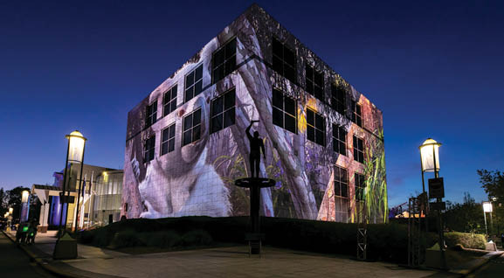
As the butterfly soars higher, the forest is restored with the surrounding environment regenerated.
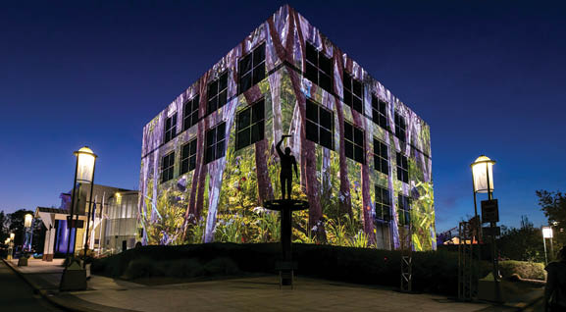

Tourism Australia ‘Live from Aus’
Australia’s tourism industry was hard hit by COVID-19. With national and state borders closing and many service-centric industries grinding to a halt, Tourism Australia focused on a domestic marketing campaign to inspire Australians to plan their next getaway in Australia. The ‘Live from Aus’ campaign showcased amazing Australian tourism experiences through a program of social media events over the weekend of 16–17 May 2020.
Questacon was featured as 1 of only 2 Canberra-based attractions, in a live 45-minute curated segment taking viewers behind the scenes. Presented by our science communicators, the segment explored Questacon’s beehive exhibit, the science behind the elements, as well as explosions to excite audiences for Questacon’s eventual reopening. The segment attracted 151,000 views worldwide.
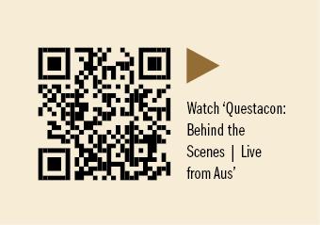

Floriade Revisited
For the first time in 33 years, Canberra’s celebration of spring moved from its traditional home in Commonwealth Park to sprout up across Canberra at various national institutions, community centres, and schools as Floriade: Reimagined. We participated in the event (12 September – 11 October) with beautifully prepared
tulip arrangements. The extra-large pots were positioned in entry ways to the Centre, one of which surprisingly invited a mother duck to nest and raise her young. After the blooms finished and the festival was over, the bulbs were recycled to be re-used next season.
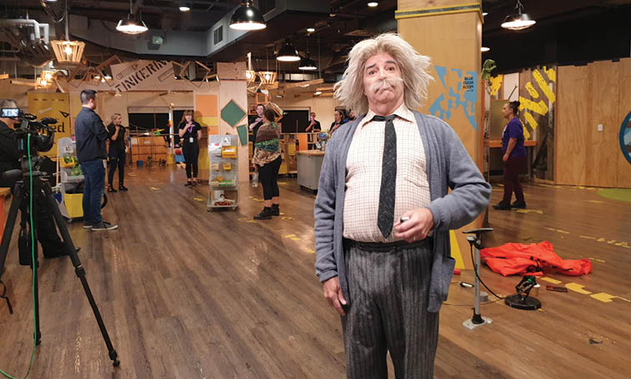
Figure 46: Questacon staff member, Mr Patrick Helean, as Albert Einstein for Tourism Australia’s ‘Live from Aus’ video
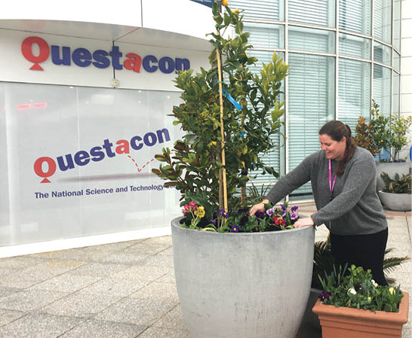
Figure 47: Questacon staff member, Ms Tegan Cross, planting flowers during Floriade
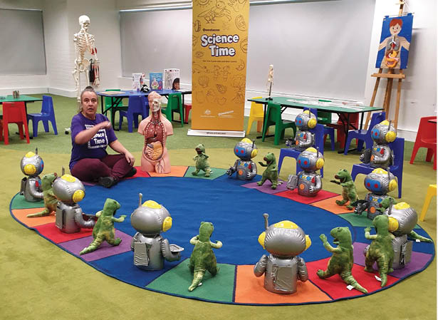
Figure 48: Questacon staff member, Ms BJ Anyos, presenting Questacon Science Time for Tourism Australia’s ‘Live from Aus’ video.

International Engagement
As Australia’s National Science and Technology Centre, we showcase Australian science excellence and innovation on the international stage, sharing best practice and the capabilities of Australian science communication. As a leader in the science centre and science museum sector, we play a role in cultural diplomacy via international events, conferences and workshops to facilitate people-to-people, institution-to-institution and country-to-country interactions through exhibits, shows and workshops.
We are an active member of peak international bodies, the Association of Science Technology Centers (ASTC) and the Asia Pacific Network of Science and Technology Centres (ASPAC), with Questacon’s Director, Professor Graham Durant serving as the Vice-President for ASPAC since 2017. We have strong relationships with science centres across the Indo-Pacific region, supporting international soft diplomacy and the United Nations Sustainable Development Goals.
Before international travel restrictions were introduced, we welcomed delegates from various international science centres and museums. We continued to build our relationship with the Japan Aerospace Exploration Agency (JAXA), displaying the Hayabusa I and II models in the Centre, and cultivated new partnerships with the Aldrin Family Foundation and NASA through public presentations and student workshops.
On 3 December, Questacon hosted a virtual space exchange with the Aldrin Family Foundation. Students from Yarralumla Primary School, Canberra, interacted with students at the Kennedy Space Centre’s Star Base in Florida. The Aldrin Family Foundation President, Dr Andrew Aldrin, presented virtually from Colorado in the US, on the democratisation of space before inviting and answering questions from the students.
Mr Jim Christensen, Executive Director of Share Space Education, then led an interactive exploration of the distances and calculations involved in humankind’s future colonisation of Mars. The event inspired both students and teachers to dream of and plan for careers in the growing global space industry.
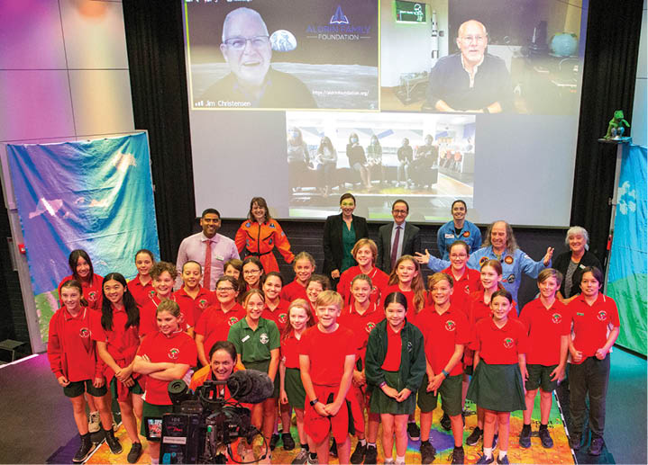
Figure 49: Children from Yarralumla Primary School at the virtual space exchange with the Aldrin Family Foundation.
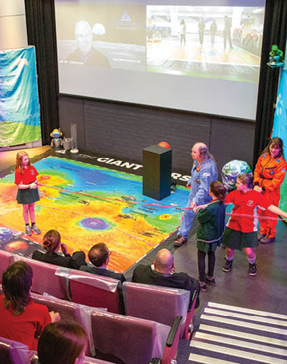
Figure 50: Children from Yarralumla Primary School at the virtual space exchange with the Aldrin Family Foundation.

Delegation Visits and Highlights in 2020
17 January
A delegation of curators, administrators and exhibit specialists united under the Japanese Council of Science Museums, coordinated by the Tokyo National Museum of Nature and Science.
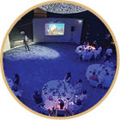
25 February
Mr Badri Younes, NASA Deputy Associate Administrator, presented a public lecture at Questacon on The Science of Space Communications.

27 February
We displayed the Hayabusa I model at the Japanese Ambassador’s residence, to celebrate the Japanese Emperor’s Birthday reception.
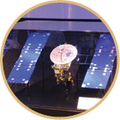
5–9 March
The Palestine Al-Nayzak Organisation worked with Questacon teams in a 10-day residential cultural exchange, to co-design a flat-pack travelling science exhibition themed ‘Science and the Arabic-Islamic Golden Age’. The delegation focused their visit on increasing cross-cultural understanding of Arab-Muslim culture and raising awareness of their philosophy of science inventions. With Questacon’s support,
Al-Nayzak received a grant from the Council of Australian-Arab Relations, funded by the Department of Foreign Affairs and Trade, to visit Australia.
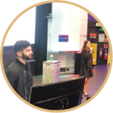

16 May
Questacon at Home activity sheets were developed for families to explore colour and light, to promote the International Day of Light.

18 August
During National Science Week, Dr Adrian Brown, NASA Deputy Program Lead Scientist for the Mars 2020 Rover Mission, presented to geology and space enthusiasts on the challenges and progress of the space mission.
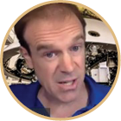
16 October
During World Space Week, NASA Solar System Ambassador and Human Space Flight Mission Manager, Ms Rosa Avalos-Warren, presented a virtual excursion to Australian students, including insight on her role as a STEM engineer operating from NASA’s Mission Control Center and Mission Evaluation Room.

21 October
Questacon Deputy Director, Dr Bobby Cerini, presented in a global webinar hosted by the Nelson Mandela Bay Science and Technology Centre. The webinar explored varied ways the global science centre sector has responded to the COVID-19 pandemic.

19 November
The Embassy of Japan in Canberra and the Japan Exchange and Teaching Alumni Association (JETAA) hosted a film screening of Hayabusa 2012 at the National Film and Sound Archive. Questacon’s Hayabusa I exhibit was on display and Questacon Director, Professor Graham Durant, introduced congratulatory messages from Dr Andy Thomas and Dr Mamoru Mohri, to promote the return of the Hayabusa II landing in Australia in December 2020.


Questacon People

Supporting the Australian Government’s Response to COVID-19
Thirty-five of our front of house workforce were redeployed to Services Australia during 2020. They helped manage and process applications for the Australian Government’s JobSeeker initiative to support Australians in their time in need. Staff quickly adapted their broad range of skills from explaining exhibits and managing the Centre’s information desk, and academic disciplines in medical science, ecology, astronomy, physics and environmental management, to their new support roles at Services Australia.
In September, we hosted an appreciation event under the Mars exhibit, with Department Secretary, Mr David Fredericks PSM, personally thanking the redeployed staff for their efforts and commitment to the Australian Public Service. Each secondee was also presented with a certificate of appreciation from the Australian Public Service Commissioner, Mr Peter Woolcott.
I really enjoyed redeployment –it’s been clear how important the work I’m doing is and how it is beneficial to the community during this time of crisis.
Ms Gabrielle Magyary, Gallery Assistant
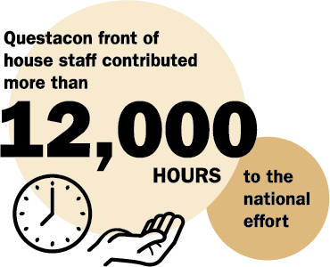
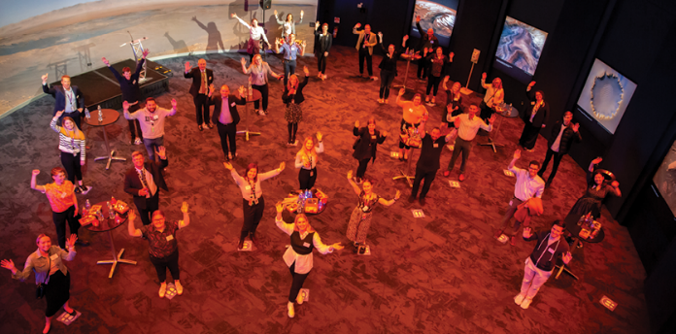
Figure 51: Appreciation event with Department Secretary, Mr David Fredericks PSM.
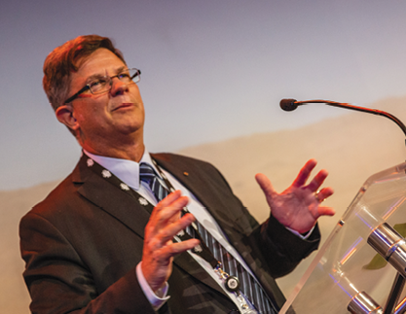
Figure 52: Department Secretary, Mr David Fredericks PSM speaking at the appreciation event.
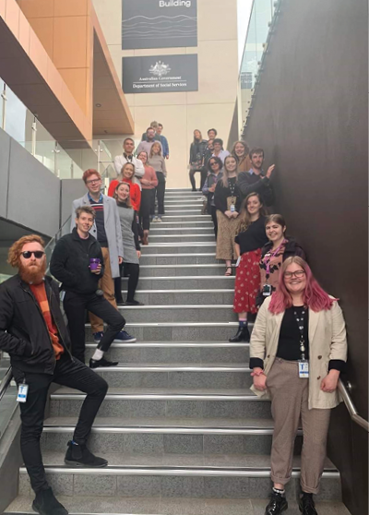
Figure 53: Questacon staff redeployed to Services Australia.

Investing in Questacon’s Greatest Asset
Our commitment to workplace mental health through supportive workplace culture is recognised through our silver status in the Australian Capital Territory Government’s Healthier Work Scheme. We invest in our people by looking after their mental health and wellbeing. We provide support networks, initiatives and activities such as Mental Health First Aid, have established Wellbeing Champions in the workplace, host fun activities such as yoga under the Moon and sporting games, and promote wellbeing through mindfulness and positive mindset meditation, stress management and wellness checks. Our exceptional group of COVID-19 Champions supported our workplace and develop COVID-safe work plans, policies and procedures.
In early 2020, our Work Health and Safety staff took part in the Australian Public Service Mental Health Capability Framework piloted through our department, focusing on applying evidence-informed practice to mental health and wellbeing initiatives. The Framework aims to build mental health capability, to develop and sustain positive mental health in the workplace, and to strengthen responses and identification to vulnerable staff.

Behind the scenes
We worked closely with our cleaning crew during an uncertain and extremely cautious period where sanitisation and cleaning was required around the clock. Additional COVID-safe protocols were added to the regular cleaning procedures to ensure the safety of all staff and visitors. We introduced ‘follow-me cleaning’, where gallery spaces are cleaned between groups moving through the Centre. The new protocols were enacted to work seamlessly with the Mission to Mars visitor experience, sanitising each item and area that may have been touched along the way.
It’s been a drastic change. We have to be extra careful of everything now, to make sure visitors are safe and to keep us safe too.
Mr Tshering Wangchuk, Kamberra Indigenous Cleaning
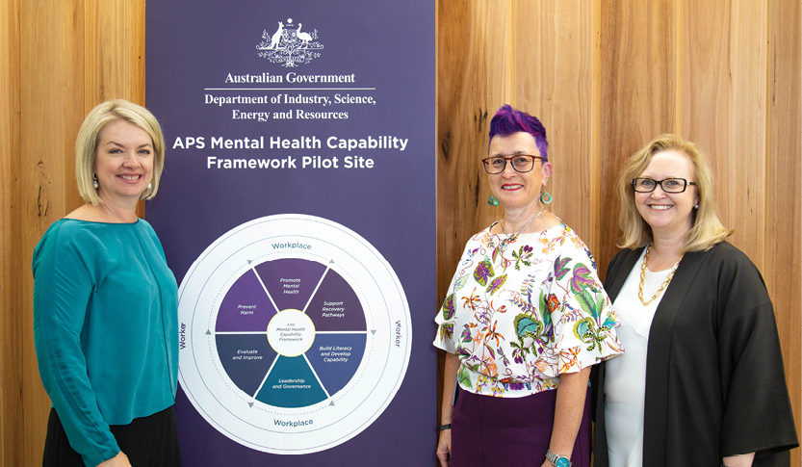
Figure 54: Work Health and Safety staff, Ms Karen Jahne, Ms Mary Kary and Ms Janean Richards, take part in the Australian Public Service Mental Health Capability Framework.
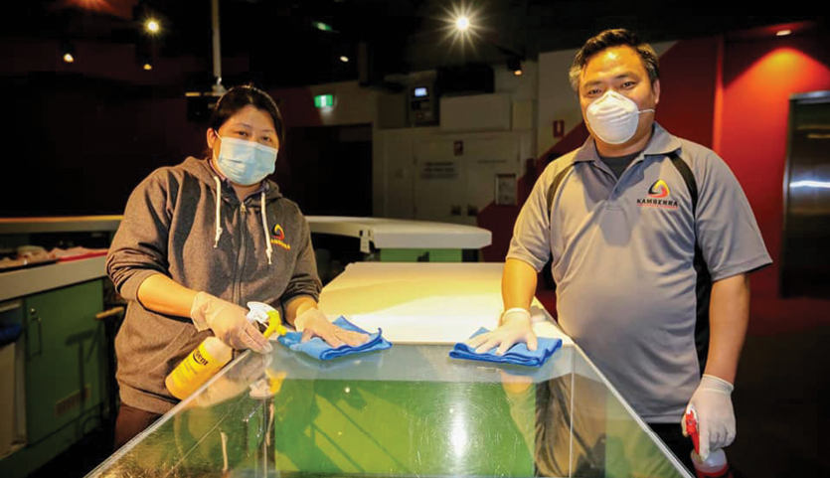
Figure 55: Cleaning staff, Ms Choney Lhamo and Mr Tshering Wangchuk, from Kamberra Indigenous Cleaning.

Apprenticeships and interns
In December, Electro-Technology trainee, Mr Zeke Turner, completed his Australian School-Based Apprenticeship at Questacon. This was a rich and rewarding exercise for both Zeke and the team as they learnt and developed new skills and ways of working in a COVID-safe environment. Zeke’s transformation into a skilled electronics technician was supported by the team. He was nominated as the 2020 ACT School-Based Apprentice of the Year and shortlisted as 1 of 8 finalists. The experience has reaffirmed Zeke’s passion for a career in electronics, and he is reviewing options for further studies and employment with Questacon and in the electronics industry.
We are pleased to provide internships to people of Indigenous background for a hands-on experience within their fields of study. Ms Tia Rosevear is a Darug woman from the New South Wales Blue Mountains region and is Questacon’s first Indigenous internship in the Digital Engagement team. Tia started her internship with Questacon in 2019, and has now completed a Certificate III in Media Production at Canberra Institute of Technology. She continues to extend her knowledge and technical aptitude in technology advancement, the evolving digital environment and professional industries. Through ongoing one-on-one mentoring, and facilitating a hands-on approach, Questacon provides Tia with opportunities to produce broadcast quality content, with professional-level equipment and studio facilities.
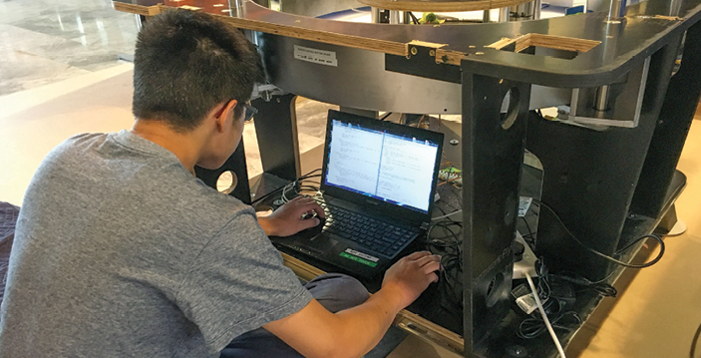
Figure 56: Electro-Technology trainee, Mr Zeke Turner, programming an Australia In Space exhibit.

Aurora foundation 2020 interns
In January, Ms Bronte Ayoub, a Kamilaroi woman and student teacher from Sydney, began her 6-week internship with us. This was at a time when the bushfires and smoke were at their most devastating. In fact, as Bronte arrived for her first day at Questacon, the building had to be closed due to the poor air quality inside.
During her internship, Bronte contributed to the development of our Indigenous Engagement Strategy and a Cultural Protocols Guideline document, mapping activity against the department’s Reconciliation Action Plan, and writing useful First Language words and phrases for staff. Bronte also had hands-on experience with an Engineering is Elementary workshop, which gave her new knowledge and skills to take into her classroom.
In July, Ms Audrey McInnerney joined us for a 4-week placement at a time when travel restrictions were in place across the country, and so she became Questacon’s first remote intern, working from Brisbane. Audrey is a Wiradjuri woman and a molecular plant scientist. During her internship, Audrey used her science and research skills to undertake a scan of the Indigenous STEM sector.
Audrey’s greatest legacy from her internship was writing and filming the Science in First Languages video, ‘Yalblinya-dhi (learn about) Legumes’, which was inspired by her field of study in plant science and the impact of Wiradjuri traditional thinking on her research. Audrey connected with Wiradjuri Elders to learn more about the Wiradjuri language, a very personal and rewarding opportunity. Since completing her placement with Questacon, Audrey has commenced a Masters at Cambridge University in the United Kingdom.
I also was assisting the team with the wording of the Acknowledgement of Country [for] the website and also at the front of the building before you enter. This was a very special task for me because of the importance of Acknowledging the Country you are standing on.
Ms Bronte Ayoub, 6-week internship, 2020
I found it really valuable to connect with language and learn Wiradjuri that I can use in the context of my research, and I definitely developed my science communication skills.
Ms Audrey McInnerney, 4-week internship, 2020

Mind in Residence
The Questacon Mind in Residence program was officially implemented in 2016 through the engagement of the first Mind in Residence, Emeritus Professor Hans Bachor AM,
as an expert advisor in science communication and physics. The program brings experts and thinkers to the organisation to provide an intellectual spark for continual improvement. Professor Bachor has continued his ongoing residency, providing expert advice across Questacon to our science communicators and across exhibition design content. In 2020, 2 of our Mind in Residence Professors, Rob DeSalle and Hans Bachor, collaborated to publish the book, The Natural History of Colour.
In January 2020, Questacon welcomed Professor Fred Watson, Australia’s Astronomer at Large, into the program after a long history of collaborating on events, and delivering a series of Moonlighting Scientists public presentations. Professor Watson’s expertise as an astronomer and interest in the history of science came to life when speaking with young people through media appearances, visitors and special guests.
He has contributed extensively to Questacon’s new travelling exhibition, Australia in Space, and as a content contributor on the Mission to Mars visitor experience. Professor Watson also appeared on a television program in the Philippines created by Questacon’s partner institution, the Mind Museum.
Questacon recognises and greatly values the contributions from the experts across the organisation. The Mind in Residence program is set to evolve and expand in the coming years. In 2021, Questacon plans to increase the diversity of our influencers, to amplify the voices of young Indigenous Australians through the Mind in Residence program.

Employment confidence
Questacon’s inclusive workforce and culture is welcoming for all staff, volunteers and visitors. We continue to provide employment opportunities for people with disabilities, and provide better disability access to Questacon’s facilities. In 2020, we further developed our employment pathways through a new partnership with Workways Australia, a not-for-profit disability employment services provider. Workways Australia supports Questacon’s customer service assistant, Mr Shane Haby, to work in a number of different teams and sections.
WorkWays Australia produced a video about Mr Shane Haby and his cadetship with Questacon, which was launched on International Day of People with Disability. Shane was delighted to be part of this exciting opportunity, to share his first-hand experience about living with a disability, the challenges in building a career, and his time with Questacon.
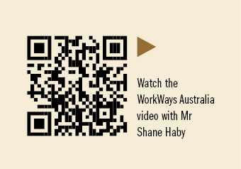
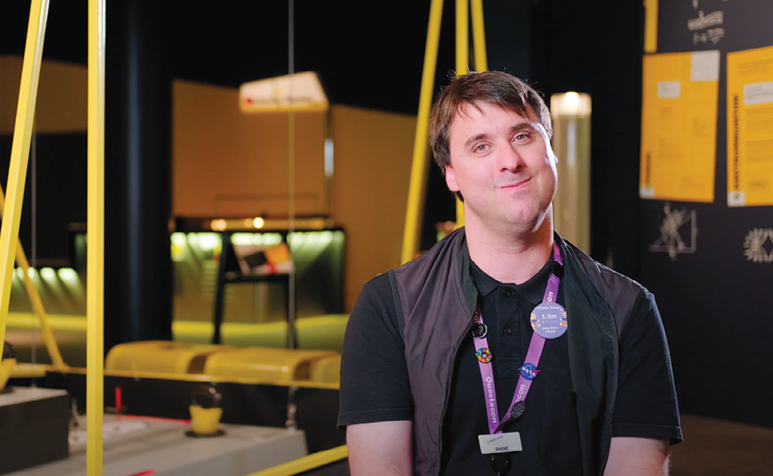
Figure 57: Screenshot of Mr Shane Haby in Workways Australia’s video.

Questacon volunteers
Questacon has a dedicated team of 60 active volunteers, who in 2020 contributed a total of 2,167 hours. Despite the year’s challenges, our volunteers remained an integral part of Questacon.
Our volunteers supported a range of events in early 2020, including Little Explorers Month and Enlighten, increasing awareness and understanding of science and innovation through supporting inspirational learning experiences. Later in the year, they stayed in touch through Zoom meetings and enjoyed a special in-person volunteers-only Mission to Mars tour.
Our diverse volunteer team worked remotely on a range of projects and activities from home and at the Centre. They helped develop a presentation on space rovers using a 1:5 scale replica model of the Apollo Lunar Rover. To support the beehive installation, volunteers developed a mini tour for visitors to explore the world of plants and bees.
This year, the 2020 Student Training Program was unfortunately suspended due to the pandemic. However, this presented the opportunity to review the program, research and devise innovative ways to align activities with the Centre’s operations, and explore a broad range of topics for future students to engage in.
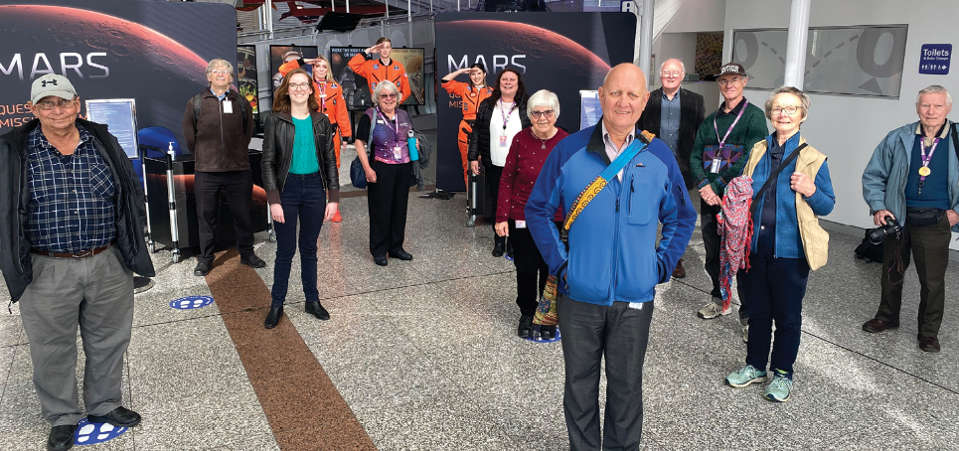
Figure 58: Questacon volunteers in the Centre foyer.

Vale Mr Ian McLeod, Emeritus Volunteer 1931–2020
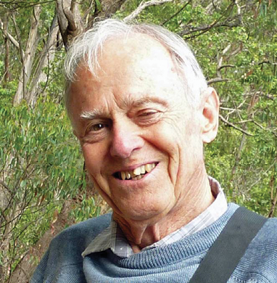
Figure 59: Ian McLeod
Ian was a very positive and passionate member of the Questacon family for 28 years. As a beloved member of the volunteer team, he applied his geology expertise, delighting in the opportunity to pass on knowledge to young visitors and colleagues during every shift. During more than 4,600 volunteer hours, he inspired our visitors, volunteers and staff to explore the environment and its underlying scientific phenomena.
Ian is remembered as an adventurer and a story teller, always taking opportunities to explain environmental formations on annual volunteer field trips, a key highlight for all in attendance. Throughout his time at Questacon, Ian contributed to important projects, even building the first wooden Pythagoras exhibit at his home workshop, an exhibit that is still used to this day and admired by many. Ian’s dedication to our organisation for nearly 3 decades shows us all what it is to be a loyal and committed member of our community. We are exceptionally grateful for every one of Ian’s volunteer hours, and his passion for Questacon.

Q Awards 2020
The Questacon Staff Awards are an opportunity for colleagues to recognise the achievements of other staff members during the year. Nominations can be made for both individuals and teams who have gone above and beyond in their role, achieved exceptional results, developed their professional skills or demonstrated outstanding creativity and innovation.
A record number of nominations in 2020, despite many staff working remotely for some of the year, reflected and acknowledged the ongoing high level of achievement and contributions from staff across the division.
Matthew Riches: For being the levelling factor for Questacon during unprecedented times. Matthew always brings his calm demeanour and approachable manner to times of high stress and anxiety, and has demonstrated exceptional management and delivery of Questacon’s business continuity requirements.
Michelle Lauder: For always demonstrating a calm and considered manner in stressful scenarios including the bushfires, smoke, hailstorms and the global pandemic. Michelle worked collaboratively across all areas of Questacon to develop and deliver reassuring messages, in a changing environment, to diverse audiences.
David Richardson: For commitment to ensuring his entire team are provided with equal opportunities for work and growth. David is always compassionate and generous with his time and focused on promoting an inclusive and supportive work environment for all.
Frank Valeri: For going above and beyond the expectation of a valued team member. Frank’s strong empathy towards members of his team and his sharing and caring manner was appreciated by the Production Team who have continued to work on site, under unique and difficult circumstances.
Hero Cook: For being a strong advocate in the development and delivery of the Questacon Mission to Mars visitor experience, inspiring positivity in everyone she worked with. Hero worked collaboratively across teams, responding to every request and delivering an exceptional standard of work.
Steph Hodge: For consistently putting in a huge effort to adapt the Questacon event management business in an extremely restricted environment. Steph’s knowledge and experience enabled her to adapt to restrictions, completely reimagine the way events were delivered and coordinate 2 successful high-profile celebrations.
Meg Bongers: For outstanding representation of both Questacon and the National Programs Team in the management of national programs and the Questacon Consultative Committee.
Tim Crowther: For demonstrating exemplary relationship management of stakeholders, paving the way forward and providing comprehensive solutions to manage Questacon’s travelling exhibition assets.
Peter Pateros: For being instrumental to the travelling exhibitions team in an environment of restricted activities, ensuring priority stakeholders were constantly supported and managing and overcoming the mountain of challenging scenarios.
Q Production Team: For exceptional team performance to develop, engineer, program and fabricate 2 major space exhibitions in parallel during a global pandemic. An achievement of 35 interactive exhibits, 12 large infographic displays and set work in a unique 12-month period.
Zeke Turner: For outstanding commitment and drive demonstrated as an Australian School-Based Apprentice: Electro-Technology Trainee. Zeke has a strong aptitude for self-management and a voracious appetite to learn new skills, completing his in-school traineeship at Questacon and leading to an industry apprenticeship.
Q Facilities Team: For consistently delivering an exceptional level of service and support across the organisation. The team’s ability to adapt quickly to changing environments, including smoke, hailstorms, flooding in our buildings and the global pandemic, demonstrates resilience and commitment to Questacon.
Q Cleaning Crew: For commitment in delivering an exceptional level of service through their cleaning regime, which provided a safe and clean environment for staff and visitors during the unique period of 2020.
Visitor Services and Visitor Programs: For demonstrated resilience and collaboration working through an immensely challenging year. The frontline staff in these teams have been exceptionally inspirational, not only engaging Questacon visitors in a new visitation format, but keeping everyone safe in the process.
The Greater Casual Cohort: For the professional, resilient and good-humoured response to a period of extreme uncertainty. Our casuals developed new ways of working – supporting external organisations, creating online content, developing new procedures, increasing their knowledge and providing valued support.
Elisha Deschamps: For demonstrating adaptability, resilience and passion in creating an inclusive work environment in difficult circumstances. Elisha is a positive and influential leader and transitioned the entire casual cohort to varied working arrangements. She influenced the strong collaboration between teams.
Shannon Cook: For recognition of outstanding perseverance, professionalism and positive attitude in supporting the Learning Experiences and Front of House delivery teams. Shannon’s skill in working across multiple sections was instrumental in the development of Questacon Mission to Mars and Questacon’s reopening strategies.
Peter Mascini: For outstanding achievement as the Digital Learning Manager and his ability to always put the needs of his team first, supporting them during a renewed focus on digital content. Peter overcame numerous technical challenges for this role, including making his first ever Facebook account!
Michaela Ripper: For being instrumental in supporting and delivering Questacon’s new suite of online activities while managing the impacts of bushfires and the COVID-19 pandemic. Michaela’s quality outcomes were demonstrated through her redesign and reimagining of the Questacon online experience.
Sarah Mason: For providing crucial leadership for the Digital Engagement Team to successfully deliver a series of significant and high-priority projects. Sarah’s outstanding advocacy and ongoing commitment for her team, colleagues and Questacon’s audiences ensured those around her were strengthened in their resolve.
Digital Engagement and Digital Learning: For their collective high-level performance to undertake a critical business realignment in the digital space and achieve incredible success while overcoming the year’s challenges, collaboratively delivering elegant solutions, under significant pressure.
Ingrid Yung: For providing exceptional customer service in a courteous and friendly manner. Ingrid always demonstrates an eagerness to help and support her colleagues, and ensures the Questacon network is constantly operating at optimal capacity.
Enamul Islam: For providing unwavering leadership, management and support for Questacon to implement an internal IT strategy that provided staff with IT assets, ensuring effective ‘working from home’ solutions to enable the organisation to maintain critical business activities and connections.
James Redden and Ms Eloise Perez: For the success of the online shop during a challenging 2020. This is a testament to both James and Eloise in their ability to work collaboratively and think outside the box in developing new and innovative commercial solutions.
Kate Gorrie: For exceptional organisation, prioritisation and calmly managing the delivery of a new Questacon travelling space exhibition and a permanent space exhibition designed and produced by Questacon, to be installed in the Australian Space Discovery Centre, Adelaide.
Michael Bennett: For leveraging various knowledge-banks, including project and commercial experiences, to bring together the visitor program for the Australian Space Discovery Centre. Michael’s professionalism shone through, demonstrating flexibility and capability to ensure stakeholders strategic goals are on track.
Concepts Team: For collectively being team focused on advocating for the visitor experience at Questacon. The team’s enthusiasm and professionalism has seen them perform at the highest level under immense pressures this year – coming together as a supportive and cohesive team.
Evaluation Team: For the outstanding performance to engage Questacon staff and a diverse array of stakeholders in the development and delivery of a complex and ambitious monitoring and evaluation program to support Questacon’s National Presence Strategy.
Women in STEM Group: For the outstanding effort of a cross-Questacon team in delivering a coordinated program to deliver against national priorities for greater recognition and engagement of Women in STEM.
The Social Club: For recognition of their continued drive to engage and connect the entire Questacon team, bringing people together (virtually!) throughout a challenging year. The Social Club worked tirelessly to minimise staff feeling isolated and created a number of interactive, stimulating and inclusive activities.
Tristan Hoffmeister: For demonstrating strong leadership, drive and resilience to lead the delivery of Questacon’s response to the pandemic, always focused on the safety and wellbeing of Questacon staff and visitors and incorporating a strong consultative and communication process across the organisation.
Jared Wilkins: For demonstrating exceptional leadership to Questacon and the National Programs Team. Jared’s leadership and role-modelling has helped create a positive team culture for staff to seek assistance, which was vital in enduring a difficult year.
Craig Whelan: For his excitement and commitment to the success of the Australian Space Discovery Centre while always being passionate about Questacon. Craig’s unshakable ‘can do’ attitude always supports positive staff morale and everyone he engages with.

Length of service

Questacon Staff

25 years
Geoff Crane

20 years
David Cannell
Carolyn Moore-Crouch
Tim Crowther
Andrew Webster
Gosia Sikorski
Sharren Kelly

15 years
Peter Mascini
Michelle Canning
Patrick Helean
Peter Pateros

10 years
Peter Larter
Ian Perry
Angie Good
Angela Mitchell
Kate Gorrie
Sue Alexander
Shannon Cook
Luke Mulders
Luke Hartley
Sharon Smith
Benjamin Villani

5 years
Janet Berenyi
Nicholas Marshall
Tristan Hoffmeister
Glen Goggin
Michael Bourke
Adrian Schmidt
Jessica Trezise
Jesse Jorgensen-Price
Winkei Lee
Lachlan McGinness
Jason Le
Frank Valeri
Eloise Brennan-Tucker
Tharika Liyanage
David Watts
Catherine Malam
Carrie Bigg
Michael Brennan
Brittany Lewis
Stuart Harris
Alice Bilton-Simek
Geoffrey Bonning
Cassandra Doig
Emma Hehir
Rachael Lowe
Garry Saju

Questacon Volunteers

10 years
Lorraine Anderson
Collin Milner

5 years
Leonie Jones
Pampa Ray
Thomas McCoy
David Royds
We wish to thank Robin Stanier for completing 19 years as a Questacon Volunteer. Robin was the recipient of an Emeritus Award in recognition of outstanding commitment and delivering exemplary service to the Questacon Volunteer Program.
In 2020, we also recognise and thank Dr Stephen Douglas, for dedicating 7 years of service as a Questacon Volunteer.
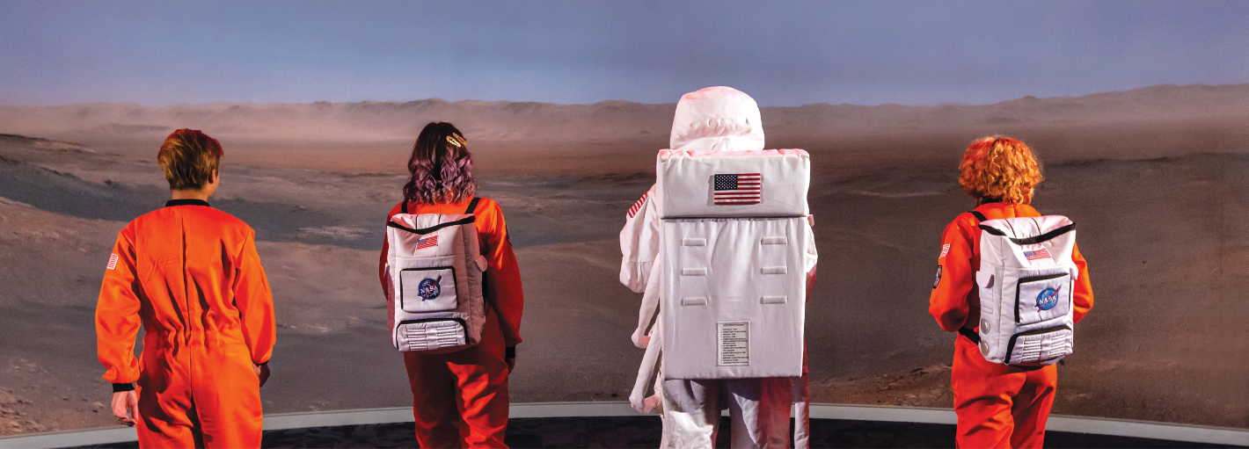

Principal Partners

Founding Partner

Supporting Partner

Collaborative Partner

Corporate Supporters


www.questacon.edu.au
